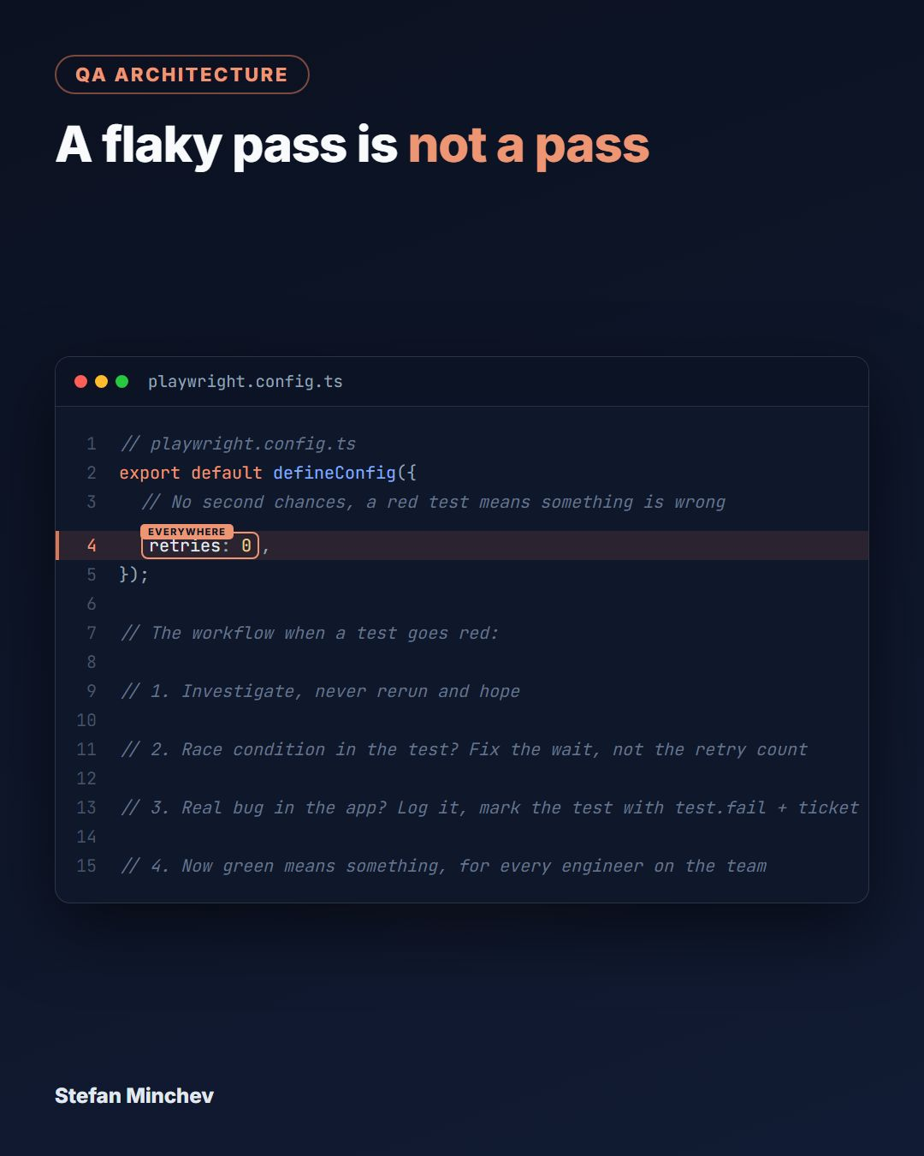
A test that passes on retry did not pass.
`retries: 2` in the config feels responsible. In practice it is how flaky tests learn to hide. Fail, retry, pass, green, ship. The flake survives and multiplies.
The config is only half the disease. One tolerated flaky test breeds the re-run culture, everyone clicks re-run until the pipeline turns green.
My number is zero. Local, CI, nightly, everywhere. No flaky test gets to live.
A red test is information. A retry is how you burn that information before anyone reads it.
With zero retries, every failure gets the same treatment:
🔸 Investigate, never rerun and hope
🔸 Race condition in the test? Fix the wait, not the retry count
🔸 Real bug in the app? Log it and mark the test with test.fail plus the ticket ID
This is not free. The first weeks surface every unstable wait and every hidden race your retries were absorbing. That is the point. You fix them once, and green starts meaning something for the whole team.
--—
There is a test in my suite that must fail for the build to stay green.
The bug is real, the ticket is written, and the fix is not coming this sprint. Most teams handle that moment in one of three ways.
🚩 Skip the test and silently lose the coverage
🚩 Delete it and forget the scenario ever existed
🚩 Let CI burn red until everyone stops reading the failures
Playwright has a fourth way: test.fail. Mark the test with the ticket ID and it keeps running on every build. The red result is reported as an expected failure, so CI stays green while the bug lives.
Here is the part I love. The day a dev fixes the bug, the test suddenly passes, Playwright reports "Expected to fail, but passed" and fails the run. Your pipeline literally tells you to delete the marker and keep the test.
The suite becomes a living bug tracker. No lost coverage, no stale tickets, no human memory required.
For a test that crashes instead of failing, test.fixme skips it the same self-documenting way.
How does your team keep CI green while a known bug waits for its fix?

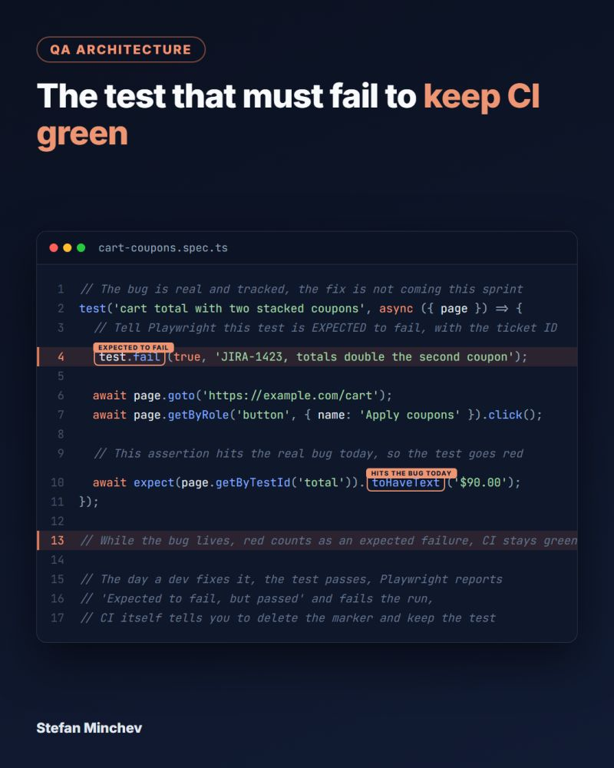

One custom matcher can retire the same assertion block copy-pasted across multiple test files.
Every team hits this. A routine check needs three lines. Grab the badge, assert it is visible, assert its text. Multiply that by every test that touches an order.
Playwright's `expect.extend` lets you name that check once.
You wrap the component internals inside a custom matcher and expose one semantic assertion the whole team reuses (see image).
🔸 `toHaveOrderStatus('Shipped')` reads like the requirement, not the markup
🔸 New engineers call the matcher without learning a single internal test ID
🔸 A selector change is one edit inside the matcher, not one per file across the suite
Bonus. On failure, capture the actual badge text so your CI log says what it saw, not a vague "text didn't match".
Same idea scales to any domain state. A toast becomes `toBeErrorNotification('Access Denied')`. Your assertion library starts speaking your product's language.
Are you still forcing your team to copy-paste raw element chains for routine checks, or have you wrapped your domain rules into semantic custom matchers?

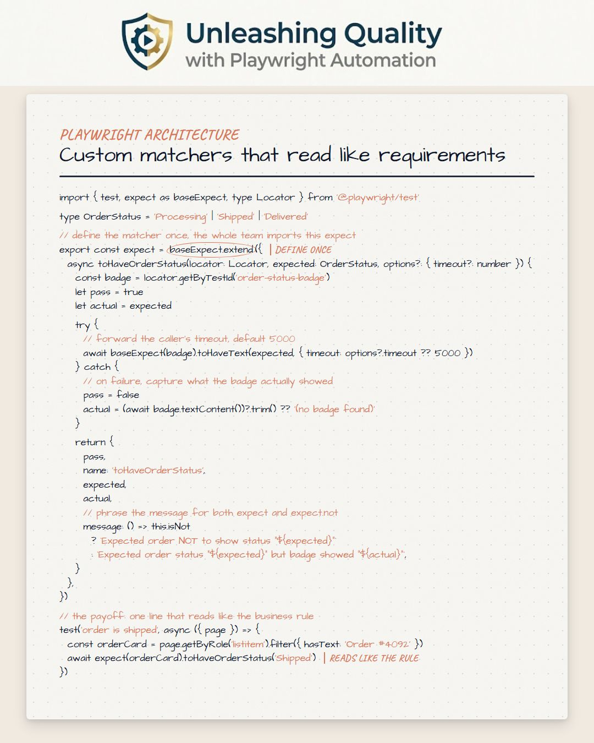

Broken test code used to reach our CI. Now it cannot even leave the IDE.
Last week I shared the ESLint matrix that turns Playwright anti-patterns into hard errors. One problem remained: a linter someone has to remember to run is a suggestion, not a gate.
Husky and lint-staged close that hole. The entire pre-commit hook is one line: `npx lint-staged`.
Here is what fires on every commit:
🔸 lint-staged collects only the staged files, so commits stay fast
🔸 ESLint blocks the missing await, the raw `any`, the forgotten `test.only`
🔸 Prettier seals the formatting before the diff even exists
🔸 The `prepare` script registers the hook for every teammate on npm install
No discipline required. The gate runs whether you remember it or not.
I packed the full setup into a step-by-step guide, every command executed and verified on a clean project before publishing.
Link is in the comments 👇
The first 100 copies are free, so early readers can grab it before I decide on pricing. Once those are claimed, the offer changes.
Do you gate commits locally, or is CI your first line of defense?

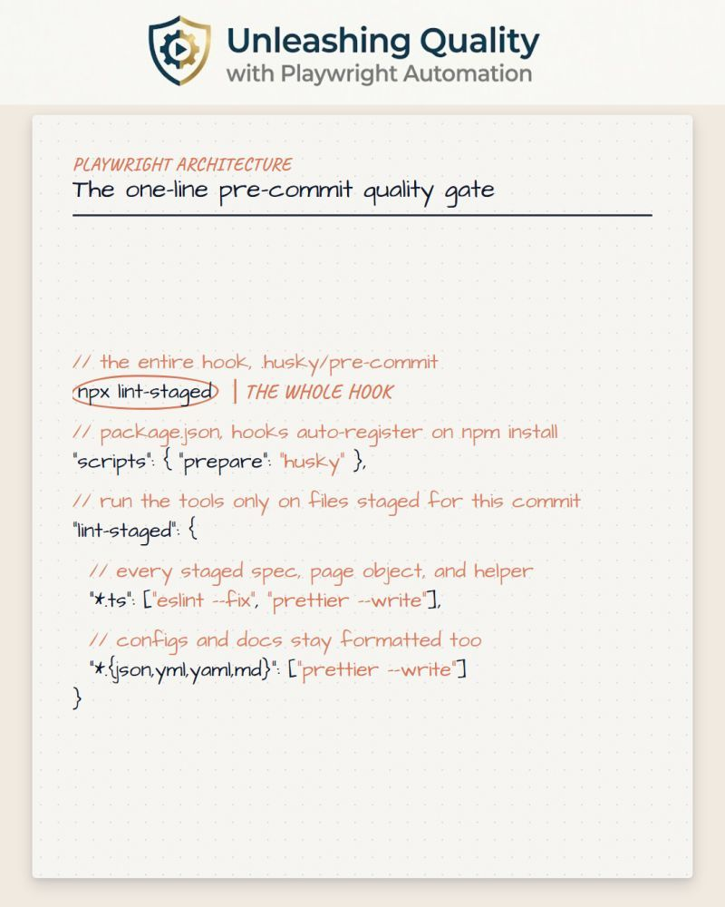

A Playwright repo without strict lint rules is a ticking time bomb.
Application code gets strict linting. The automation suite gets a loose config and a shrug. That double standard is exactly where broken CI runs start.
So I make the framework self-policing with one shared flat ESLint config. Every structural anti-pattern becomes a hard error before the code reaches a pull request:
🚩 A raw `any` escaping type safety
🚩 A missing await on an assertion
🚩 A forgotten `test.only` or `test.skip`
🚩 An arbitrary `waitForTimeout` burning CI budget
Push one of these and the build breaks instantly. No debate, no "we will fix it later".
The payoff is review time. Seniors stop hunting for missing awaits and loose types, because the linter catches them locally before anyone opens the diff.
Next up I will talk about wiring this config into Husky, so every rule fires automatically in a pre-commit hook.
Is your framework self-policing these anti-patterns, or is your team catching missing awaits the hard way inside broken CI runs?

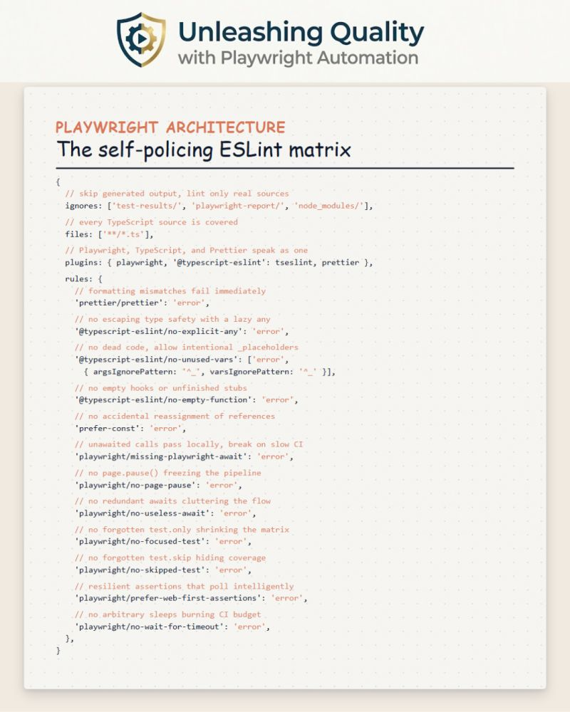

Scatter `process.env` calls across multiple Playwright test files and refactoring becomes a nightmare.
Most teams do not think twice about it. A test needs the base URL, so they write `process.env.BASE_URL!`. Another needs admin credentials, so they write `process.env.ADMIN_PASS!` right there in the spec.
Three months later, someone renames `ADMIN_PASS` to `ADMIN_PASSWORD` in the CI config. Half the suite runs fine. The other half crashes with `Cannot read properties of undefined` buried inside a login flow.
There is a better pattern: one centralized, validated config module.
Create a frozen `ENV` object in `src/config/env.ts`. Map every environment variable exactly once and guard required ones with a `throwMissingEnv` helper that fails immediately on startup.
🚩 `process.env.ADMIN_USER` scattered across multiple files
✅ `ENV.adminUser` imported from one validated module
If CI forgets to inject `ADMIN_PASS`, the framework throws within milliseconds of boot. Not after a full login sequence. Not buried in a stack trace. Right at the gate.
You also get IDE autocomplete on every `ENV` property and a single file to update when variables change.
Are your environment variables scattered blindly across your specs, or do you validate them at the gate with a centralized configuration module?

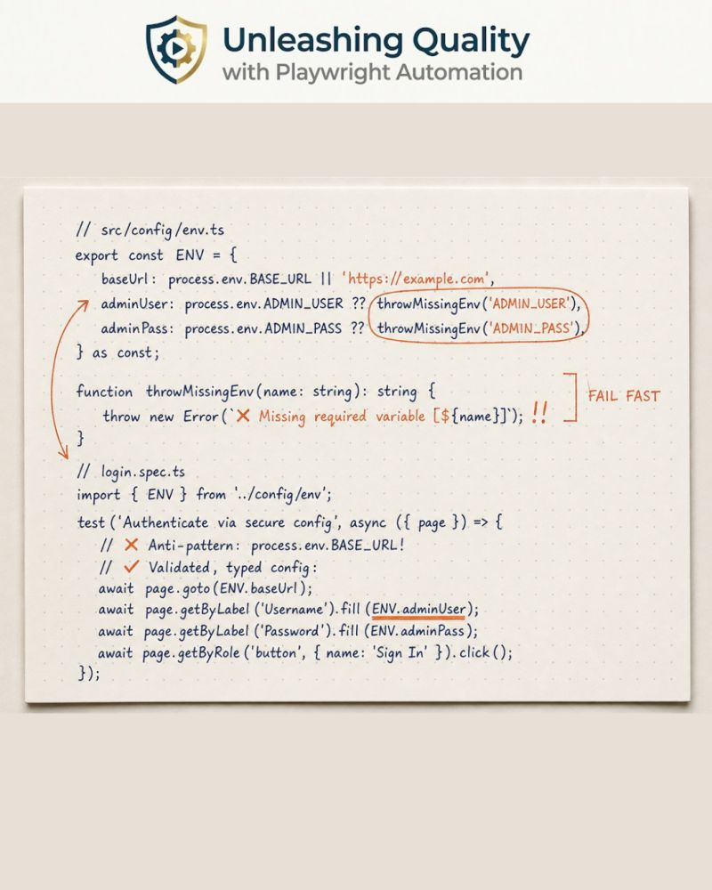

Most teams treat WCAG compliance as a manual audit item. It doesn't have to be.
`AxeBuilder` from `@axe-core/playwright` scans the live DOM state after any interaction. Your Playwright tests are already navigating real pages, filling real forms, and clicking real buttons. Adding accessibility coverage at that point costs one line.
The scalable way to do it is a single custom fixture.
Centralise the scan logic, the WCAG tags, and the global exclusions in `assertAccessibility()` once. Every test inherits it. When compliance rules change, you update one file instead of forty.
Your spec stays clean and declarative. You drive the UI with `getByRole()` and `getByLabel()` exactly like a real user. When you want to audit compliance, one call is all it takes.
User-flow logic in the test. Accessibility configuration in the fixture. You're scanning against the same accessibility tree screen readers actually use.
Does your Playwright suite currently catch accessibility regressions automatically, or is WCAG compliance still a manual checklist item before releases?

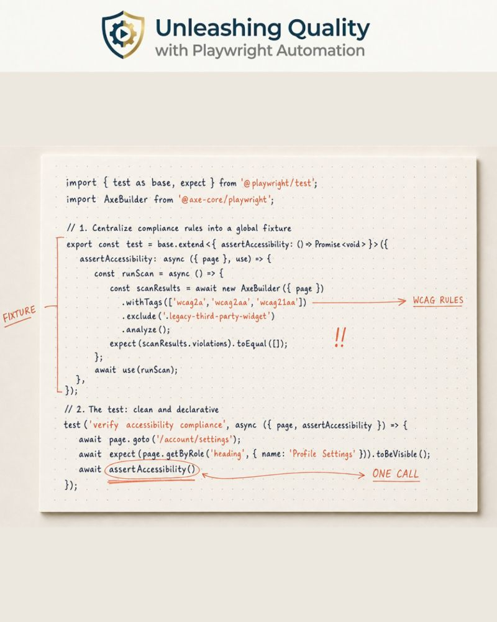

Your tests passed. Your checkout form is still confusing everyone who tries it for the first time.
Playwright tells you the form submits. It doesn't tell you users stare at step 3 for 20 seconds before giving up.
That's not a bug. No script will ever catch it.
This is what whole-team exploratory testing is for.
Not because automation is broken. Because automation asks the wrong question.
It asks: "Does it work?"
Your team should also be asking: "Does it make sense?"
When a developer, designer, and product owner sit down with the same staging build:
The designer notices the micro-interaction that feels weirdly sluggish
The developer spots the console flooding with 400s nobody is handling
The product owner flags the copy that's grammatically fine but sends users the wrong way
The QA engineer finds the race condition behind the double-click on the submit button
Some of those are real bugs your scripts never reached. Some are UX issues no assertion can measure. None of that lives in a test report.
How often does your full product team actually use the app together before a release?

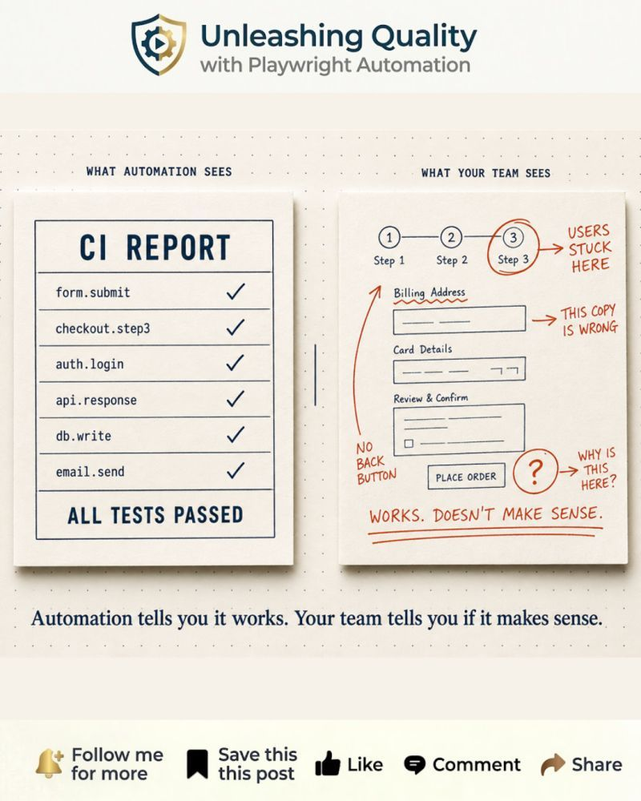

`page.waitForTimeout(5000)` is not a fix for a flaky test. It is an admission that you are guessing when your application finishes async work.
Every hardcoded sleep you scatter across your test suite slows it down and leaves the race condition buried, waiting for a CI runner that runs just a bit slower than your local machine.
The fix is to let Playwright sync with DOM state directly.
`toBeHidden()` polls the DOM continuously. It proceds the exact millisecond the spinner disappears, not 5000 ms later regardless of whether it is gone.
Pair it with `toBeEnabled()` on submit buttons that unlock after backend validation, and you eliminate an entire class of timing-related flakiness.
Your tests run at the maximum speed the application allows, fast locally and resilient on CI runners.
How many hardcoded sleeps are currently holding your test suite's speed hostage?

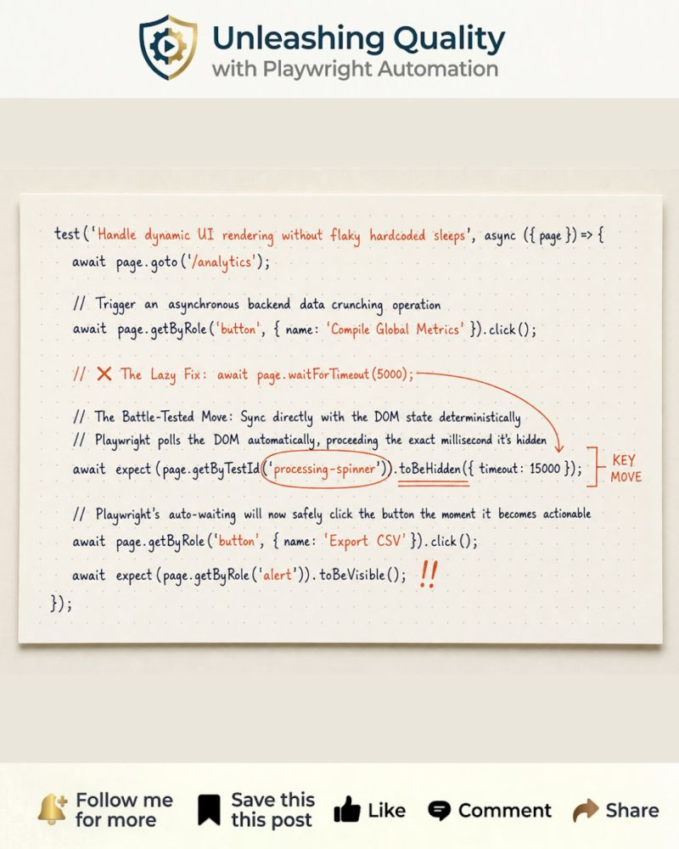

Chasing 100% test coverage is quietly killing your engineering velocity.
If your primary metric for QA success is hitting 100% automation coverage, you aren't fighting bugs. You are building a massive, flaky monster that your developers will eventually learn to ignore.
Trying to assert every single UI element, error message, and obscure edge case through browser automation leads straight to three things:
🔴 False sense of security - brittle tests that only check if a button exists do not prove your app is healthy. They just prove nobody moved the button.
🔴 High maintenance, low value - you burn 80% of your time maintaining tests for edge cases that hit 0.01% of users.
🔴 CI/CD Bottlenecks - Your regression suite takes 45 minutes to run, killing developer deployment velocity.
The modern QA stack is not about automating everything. It is about automating smartly.
Successful teams use a strategic 3-Layer Framework:
Layer 1: TypeScript for Static & Contract Validation
Stop using heavy browser instances to test data structures or missing properties. Leverage strict TypeScript interfaces to catch API contract changes and data mismatches right in the IDE or at the unit/component level before a browser even opens.
Layer 2: Playwright for High-Value Functional Journeys
Ruthlessly restrict your E2E browser automation to critical revenue-generating flows (e.g., Authentication, Checkout, Core Workflows). Keep these tests blazing fast, bypass the UI for test setup using Playwright’s native API capabilities, and shard execution to keep pipeline times under 10 minutes.
Layer 3: Visual AI for Layout Health
Stop writing 50 line-by-line DOM element assertions to check if text, colors, and images are rendered correctly. Replace them with a single Visual AI baseline check. Let machine learning distinguish between dynamic data updates and actual visual degradation or broken CSS.
Quality is about risk mitigation and feedback speed, not vanity metrics.
Save the chart below to help convince your stakeholders it is time to delete low value tests and focus on speed.

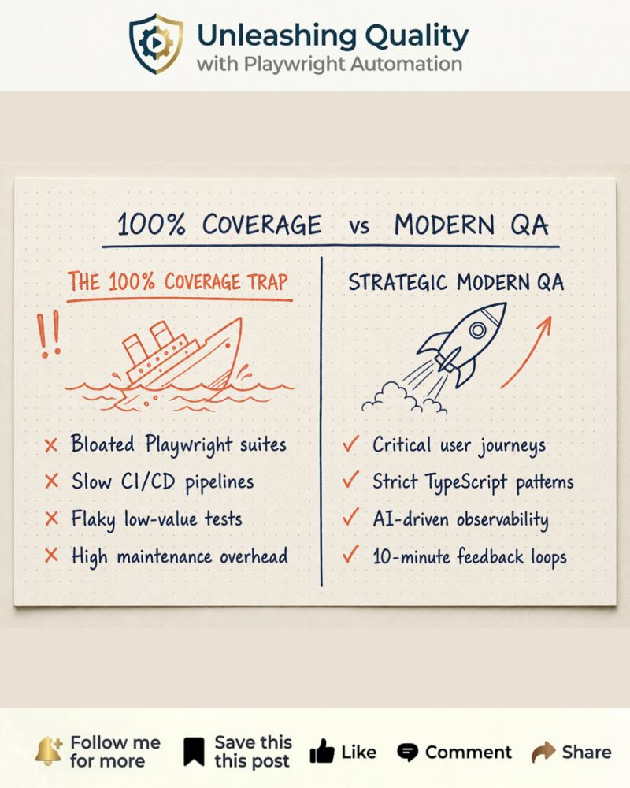

Stop burning CI credits on a checkout flow that was doomed before it even started.
I learned this one the expensive way. A downstream service was down, and every checkout test still spun up a browser, walked half the flow, then timed out. Multiply that by retries and parallel shards and one bad deploy quietly ate a big chunk of our CI minutes for the day.
The fix was embarrassingly small. Before Playwright boots a single browser, hit a health endpoint and fail the whole suite in one cheap request.
🔸 `test.beforeAll` calls `request.get('/api/health')`
🔸 `expect(response.ok()).toBeTruthy()` with a loud abort message
If the core service is offline, the suite stops in under 200 milliseconds instead of grinding through heavy UI sessions until every test hits its timeout (see image).
That one gate protects your cloud bill, kills false-alarm flakes, and keeps the feedback loop fast for the whole team.
🚩 The anti-pattern is letting the suite spin up multi-tab browser sessions and attempt full UI checkouts while a payment gateway is entirely down. You get cascade timeouts and burned credits for zero signal.
A failing dependency is an environment problem, not a test failure. Catch it at the door.
Do you use fail-fast API gates in your automation pipeline, or do you let your tests run to their maximum timeout threshold when downstream environments crash?

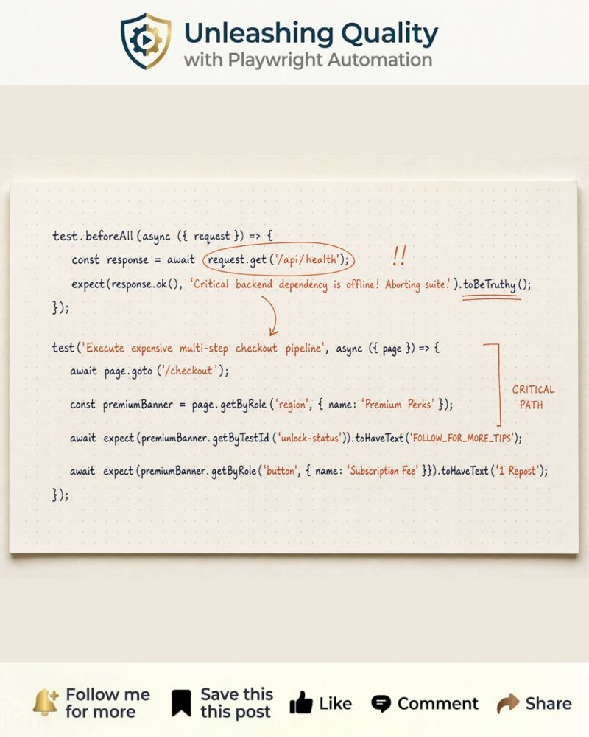

You need to revoke a user's access mid-session and prove the block works without restarting the browser.
Here is the challenge. Test an Admin changing a regular user's permission settings, then immediately verify that user loses access. No browser restart. No logout. No login dance.
Most engineers reach for the slow path. Log in as the Admin in one session. Make the change. Click logout. Log back in as the User through the UI. Assert the result.
That sequence is brittle and painfully slow. Every extra login round trip inflates your CI runtime and adds another step.
Playwright already solves this. You can run two isolated browser contexts inside a single test, each loading its own authenticated state.
🔸 One context boots as the Admin from `state/admin.json`
🔸 A second context boots as the User from `state/user.json`
The Admin changes the permission. The User hits the protected route in parallel. You assert the access change in real time (see image).
No logout. No re-login. Two roles with fully isolated cookies and storage, living side by side in one test.
This is how you catch permission sync bugs the instant they happen. And you slash a multi-minute multi-role flow down to seconds.
How do you approach multi-role testing in your E2E suites? Do you orchestrate multiple active browser contexts at once, or do you stick to sequential login and logout UI flows?

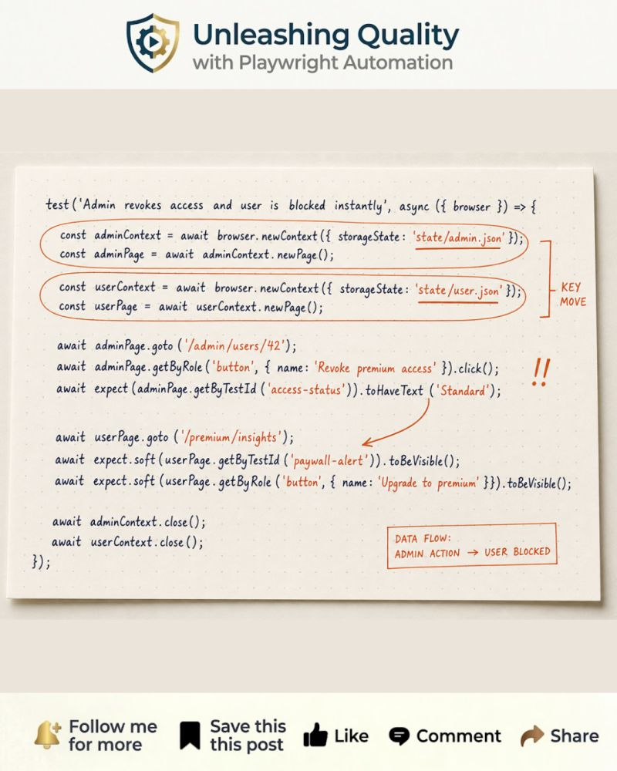

Stop digging through 300-line stack traces when a 50-step E2E test fails in CI.
This is the question that separates script writers from framework architects. When a massive end-to-end flow blows up midway, how do you pinpoint the failure without manually tracing every await before the crash?
Most engineers write the test as a continuous stream of 50 uncommented commands. The HTML report fires back a generic line number, and now you are reverse engineering the application state.
🚩 50 awaits in a row with no logical boundaries
🚩 The report gives you a line number, not a business step
Playwright's `test.step()` fixes this completely.
Wrap each logical chunk of the flow inside a `test.step()` block (see image). Each step gets a clear, human-readable label inside your HTML report. When a step fails, the report points to the exact business intent that went under, not a raw line of code.
`await test.step('Step 2: Hit the algorithm with engagement', async () => { ... })`
This is a deliberate design choice. You stop debugging code lines and start debugging business flows. Your test report becomes a stack trace at the user journey level, not the syntax level.
How do you break down long E2E user journeys? Do you rely on modular `test.step()` blocks to keep your reports clean, or do you prefer chopping them into tiny, disconnected test files?

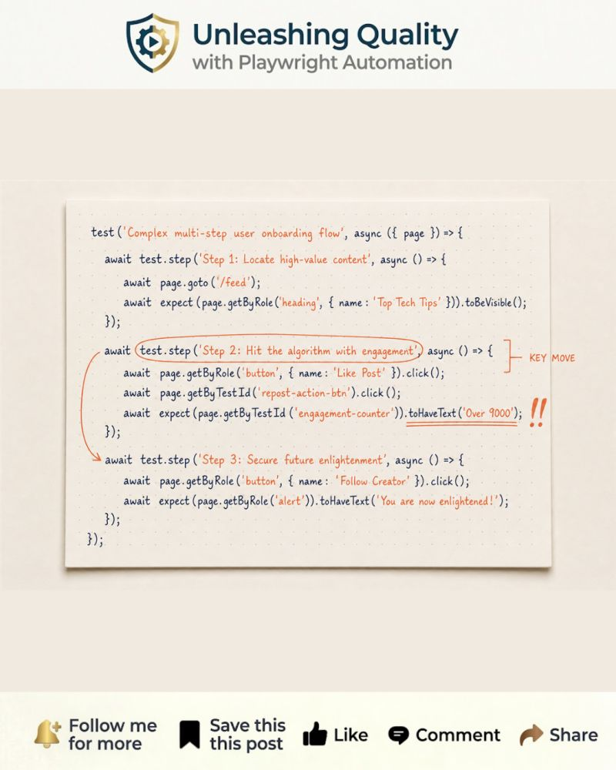

Stop debugging multi-field pages one assertion at a time.
You know the loop. Test fails. Fix the one broken field. Rerun. Find the next broken field. Fix it. Rerun again.
With hard `expect()` chains on independent UI elements, every failure stops execution immediately. You are debugging one issue at a time when five might be broken simultaneously. Your CI is lying to you by design.
Playwright's `expect.soft()` changes this completely.
Soft assertions collect every failure and report them all at the end of the test run. Execution continues even when an assertion fails partway through.
🚩 Avoid this pattern on independent fields:
🚩 `await expect(page.locator('.checkout-summary > div:nth-child(2)')).toHaveText('Engagement Fee')`
A dev adds one extra wrapper div and your entire test bleeds red for the wrong reason.
Here is the soft approach with semantic locators (see image).
Every soft assertion runs. Every failure is logged. You fix them all in one shot instead of one rerun at a time.
This radically slashes debugging time and keeps your CI feedback loop fast.
`expect.soft()` is not a workaround. It is a deliberate design choice when you need to audit every field on a page in a single pass.
How do you handle multi-field validations in your automation framework? Do you let them run soft, or do you prefer breaking them out into isolated micro-tests?

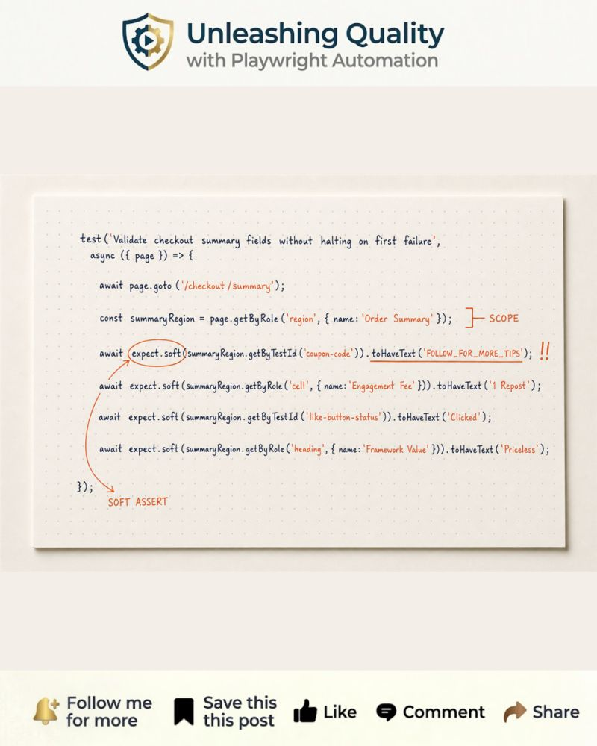

This is the classic async race condition trap interviewers use to filter out junior Playwright candidates.
You click a link. A new tab opens. You try to interact with it.
In CI, your test flakes with a timeout. Locally it passes every time.
The culprit is execution order.
Most engineers write it like this:
🚩 Click fires before the event listener registers
🚩 New tab opens before Playwright starts watching
By the time `context.waitForEvent('page')` is called, the browser has already opened the tab and the event is gone. The promise times out.
The fix is one JavaScript concept applied deliberately: register the listener and fire the trigger at the same time.
`Promise.all` locks both into the same tick. `context.waitForEvent('page')` registers first, then the click fires. The race condition is permanently closed.
In the snippet, the listener and the click are wrapped together inside `Promise.all`. The new page reference drops out of the destructured result. You can assert the URL, read headings, or run the full verification flow from there.
This pattern works for any multi-tab scenario. External billing portals. PDF preview tabs. OAuth pop-up windows. If your app opens it, you own it.
CI runs slower than your local machine. That timing gap is exactly where this race condition lives.
Now you can answer it like a senior.

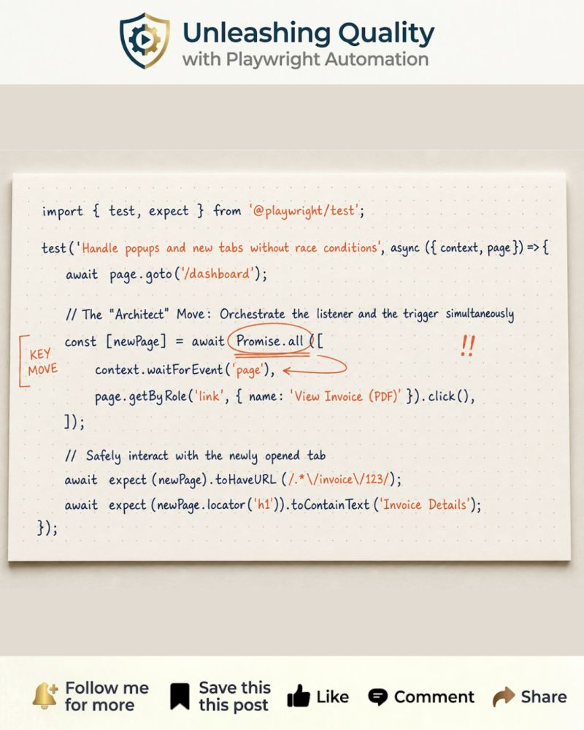

Your status check passes, but the data contract is broken underneath.
`expect(response.ok()).toBeTruthy()` only tells you the server didn't crash. It says nothing about whether the data your frontend depends on actually matches the agreed contract.
If the backend silently converts a required field to `null`, or returns extra unmapped keys, your 200 OK assertion still passes. Your frontend breaks in production instead.
This is the Schema Sniper pattern, modernized for Zod 4.
Define your contract with `z.strictObject`. Declare each field using top-level Zod 4 format functions like `z.uuid()` and `z.email()`. Then call `userProfileSchema.parse(await response.json())` right after the request. That single line validates the shape and returns a fully typed object.
`z.strictObject` fails the test immediately if the backend adds a rogue field or silently changes a type. No more hunting through obscure UI errors to trace a silent API drift.
Are you validating the structural schema of your API responses, or just trusting the status code?

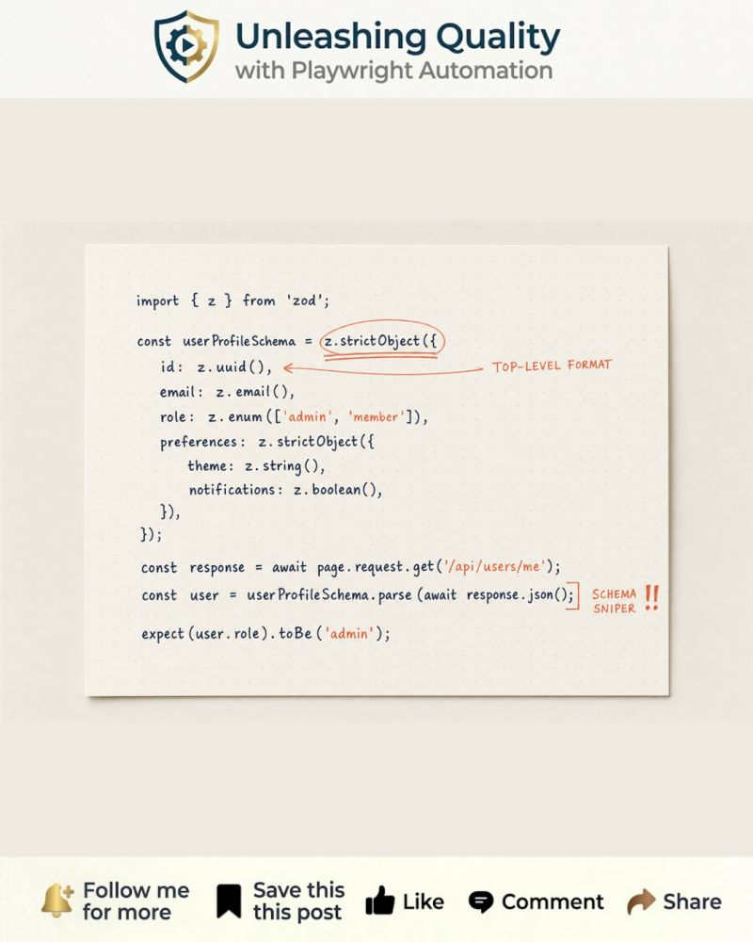

Stop writing while loops to wait for a database update. You’re over-engineering your own stress.
We've all been there: you trigger an action like placing an order, but the backend needs a few seconds to process it.
The old way usually looks like a messy while loop with `page.waitForTimeout(1000)` inside. It's brittle, hard to read, and leads to flaky tests whenever the environment runs slow.
The Playwright way is `expect.poll`. It's a built-in "smart waiter" that retries your logic until a condition is met, with configurable intervals and a clear timeout.
Here's how it works: create the order, then pass an async callback to `expect.poll` that fetches the order list and returns the status of your specific order. Add a backoff strategy via `intervals`, a `timeout`, and a clear `message` for failures. Chain `.toBe('COMPLETED')` at the end. That's it.
No custom retry logic. No guessing how long to sleep. `expect.poll` handles the polling, the intervals, and the assertions in a single readable block.
🚩 Anti-pattern to avoid: the "sleep and hope" method calls `page.waitForTimeout(5000)`, then checks the status in a separate assertion.

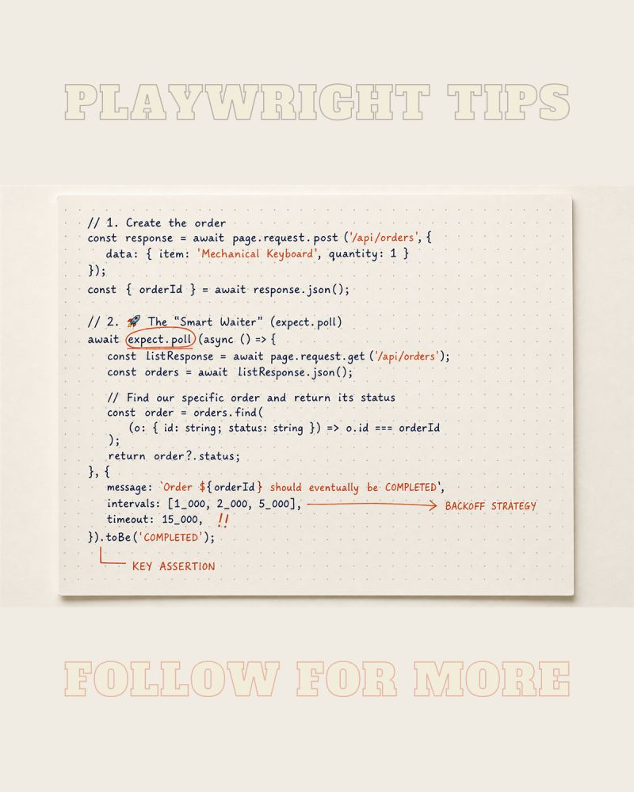

I tested a New Year's Eve countdown in the middle of May without touching the server clock.
Time-dependent UI is one of the hardest things to test reliably. Expiring banners, countdown timers, session timeouts, "Early Bird" pricing cutoffs. They all depend on the clock, and the clock is not your friend.
Most teams do one of two things when they need to test time-sensitive logic.
🚩 They call page.waitForTimeout(10000) and literally wait for the timer to expire
🚩 They SSH into the Staging server and manually shift the system clock
Both are painful. One bloats your suite runtime. The other terrifies everyone who shares that environment.
Playwright has a built-in answer: the Clock API.
With page.clock.install() you freeze time at any arbitrary point. Then page.clock.fastForward() jumps the clock forward by exactly the amount you need, instantly, no real waiting required.
Here is what it looks like in practice. I freeze the clock to 10 seconds before midnight on New Year's Eve, confirm the discount timer reads 00:10, then jump 11 seconds into the future and assert the UI marks the offer as expired and disables the buy button.
The whole thing runs in milliseconds.
This also works for throttling setInterval callbacks, validating JWT expiry, testing cron-driven UI updates, and any other logic that relies on Date.now(). If it depends on the clock, page.clock owns it.
Are you still hacking your server clock to test dates, or have you started using the Playwright Clock API?

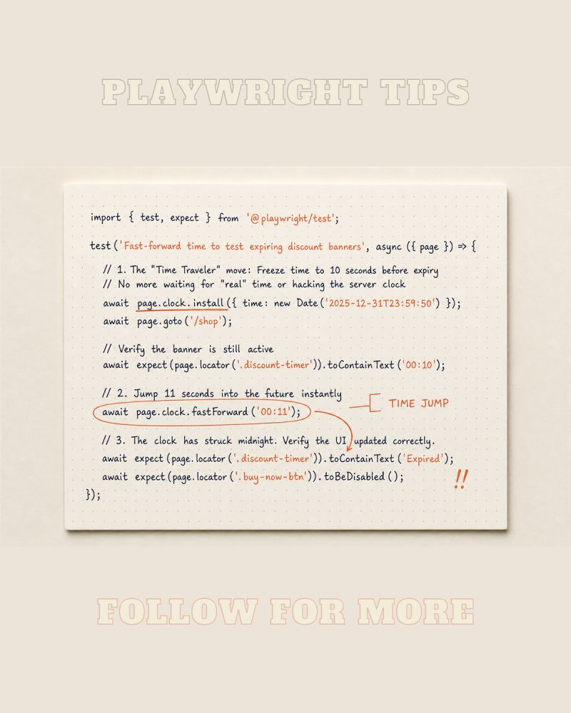

Stop relying on 'perfect data' to test your UI.
Most teams spend 10 minutes seeding a database just to verify if a single banner shows up. Then 10 more minutes cleaning state when the test breaks halfway.
🚩 Manual test users
🚩 Dirty staging environments
🚩 Flaky waits for data to sync
This is test data fatigue. It kills velocity and confidence.
There is a smarter way. Hijack the network and decide exactly what your UI sees.
Playwright gives you page.route plus route.fulfill. Intercept the API call, fetch the real response, modify it on the fly, return whatever scenario you need.
In the snippet, a standard user response gets rewritten with subscription PREMIUM and a list of VIP features. The dashboard renders premium without touching the database.
Want to test an expired subscription? Mock /api/v1/billing/status and return expired.
Want a 500 error? Return an error response in milliseconds.
Want an empty state? Return [] and watch the UI react.
✅ No database seeding
✅ No test data fatigue
✅ No staging dependency
✅ Deterministic, reproducible scenarios
Your tests stop being data-dependent and start being state-driven. That is the difference between writing tests and architecting them.
Do you prefer mocking the network for UI tests, or do you still believe in full end-to-end database integration for every scenario?
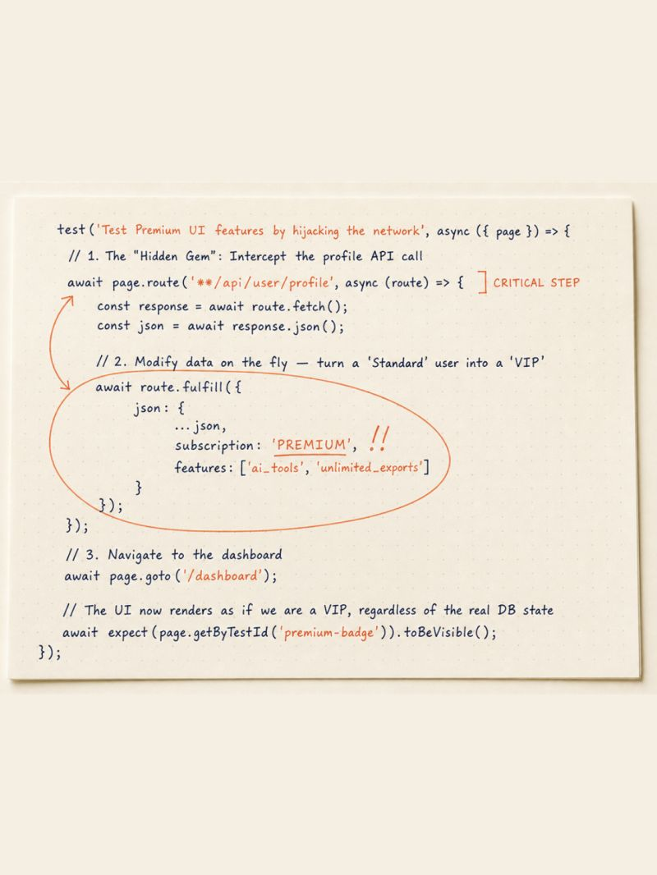

The Page Object Model is one of the most misapplied patterns in test automation. Not because teams don't understand it, because they apply it to everything.
➡ This is part 4 of my Playwright Tutorial series. Last week I covered fixtures. Today: the Page Object Model.
I've seen page objects with a dedicated method for every single action. Click a button? Method. Fill one input? Method. Check a label that appears in exactly one test? Method.
The result is a page object with 80 methods and a test file you can't read without having the page object open on the other monitor.
POM serves two things: reuse and readability. When every method is called exactly once, you've achieved neither.
The rule I follow is simple:
🔸 If an action is shared across tests, it belongs in the page object.
🔸 If an action only exists in one test, it belongs in the test.
Keep it visible. Keep it where the reader's eyes already are.
Follow along for the next post in the Playwright Tutorial series.
Where do you draw the line between what goes in the page object and what stays in the test?

-----------------------
Your UI test suite should protect user journeys, not mirror your ticket board.
That difference decides whether automation helps the team or slows it down.
I've seen this pattern too many times:
A ticket gets built.
A UI test gets added.
Another ticket gets built.
Another UI test gets added.
It feels responsible.
It is not.
It is like checking every room in a building by walking the entire building each time you replace one light bulb.
You can do it, but soon the inspection takes longer than the work.
The cost shows up fast:
1. Every small rule change becomes another brittle UI scenario
2. CI slows down
3. Flaky tests start hiding real failures
4. The team stops trusting the suite
That is not quality engineering.
That is test debt with a nice report.
The better approach is simple:
✅ Business logic: API and integration tests.
✅ Critical flows: E2E UI tests.
✅ Ticket edge cases: test them at the lowest layer that proves the risk.
A good E2E suite should answer: "Can our users still complete the core things?"
It should not answer: "Did we automate the ticket board?"
Where do you draw the line between API/integration coverage and E2E UI coverage?
------------------
Your beforeEach works. Until you need the same setup in 4 different test files.
➡ This is part 3 of my Playwright Tutorial series. Last week I covered tags. Today: fixtures.
Think of a fixture as a helper you attach to your test. It creates what the test needs, hands it over, and cleans up when the test is done.
Every fixture has three parts:
1. Setup: create the test data (via API, database, or UI)
2. use(): pass whatever you created to the test, the test runs here
3. Teardown: everything written after use() runs automatically when the test finishes
That last part is the one most people miss. Cleanup is built in. No afterEach. No risk of forgetting it.
Here is how this looks in practice. The fixture calls the API to create an order. The test receives the order ID, already in the database, ready to use. When the test finishes, the fixture deletes the order automatically.
✅ Your test gets clean data. Your database stays clean after.
And because a fixture lives in a shared file, you can import it into any test file in the project. Write the setup once. Use it everywhere.
Three things that make fixtures better than hooks for this:
1. Reusable across any test file, not just the one they are defined in
2. Teardown is guaranteed, it runs even if the test fails
3. They compose, a fixture can use other fixtures as input
That third point matters more than it sounds. Your order fixture can use Playwright's built-in request fixture. Another fixture can build on top of yours. You add layers instead of duplicating setup.
Follow along for the next post in the Playwright Tutorial series.
What test data do you currently set up and tear down manually that a fixture would handle for you?

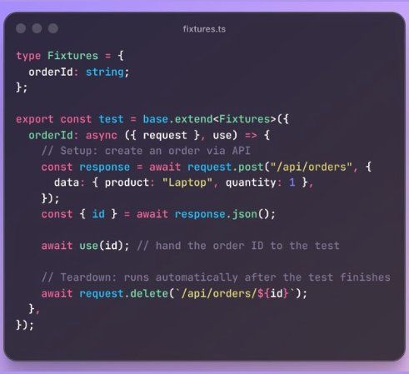

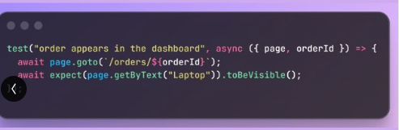

Writing detailed, step-by-step manual test cases in Jira, TestRail, or any TCMS your team uses in 2026 is a massive waste of engineering time.
Step 1: Open the browser.
Step 2: Navigate to the login page.
Step 3: Enter a valid email address.
Step 4: Click "Sign In".
Expected result: User is redirected to the dashboard.
Your developer just renamed that button to "Log In".
Your test case is already wrong. Your TCMS doesn't know. Nobody updated it.
This is what detailed manual test documentation looks like in practice. It's outdated the moment someone merges a PR. I've watched QA engineers spend half a sprint writing test cases that nobody read. Not developers. Not product owners. Not even the QA engineer who wrote them two months later.
The documentation exists. The confidence is fake.
Here's the thing: you don't need to stop having test steps in your TCMS.
You need to stop writing them there.
In one of my current project, our Playwright tests look like this:
test step('GIVEN the user is on the checkout page', ...)
test step('WHEN the user applies a discount code', ...)
test step('AND confirms the order', ...)
test step('THEN order confirmation is displayed', ...)
These steps are visible in our TCMS. Automatically. Because the test is linked directly in the code.
One annotation. That's it.
Take Qase as an example. Two lines at the top of your test:
qase suite('Checkout Flow') // <-- This is the suite name in the TCMS
qase id(123) // <-- This is the test case ID in the TCMS
Your test case is registered. Your steps are synced. When the flow changes, the developer updates the code. The TCMS reflects it.
You write the steps once. In the place where they actually run.
Not once in TestRail or wherever your team manages tests. Then again in your automation file. Then again when someone renames a button.
The steps live in the code. Your TCMS just shows them.
The integration already exists. Most teams just don't use it.
When did you last update a test case in your TCMS and your Playwright test separately because someone changed a label?

------------------
500 tests. You only need to verify one feature. You run all 500. There is better way.
Without tags, every pipeline run is all-or-nothing. That's not a strategy.
➡ This is part of my Playwright Tutorial series.
No tags means no control. You either run everything or you grep test names or files and hope for the best.
Tags give you a surgical option.
These are the three conventions worth adopting:
🔸 @smoke - critical paths only. Runs on every commit.
🔸 @regression - full feature coverage. Runs before release.
🔸 @slow - tests that take over 30 seconds. Excluded from fast pipelines.
You can also combine them.
Run smoke OR regression:
npx playwright test --grep "@smoke|@regression"
Exclude slow tests entirely:
npx playwright test --grep-invert @slow
A test suite without tags is just a list of files. Tags turn it into a tool.
Follow along for the next post in the Playwright Tutorial series.
What tag conventions does your team use, or are you still running the full suite every time?

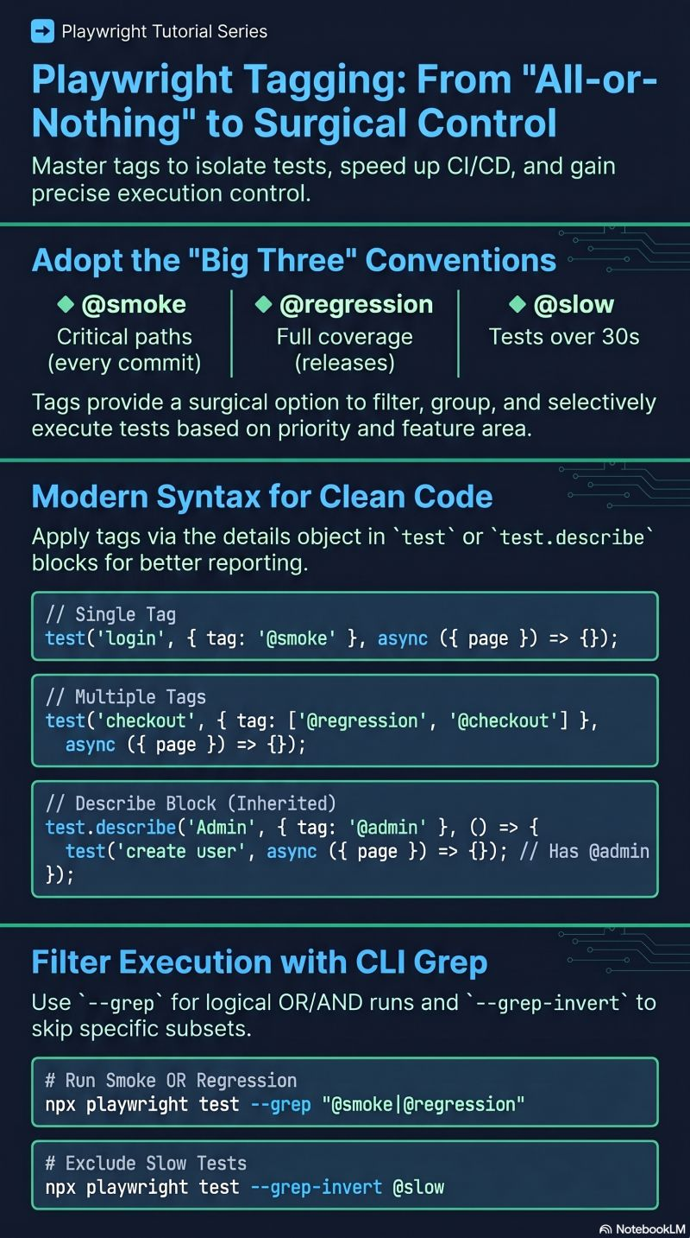

If your Playwright tests have the same 10 lines of setup code copied into every single test, you're doing it the wrong way.
Playwright gives you 4 hooks to handle setup and teardown cleanly.
➡ This is part of my Playwright Tutorial series.
Hooks are functions that Playwright runs automatically at specific points in your test suite. You don't call them manually. You define them once and Playwright handles when they fire.
There are 4 of them. Each one has a specific job. Pick the wrong one and your tests start bleeding into each other.
1. beforeAll
Runs once before all tests in the block. Too expensive to repeat per test? Put it here.
test.beforeAll(async ({ request }) => {
await request.post('/api/users', {
data: { name: 'Test User', email: 'test@example.com' },
});
});
2. afterAll
Runs once after all tests finish. Whatever beforeAll created, afterAll cleans up.
test.afterAll(async ({ request }) => {
await request.delete('/api/users/test@example.com');
});
3. beforeEach
Runs before every single test. Use it to create data specific to that test, not shared with others.
let orderId: string;
test.beforeEach(async ({ request }) => {
const res = await request.post('/api/orders', {
data: { product: 'Laptop', quantity: 1 },
});
orderId = (await res.json()).id;
});
4. afterEach
Runs after every single test. Use it to clear per-test state so the next test starts clean.
test.afterEach(async ({ request }) => {
await request.delete(`/api/orders/${orderId}`);
});
🔸 The rule: shared setup belongs in beforeAll/afterAll. Per-test setup belongs in beforeEach/afterEach.
Getting this wrong is one of the fastest ways to introduce flaky tests.
Follow along for the next post in the Playwright Tutorial series.
Which hook do you reach for most in your Playwright projects?

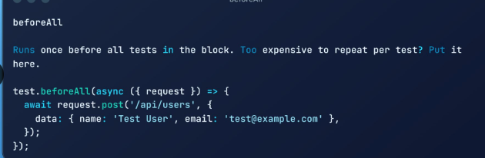

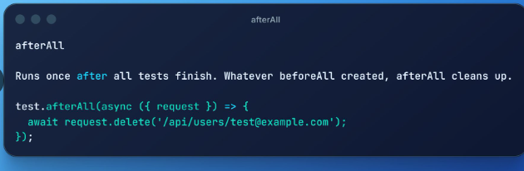

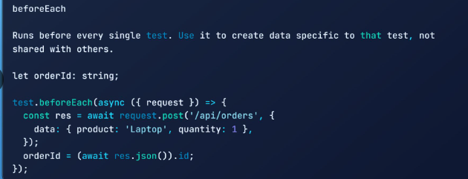

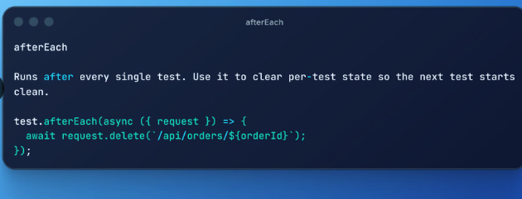

--------
lesson ABOUT ARRAYS AND OBJECTS IN TYPESCRIPT
--------

Every course I took taught me XPath. Nobody mentioned it was the worst locator you could write.
I spent months writing //div[@class='btn-submit'] and thinking that was just how automation worked.
Nobody told me there was a clear hierarchy.
Here it is, best to worst:
✅ 1. Accessibility locators (getByRole, getByLabel) - what real users interact with
✅ 2. Text locators (getByText, getByPlaceholder) - tied directly to visible content
✅ 3. data-testid - explicit, controlled, decoupled from styling
🟨 4. CSS selectors - fragile when design changes
❌ 5. XPath - forbidden. Not a last resort. Off the table entirely.
The reason this order works: the higher you go, the less likely it breaks when the app changes.
Accessibility locators survive a full redesign. XPath breaks when someone adds a wrapper div.

--------
Ivan Davidov

if your E2E tests take forever, it is usually because you do everything through the browser
logging in, opening menus, filling forms, clicking save. all that just to create the data your test actually needs
that is like driving to the store to buy a pen so you can write your shopping list. the test has not even started yet
there is a faster way. hit the backend API directly
Setup your test in the following way:
1️⃣ Arrange: use request to inject the data in milliseconds
2️⃣ Act: open the page like a user would
3️⃣ Assert: check the user actually sees the data
bonus, wrap each phase in its own test.step with GIVEN, WHEN, THEN names. your report reads like a sentence instead of a stack trace
instead of 10 clicks and 5 page loads, one POST call. the data exists so you can move on to the important part - testing
✅ fewer UI steps, less flakiness
✅ setup finishes in milliseconds, not seconds
✅ you test the feature, not the data entry form
joke aside, every UI step in your Arrange phase is one more place your test can die before it tests anything
code below - create a product via API, then check the UI displays it
how many login forms did your suite fill out today? be honest, I will wait

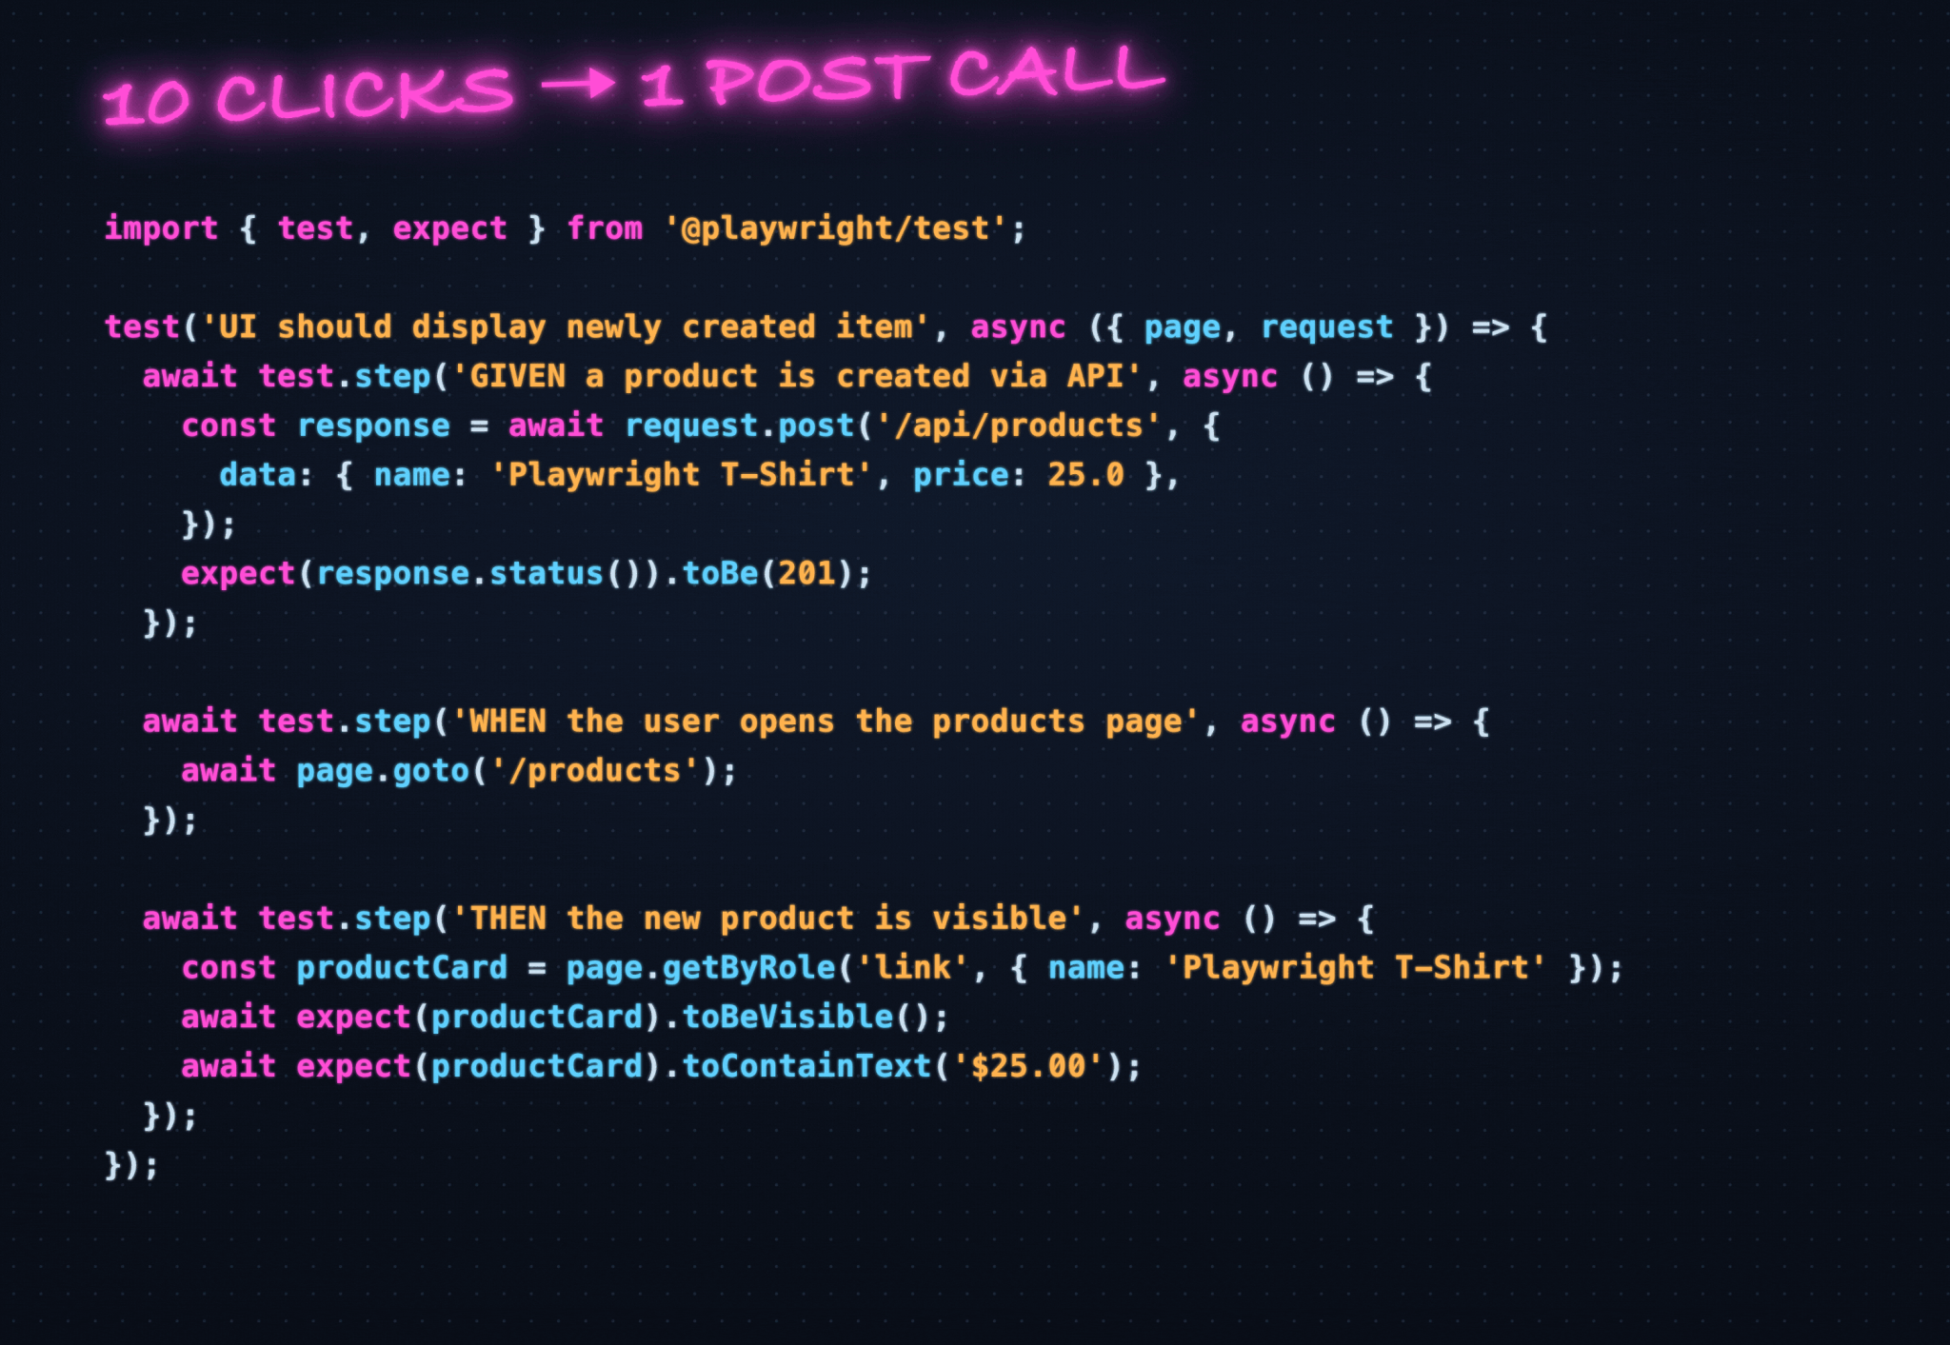

many test suite i have seen starts the same way. open the app, type the email, type the password, click login, wait for the redirect. multiply that by 50 tests and you are burning real time on a screen that has nothing to do with what you are actually testing.
the fix is a setup stage. Playwright calls it a "project dependency". it runs once before your actual tests even start.
here is how it works
1. hit the login API directly and log in from the UI
2. validate the response (i used Zod for schema validation) or the success of the login
3. save your cookies and local storage to a session file and your token as env variable
4. every other test loads that file and token and skips the login screen
your tests start exactly where the user lands after login. the login screen never touches your test results again. plus you get a token for that user for all API requests.
in my setup i used a custom API abstraction, Page Object Model as fixtures, Zod for response validation, and dotenv for environment variables. but you don't need any of that. Playwright has built-in support for storage state and API requests out of the box. the pattern works the same.
so, session file or fresh login before every test? be honest, I will wait.

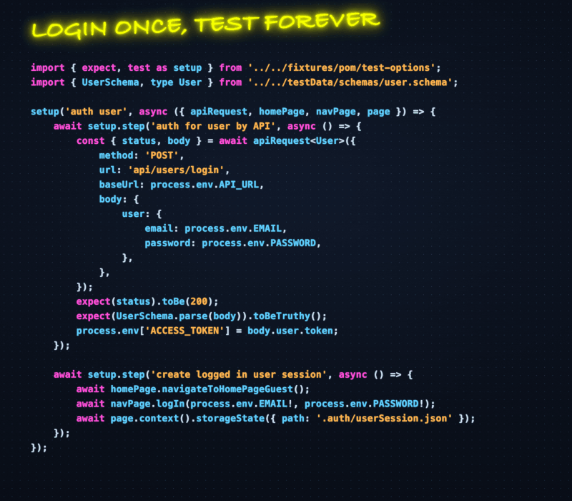

90% of your Playwright tests prove Playwright works, not that your app works
you write a test. it clicks a button, waits for a spinner, asserts the next page shows up. green. ship it. another flawless release, most probably
congrats. you just proved Playwright can click and the DOM can render. Microsoft already tested that part, for free, and they even wrote the docs.
that "green" suite is checking that your car doors open. nobody asked if the car actually drives
what you did NOT test? is the total correct. did the discount apply. did the right person get charged. is the order in the database, or just glowing on the screen for the demo.
we got addicted to asserting mechanics because mechanics are easy. toBeVisible() never asks a hard question. it nods, goes green, and lets everyone go home early
the button being clickable is not the risk. the wrong number showing up after you click it is the risk. but sure, the button rendered, great work team
joke aside, run the gut check on your suite:
🚩 assertions on visibility, existence, URLs
🚩 assertions on values, totals, state, data
first pile bigger? congratulations, you built a very expensive way to confirm the internet still loads pages
the fix is not more tests. it is meaner assertions. check the number, not the pixels

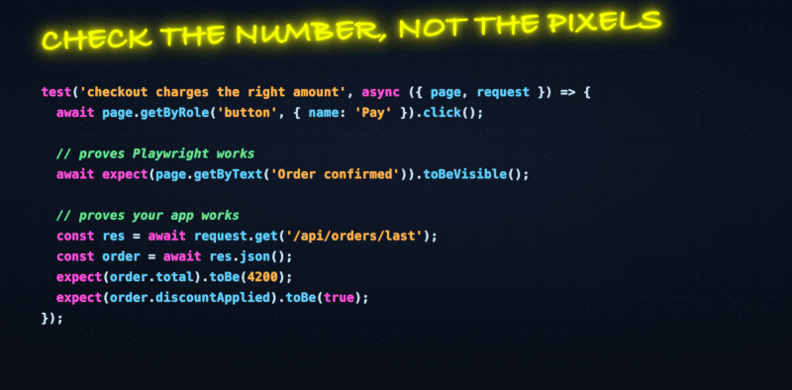

you click a link, a new tab opens, and your test needs to assert something inside it. easy, right?
then you write it like this and watch it fail half the time
```
await page.getByText("Open Support").click()
const newPage = await page.waitForEvent("popup")
```
the problem is timing. the click fires and the tab opens before you even start listening for the popup event. by the time waitForEvent runs, the event already came and went.
so you sit there registering a listener for something that already happened. the test hangs until it times out.
the fix is to start listening BEFORE the click, and run both at the same time.
```
const [newPage] = await Promise.all([
page.waitForEvent("popup"),
page.getByText("Open Support").click(),
])
```
Promise.all kicks off both operations together. the listener is armed first, then the click triggers the tab. no gap for the event to slip through.
now newPage is the handle to the second tab. you treat it like any other page.
`await expect(newPage).toHaveTitle("Support Center")`
one detail people miss. waitForEvent("popup") catches both new browser tabs and window.open popups. same pattern for both.
this is the same shape you use for downloads and file choosers too. arm the listener, then trigger it, inside one Promise.all.
how do you handle new tabs in your suite today?

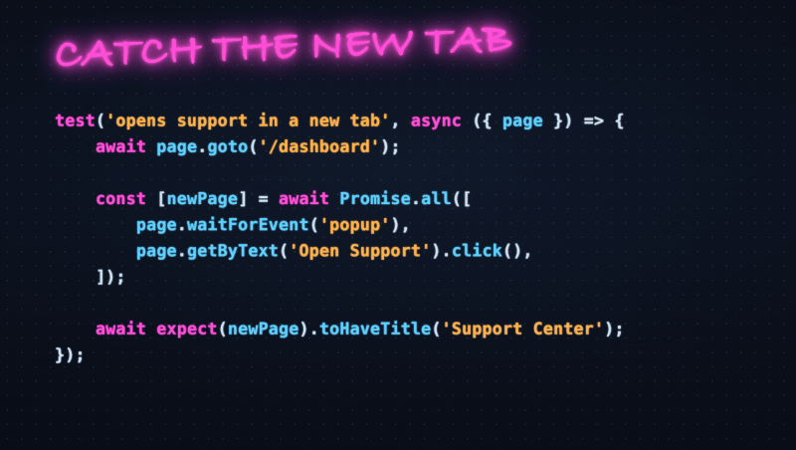

if you are testing functional logic like a signup or newsletter form, you don't need to wait for high resolution marketing images to load
but by default, Playwright waits for the page to fully load. that includes every banner, hero image, and background asset
this slows your tests down. and if those images come from a slow CDN or third party, it makes them flaky too
the fix is simple. use page.route to intercept and abort requests you don't care about
`await page.route('**/*.{png,jpg,jpeg,svg,gif}', route => route.abort())`
that one line tells Playwright to immediately kill any image request before it even starts
your page still renders. your buttons, forms, and text are all there. you just skip the heavy stuff that does not matter for your test
- faster test execution
- less flakiness from slow or unreliable CDNs
- cleaner test focus on what actually matters
this works for more than images. you can abort analytics scripts, tracking pixels, video preloads, or any request pattern that is not relevant to the behavior you are validating
try it in your suite and share how much time it saves you

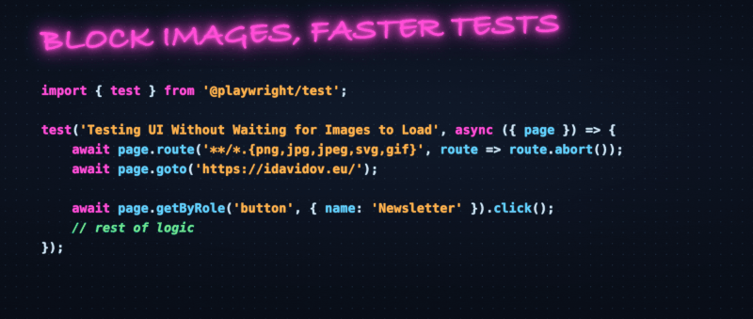

waitForTimeout(5000) burns 5 full seconds even when your state was ready in 200ms. and it still flakes when the backend is slow and needs 5500ms.
a backend status flips from "Pending" to "Shipped" after a queue picks it up. you need to wait, but you do not know how long. so a fixed sleep is always wrong in one direction or the other.
use expect.poll. it runs your check on a loop, returns the moment the condition passes, and only fails if the timeout hits. no fixed sleep, no guessing the magic number.
the snippet below ships an order through the UI, then polls the API until the status reads "Shipped". the assertion and the retry logic live in one place.
how do you usually wait for the backend response or async state?

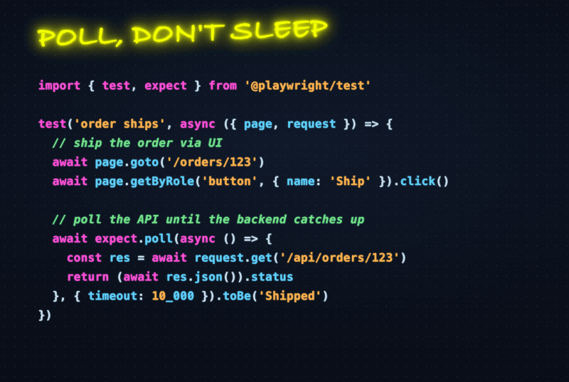

1 minute #Playwright tip to stop copy pasting the same test helper
most page helpers start clean. then you need one that skips the newsletter signup. so you copy it. then one that does not accept terms. copy again. now you maintain four helpers that do almost the same thing.
optional and default params fix this.
add a ? to a param and it becomes optional. callers can leave it out and it arrives as undefined. give a param a value with = and it becomes a default. skip it and you get the fallback.
one helper, many call styles.
registerUser(page, email, pass) just works. need to subscribe? pass true. testing the path where terms are declined? pass false. the same function handles all of it.
below is the helper. subscribeToNewsletter is optional, acceptTerms defaults to true.
how many near duplicate helpers are hiding in your framework right now?
hasztag

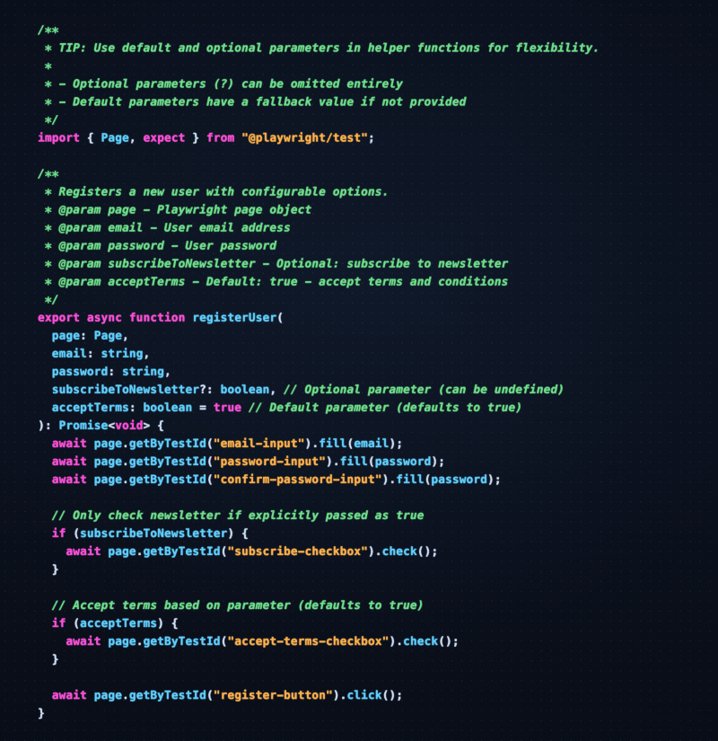

1 minute #Playwright trick to catch all bugs in a single test run
standard assertions stop your test the moment something fails. one broken check and you never find out about the other problems on the same page.
soft assertions change this. they log the failure but let the test keep going.
use expect.soft instead of expect. that is the only change.
below is an example. we validate product names and prices in a list. if "Mouse" shows $30 instead of $25, the test logs it and moves on to check "Keyboard" too.
at the end you see every failure at once. no more fixing one thing and rerunning just to find the next.
how do you handle multiple checks in one test case?
hasztag

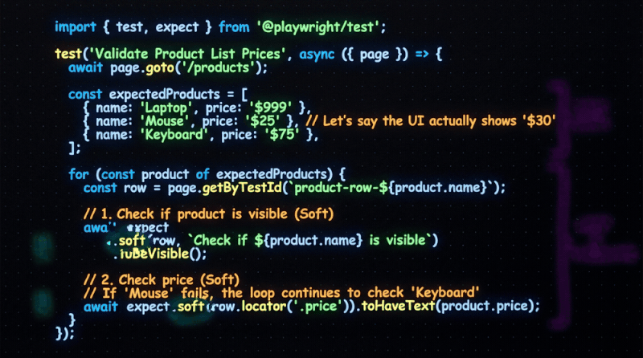

your Playwright locators have a priority order, and most suites ignore it
walk into the average test repo and you find a pile of CSS selectors and XPath. they break every time a dev renames a class or drops in a wrapper div.
Playwright gives you a ranking. start at the top, only move down when the one above does not fit.
1. getByRole
the default for almost everything. it finds elements the way a user and a screen reader do, by role and accessible name.
✅ `getByRole('button', { name: 'Submit' })`
one locator that checks behavior and accessibility at once. it shrugs off the DOM refactors that snap CSS paths.
2. getByLabel
for form fields, go after the label the user actually reads. not the id, not the wrapper class.
✅ `getByLabel('Email')`
restyle the input or move it across the page, the label still points at it.
3. getByPlaceholder
no label on the field? fall back to the placeholder. still text the user can see on screen.
✅ `getByPlaceholder('Search orders')`
4. getByText
for the non-interactive stuff like headings and banners, match the words on screen.
✅ `getByText('No users found')`
use it to assert what the user reads, not how the markup is nested.
5. getByTestId
the escape hatch. when nothing user-facing is stable or unique, add a data-testid and lock onto it.
✅ getByTestId('checkout-cta')
an explicit contract that does not care about styling or position.
below those live the raw selectors. treat the two of them very differently.
CSS is a last resort, not a habit.
🔸 `page.locator('.btn.btn-primary')`
when nothing user-facing is unique, a CSS selector will do the job. just know it chains to your styling, so a class rename can break it. reach for it only when getBy cannot.
XPath is a hard no.
🚩 `page.locator('//div[2]/form/button')`
it chains to your DOM shape. reorder one element and the path shatters. unreadable, and it tests how the page was built, not what the user does.
small syntax win. when these live in a Page Object, write them as getters, not constructor properties.
✅ `get submit() { return this.page.getByRole('button', { name: 'Submit' }) }`
less boilerplate than a readonly field you assign in the constructor. and it is safe because Playwright locators are lazy. nothing resolves until you act on it, so rebuilding the locator on each access costs nothing.
getByRole first, getByTestId last. CSS only as a last resort, XPath never.

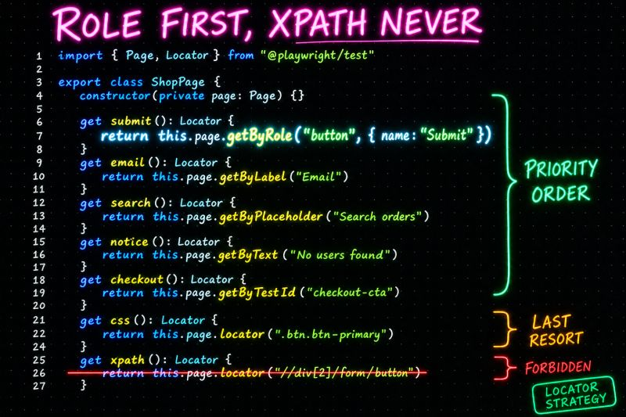

testing scenarios like empty states or server errors usually means you need to set up specific data first. modifying the database or writing seed scripts just to see how the UI reacts?
that is slow. and sometimes risky. and always unnecessary
there is a simpler way. use `page.route` to intercept the API call and return whatever response you want
in the example below, we mock the /api/users endpoint to return an empty list. then we check that the "No users found" message shows up
no database setup. no cleanup after. the test controls exactly what the frontend sees
it works great, and here is why:
- you skip the database setup entirely
- you get the exact same response every single run
- you never risk deleting or corrupting real test data
this pattern works for more than empty states. you can mock 500 errors, partial responses, slow connections, or any scenario that would be painful to reproduce with real data
do you prefer mocking API responses for edge cases, or do you seed real data in the database?

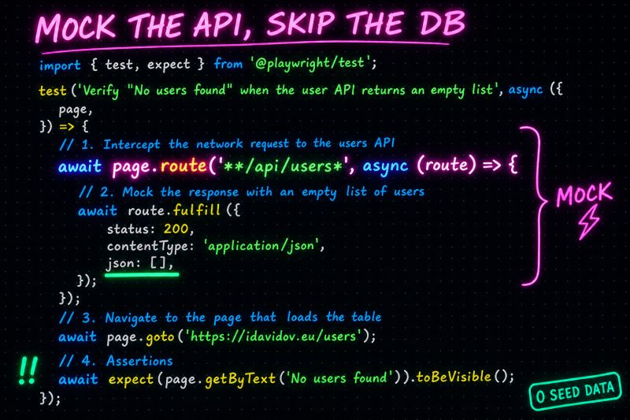

1 minute #Playwright trick to make failing tests tell you exactly where they broke
a long end to end test is one big wall of actions.
☑ search
☑ add to cart
☑ checkout
☑ pay
all stacked on top of each other.
then it fails. the report points at one assertion and stops there. was it the search? or the checkout at the end? you have no clue.
so you scroll through 40 lines of trace trying to find the part that actually broke.
test.step() fixes this. you wrap related actions in a named step. that is the whole change.
now the report shows a clean breakdown. each step has a name and expands to show what ran inside it.
when something fails you see which step went red first. you know the phase before you read a single locator.
you also get documentation for free.
a new person reads the step names and follows the flow without parsing every line.
below is a checkout flow split into three steps.
same test, much better report.
how do you keep your long e2e tests readable?
hasztag

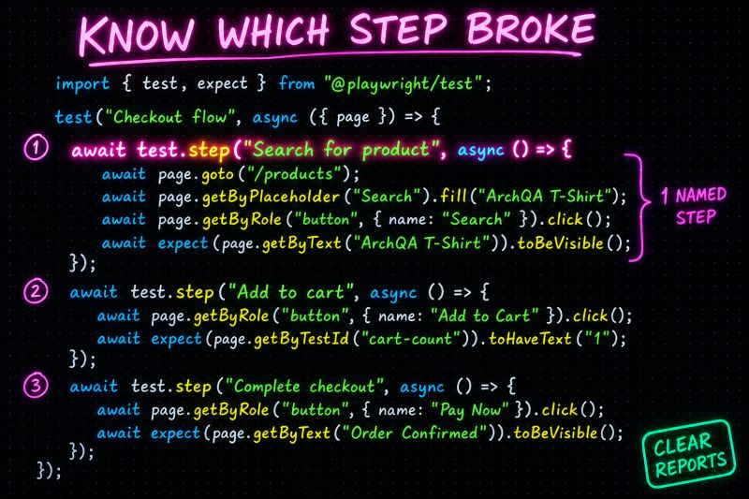
5 Playwright setup tricks i wish someone handed me on day one
this is part 1 of my 33 tricks series. configuration and core setup. the stuff you touch every day but nobody bothers to teach.
1. stop retyping the same assertion - you write the visibility check 40 times a day. make a VS Code snippet for it instead.
map a prefix to the line and let `$1` drop your cursor inside:
`"exv" => await expect($1).toBeVisible()`
type exv, hit tab, move on.
2. one npm script per tag - stop trying to remember grep flags. write them down once in package.json.
`"test:smoke": "playwright test --grep @smoke"`
now the whole team runs npm run test:smoke and gets the same slice.
3. keep secrets out of the repo - read them from process.env. the ! tells TypeScript the value is there at runtime.
`.fill(process.env.API_PASSWORD!)`
no passwords sitting in your git history.
4. tag your tests, skip the folder gymnastics - smoke, regression, slow, they can all live in the same file. tag once and filter whenever you want.
`test("Login", { tag: "@smoke" }, async ({ page }) => { ... })`
5. skip with a reason, not silence - a mobile-only or feature-flagged test should say why it skipped. one line does it.
`test.skip(!isMobile, "Mobile only")`
the next person to read the report knows exactly what happened.
none of this shows up in the getting started guide. but six months in, this is what keeps your suite sane.
which of these 5 are you already doing?

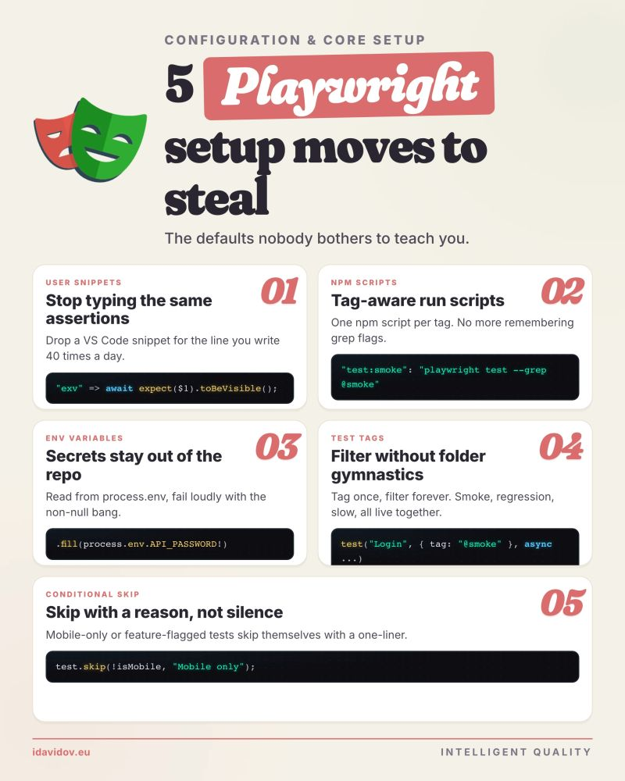

1 minute Playwright tip to keep secrets out of your test code
i still open test files and find this
`const password = "superSecret123"`
it feels harmless. one test, one string, you tell yourself you will clean it up later
but the second you commit it, that password lives in your git history forever. anyone who clones the repo can read it, and rotating the secret later does not wipe the old commits
so move it out. put your secrets in a .env file at the project root
`API_PASSWORD=superSecret123`
then read it from process.env inside the test
`await page.getByLabel("Password").fill(process.env.API_PASSWORD!)`
the ! tells TypeScript the value exists at runtime so it stops flagging it as possibly undefined
here is the part that trips most people up. Playwright does not read your .env file on its own. you load it once at the top of playwright.config.ts
`import dotenv from "dotenv"`
`dotenv.config()`
and the step everyone forgets. add .env to your .gitignore. otherwise you just moved the secret into a new file and committed that one instead
✅ no secrets sitting in your test code or git history
✅ every engineer keeps their own local .env
✅ CI injects the real values as environment variables
how do you manage secrets in your test suite today?

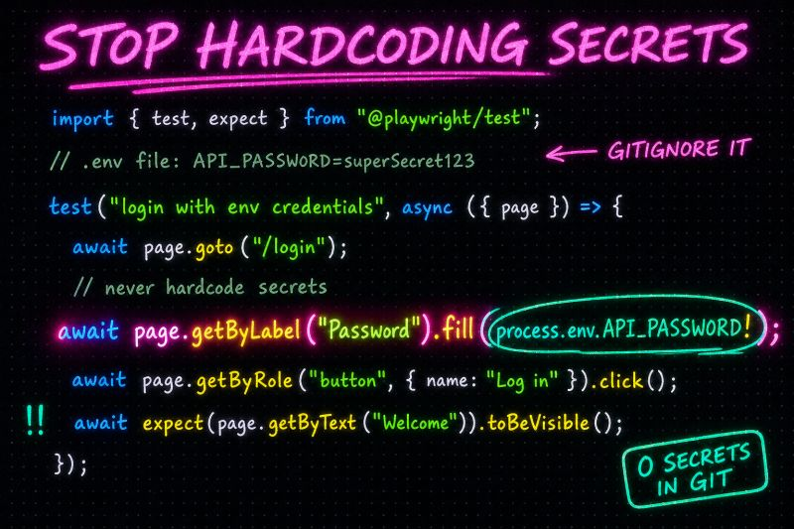

1 minute Playwright tip to run only the tests you need with tags
your suite has 200 tests. you changed one login field. you do not need to run checkout or billing to know if login still works
but most teams still run everything. every PR. every time. CI minutes pile up and failures get harder to read
tag your tests once. run a slice when you need it
add a tag in the test options:
`test("Login flow", { tag: "@smoke" }, async ({ page }) => { ... })`
then pick what runs from the CLI:
`npx playwright test --grep @smoke`
need smoke plus auth? use a regex:
npx playwright test --grep "@smoke|@auth"
wire those into npm scripts and your team gets one command for each slice. smoke before merge. regression on nightly. api tests without opening a browser tab
✅ run 12 tests instead of 200 when you only touched login
✅ same tags work in CI and on your laptop
✅ one naming convention, no duplicate test files
how do you split your suite today? tags, folders, or still running everything?

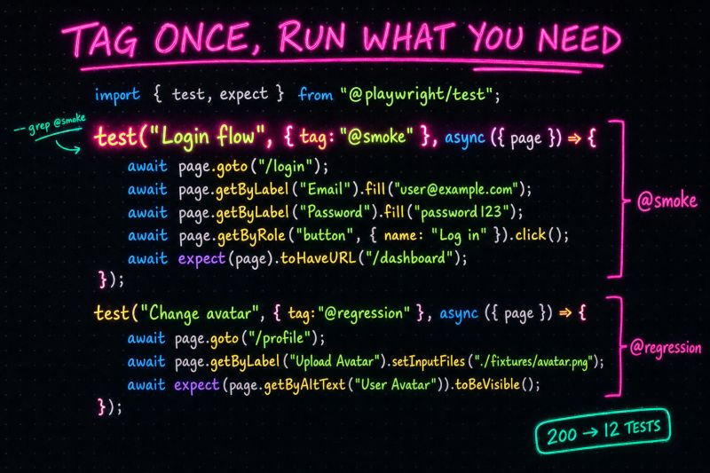

multi-language apps do not give you the right to drop accessibility locators, so use this 5 minute Playwright trick
when i start talking about accessibility locators, i get the same question a lot. what about apps with multiple languages?
most engineers panic because their trusted english text locators would break the moment they switch the testing language
so they abandon accessibility locators and fallback to the dark ages of dom manipulation
they start writing locators like this
🚩 page.locator('.form-group .btn.btn-primary .submit-btn')
🚩 page.locator('//div[@class="login-container"]/div[2]/form/button')
this is how flaky pipelines are born, and confidence in your testing is gone
a dev adds one extra wrapper div for a layout tweak and your entire test suite is broken
there is a much cleaner way in Playwright. your framework just needs a single source of truth
keep it simple. load the correct language json file at runtime using an environment variable
then pass that dynamic dictionary right back into your accessibility locators
✅ page.getByRole('button', { name: i18n.submitBtn })
playwright inserts the correct string automatically. doesn't matter if it's english today and french next sprint
you keep the user-centric accessibility locators and skip the brittle dom paths
do not compromise your architecture just because the text changes
adding a new language to the framework takes under a minute
how do you handle multi-language locators in your suite today?

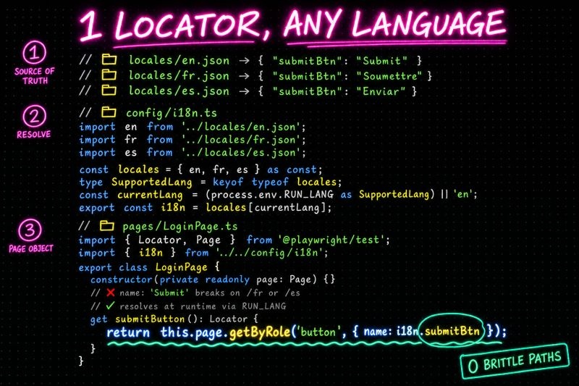

1 minute Playwright trick to catch silent API contract drift before it hits production
how many times has a backend dev quietly removed or renamed a field in an API response? no ticket. no heads up
your tests still pass because they only check status codes. you ship green. then production breaks because the frontend was reading a field that no longer exists
if you are using Playwright, the answer is Zod
you define a schema once with z.strictObject, then derive the typescript type from it with zOutput. one source of truth for both runtime validation and compile-time types
now the test parses the body against the schema right after the status check. rename a key or sneak in an extra field that strictObject did not expect, the test fails immediately with a clear validation error
✅ catch contract changes the moment they land
✅ no manual type definitions to keep in sync
✅ reuse the same schema across api tests and runtime guards
this is what end-to-end type safety actually looks like
how do you usually catch silent api changes in your test suite?

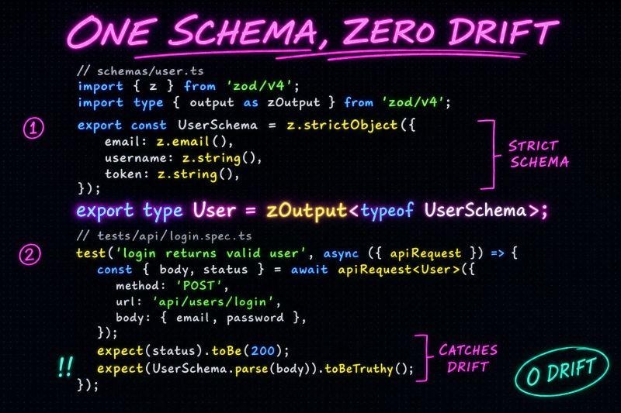

1 minute Playwright trick to perform visual regression tests for UI with dynamic data
visual regression tests are great until your UI has dynamic data. a clock that ticks every second or a randomly generated transaction id is enough to break a snapshot
so your test fails on the first run, then again, then again. you give up and disable it
you don't have to. Playwright has a `mask` option built right into `toHaveScreenshot`
pass an array of locators and Playwright paints a pink box over those elements before the screenshot is captured. the rest of the page stays pixel perfect for comparison
in the example below, the dashboard has a `current-time` element and a `transaction-id` that change every run. both get masked. the snapshot stays stable
this works for any flaky region. live counters, charts, user avatars, "updated 3 minutes ago" badges. mask once and sleep at night like a baby
what is your strategy for dynamic data in visual tests?

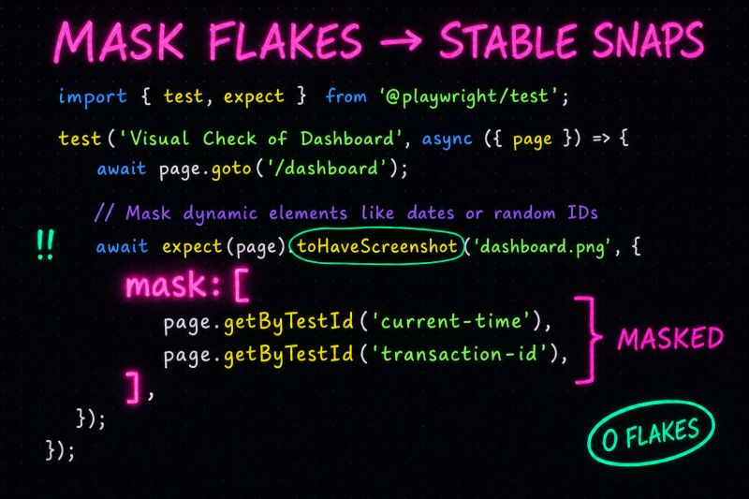

5 minute Playwright fix to stop instantiating page objects in every test. if you look at any Playwright test file written by a junior, or even a mid level engineer, you will find out that it always starts the same way
```
const loginPage = new LoginPage(page)
const dashboardPage = new DashboardPage(page)
const settingsPage = new SettingsPage(page)
```
three lines of boilerplate before you even get to the actual test logic. multiply that by 100 tests and you can imagine the pain
the cleanest fix is to extend the Playwright test and let it hand you the page objects automatically
you declare your fixtures once. then every spec just destructures whatever pages it needs
the wins are immediate
NO more new() calls in your specs
less code per test
better readability
easier refactors when a page object signature changes
the test reads like a sentence again. you focus on what the test does, not on how to wire up the dependencies
in the snippet below i extended the base test with two fixtures, loginPage and dashboardPage. each one returns a fresh instance bound to the current page. the spec just asks for what it needs and Playwright takes care of the rest
this is what I call great DX. as a summary - keep implementation details as far from the test layer as possible
do you even use POM, and if yes, how you handle it?

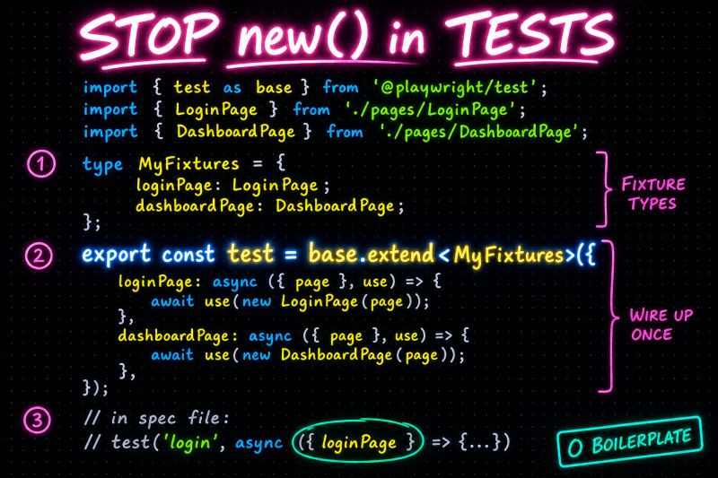

1 minute Playwright trick to grab data from an API response triggered by a UI action
you click a button in the ui. it fires an api request behind the scenes. the backend sends back something you actually need later in the test, like the id of the resource that was just created
what most people do? they fire a second api call after the ui action to fetch what was created. slower than it should be. sometimes the data is not ready yet. sometimes the wrong record gets picked
there is a cleaner way. run the UI action and the response listener at the same time with `Promise.all`
put the page object call (the trigger) and `page.waitForResponse` (the listener) inside the same `Promise.all` array. the listener subscribes first, the ui action sends the request, the response comes back, both promises resolve at once
then you destructure the response and pull whatever you need out of it
- no extra api call after the ui finishes
- you grab the real backend payload from the same network round trip
- the id is available the moment the ui is done
a common use case is cleanup. you save the id in a shared variable, then `test.afterAll` deletes the record via the api. no leftover data in the database. no broken state for the next run
how do you usually pull backend data out of your ui tests?

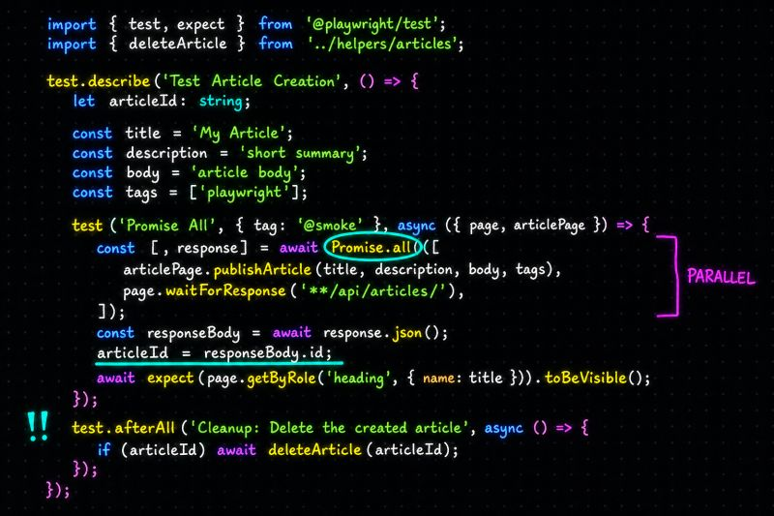
It’s strange how the easiest ideas are usually the ones people get wrong. It’s either because people think they're too simple to care about, or they just weren't explained very well in the first place.
Since I almost always talk about fundamentals and architecture, I prepared the following Cheatsheet, trying to show with practical examples the main REST API Responses you can receive.
For Success Status Codes (2xx), I show when they are returned and what you should verify from the response body
For Client-Side Failures (4xx), I show what are the common causes and I provide a practical example scenarios
For Server-Side Failures (5xx), I show what they means and which should be the testing angle
I highly recommend to go through the tables. I bet you will either learn something or catch a mistake I might made

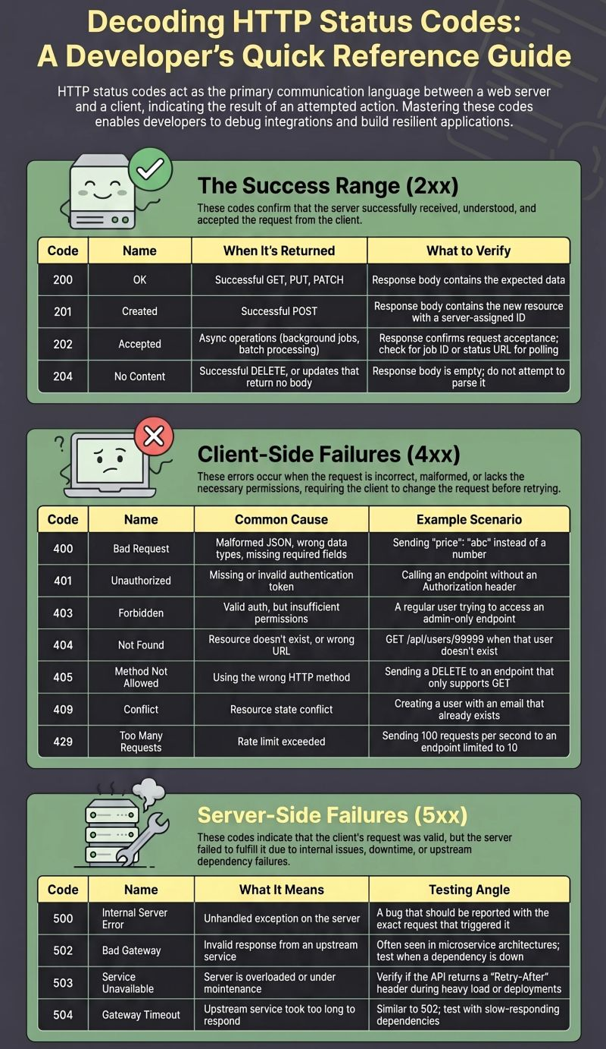

These days, I saw many times the same Cheatsheet on LinkedIn for the most important Playwright CLI commands. No need to look into printed A4 sheet to check which command you need. Here is the Ultimate Cheatsheet. Just add the ones your team uses to the package. json file.
Then, every team member can use the same commands, and as a side benefit is that there are version controlled.
Simple as that.
Cheers!
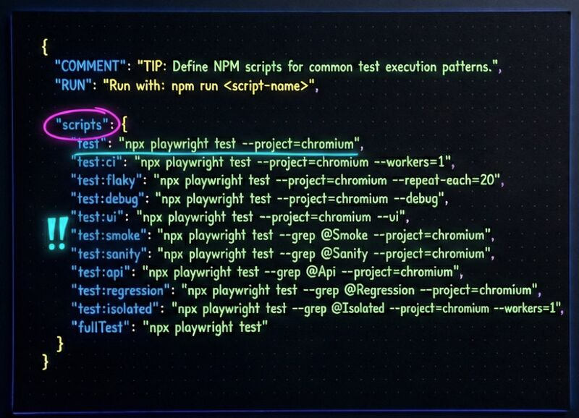

1 minute #Playwright trick to test edge cases without touching the database
testing scenarios like empty states or server errors usually means you need to set up specific data first. modifying the database or write seed scripts just to see how the UI reacts?
that is slow. and sometimes risky. and always unnecessary
there is a simpler way. use `page.route` to intercept the API call and return whatever response you want
in the example below, we mock the /api/users endpoint to return an empty list. then we check that the "No users found" message shows up
no database setup. no cleanup after. the test controls exactly what the frontend sees
it works fantastic, because it provides speed, stability and safety
- you skip the database setup entirely
- you get the exact same response every single run
- you never risk deleting or corrupting real test data
this pattern works for more than empty states. you can mock 500 errors, partial responses, slow connections, or any scenario that would be painful to reproduce with real data
do you prefer mocking API responses for edge cases, or do you seed real data in the database?
hasztag

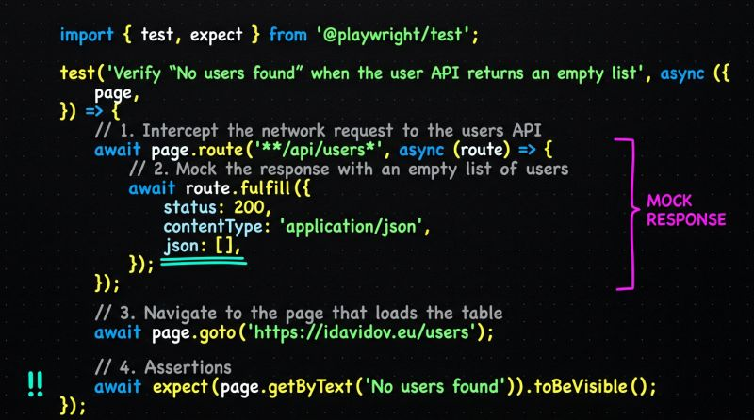

1 minute #Playwright trick to catch all bugs in a single test run
standard assertions stop your test the moment something fails. one broken check and you never find out about the other problems on the same page.
soft assertions change this. they log the failure but let the test keep going.
use expect.soft instead of expect. that is the only change.
below is an example. we validate product names and prices in a list. if "Mouse" shows $30 instead of $25, the test logs it and moves on to check "Keyboard" too.
at the end you see every failure at once. no more fixing one thing and rerunning just to find the next.
how do you handle multiple checks in one test case?
hasztag

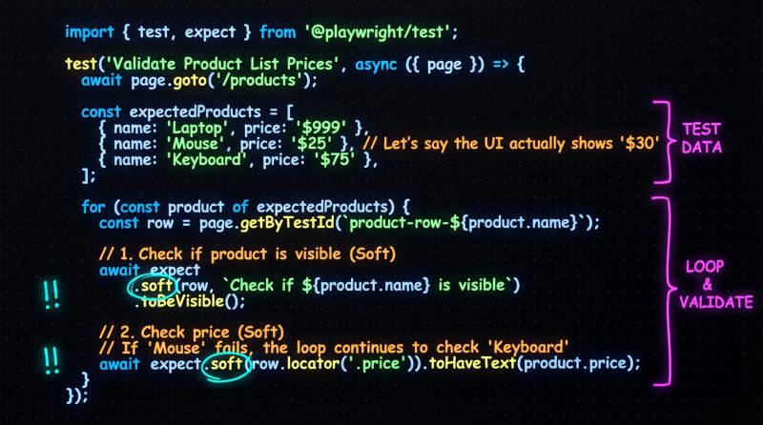

you typed "create a login test"
monday it gave you a class
tuesday it gave you a function
wednesday it hallucinated a framework you don't even use
the ai isn't inconsistent. you are
vague inputs get vague outputs
where does the file go?
what are the naming conventions?
do we use fixtures or raw instantiation?
so i stopped freestyling
built a library of prompt templates
structured requests. predictable results
my "new page object" template:
1. context: navigate to [url] and map the accessibility tree
2. output: generate pages/app/[name].page.ts
3. constraints: locators must be getters. jsdoc is mandatory
4. integration: register in page-object-fixture.ts automatically
my "new test" template is just as strict:
1. location: tests/app/[functional|api]/[name].spec.ts
2. imports: only from fixtures/pom/test-options
3. structure: test.step (given/when/then)
4. tags: @[smoke|regression] required
templates are the api for your ai
same input format. same output quality
stop guessing. start templating

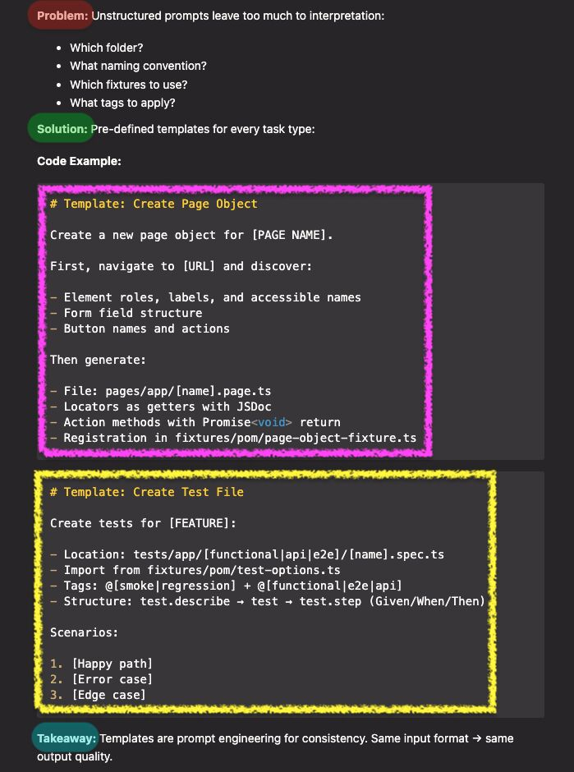

1 minute #Playwright trick for polling when stuff is not ready yet
sometimes an element does not show up right away. or a status takes a few seconds to update. you need to wait for it without hardcoding a sleep
await page.waitForTimeout(5000) is the wrong move. always! it wastes time when the condition is met earlier, and it might still be too short when things are slow
use expect.poll instead. it keeps retrying your check until it passes or the timeout hits. it returns as soon as the condition is met. no fixed sleep, no guesswork
below is an example. we ship an order via the UI, then poll the API until the status is "Shipped"
what do you use when you need to wait for a backend or async state?
hasztag
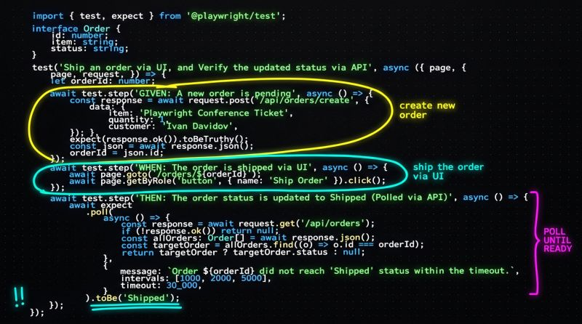

minute trick to speed up your #Playwright tests. stop clicking through the UI just to set up your test data
if your E2E tests take forever, it is usually because you are doing everything through the browser
logging in, navigating menus, filling out forms, clicking save. all just to create the data your test actually needs
there is a faster way. hit the backend API directly
this is Arrange-Act-Assert pattern
1️⃣ Arrange: use request to inject data in milliseconds
2️⃣ Act & Assert: use page to verify the user actually sees it
instead of 10 clicks and 5 page loads, you make one POST call. the data exists. you move on
✅ fewer UI steps mean less flakiness
✅ API requests finish in milliseconds, not seconds
✅ you test the actual feature, not the data entry form
below is a quick example. create a product via API, then check that the UI displays it
how often do you put API calls into your UI tests?
hasztag
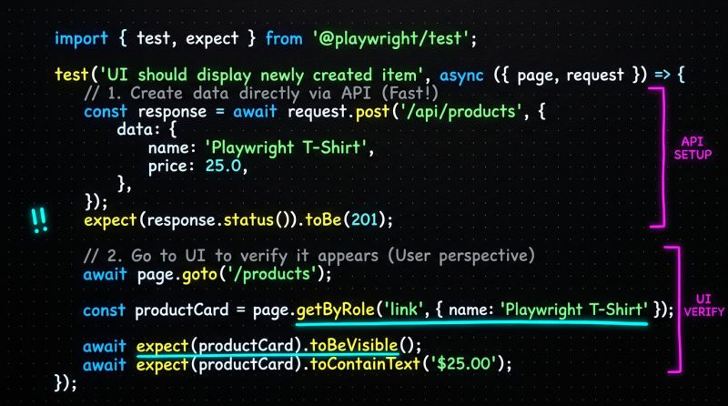

you let 10 engineers write tests their own way
10 engineers. 10 different styles
then you added ai
now you have 100 different styles
debugging is a nightmare. `grep` is useless
the reports are a wall of text
freedom sounds great on paper
in practice it's chaos. automation needs governance
so i enforced a "constitution" for test structure
three non-negotiable rules
rule one: tags belong on tests. never on describe blocks
when i run `@smoke`, i want specific scenarios
not entire files dragged along because one test matters
rule two: steps are mandatory
no giant blocks of code. we use `test.step()`
given. when. then
rule three: taxonomy is defined
`@smoke` = runs on every pr
`@destructive` = modifies shared state. runs isolated
`@api` = no browser needed
now the html report reads like a story
not a stack trace
ps: do you tag your describe blocks or individual tests?
episode 9 of 15. standardizing the execution.

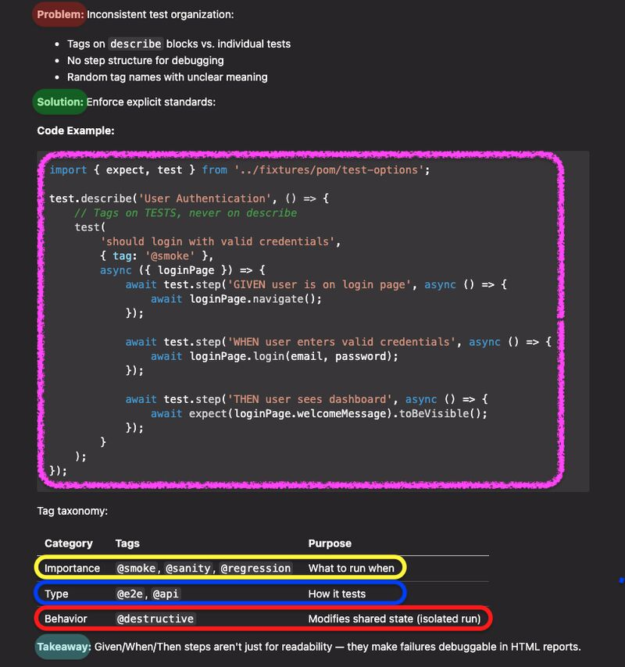

https://spartak-lab.com/problems – przejrzyj tę stronę aby zaprojektować plan nauczania, hits, lekcje w planie nauczanie również z tej strony
5 minute #Playwright trick to login once and test forever
every test suite i have seen starts the same way. open the app, type the email, type the password, click login, wait for the redirect
multiply that by 50 tests and you are burning real time on a screen that has nothing to do with what you are actually testing
the fix is a setup stage. Playwright calls it a "project dependency". it runs once before your actual tests even start
here is how it works
1. hit the login API directly and log in from the UI
2. validate the response (i used Zod for schema validation) or the success of the login
3. save your cookies and local storage to a session file and your token as env variable
4. every other test loads that file and token and skips the login screen
your tests start exactly where the user lands after login. the login screen never touches your test results again. additionally you will have a token for that user for all API requests
in my setup i used a custom API abstraction, Page Object Model as fixtures, Zod for response validation, and dotenv for environment variables. but you don't need any of that. Playwright has built-in support for storage state and API requests out of the box. the pattern works the same
i love LinkedIn discussions, so share with me how do you handle authentication in your test suite?
hasztag

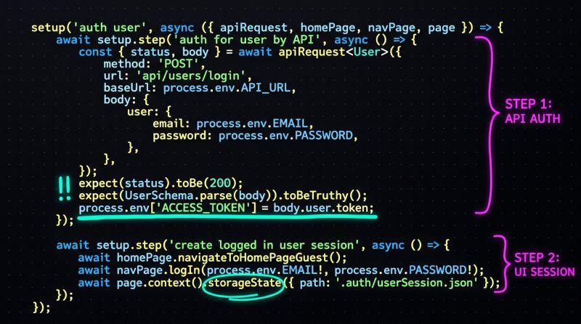

1 minute #Playwright tip to implement data-driven automation with a for...of loop
when it comes to verifying software validations, there is one pattern that makes your life significantly easier
data-driven automation
the idea is simple. instead of writing a separate test for each invalid input, you create one array of chaos and let a for...of loop do the heavy lifting
1. create an array of invalid data
2. unleash a simple for...of loop
3. sit back and watch the assertions fly
in the code snippet, we have an array of invalid emails. weird formats, missing domains, special characters, double dots, leading dots. all the edge cases that users will definitely try
then a single for...of loop generates a dedicated test for each entry. Playwright runs them all, and every single one gets its own clear pass or fail
✅ clean and readable
✅ easy to extend with new test cases
✅ each input gets its own isolated test
you write it once. one loop, one source of truth
the next time someone says "we need 15 more validation tests," you just add 15 strings to the array. done
do you automate validations like this, or do you have a different approach you swear by?
hasztag

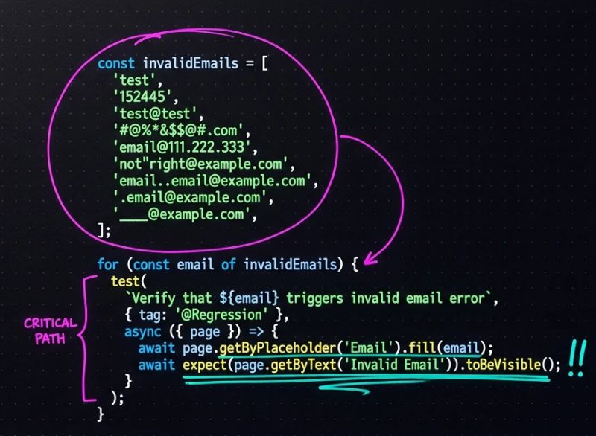
you trusted the backend developer
the docs said the field was a string. the production database said it was null
your test passed, because you cast the response to any. or maybe you just asserted status === 200
then the frontend crashed. because it tried to call `.toUpperCase()` on null
`any` is technical debt causing huge issues. api contracts drift. documentation lies. tests must verify reality, not promises
so i started using schemas
enter zod. runtime validation + static type inference
we define the contract once (see the code snippet below)
if the backend changes a field name? the test explodes immediately. not a vague undefined error. a specific schema violation
catch the drift before deployment
ps: do you validate api responses or just status codes?
episode 8 of 15. locking down the contracts.
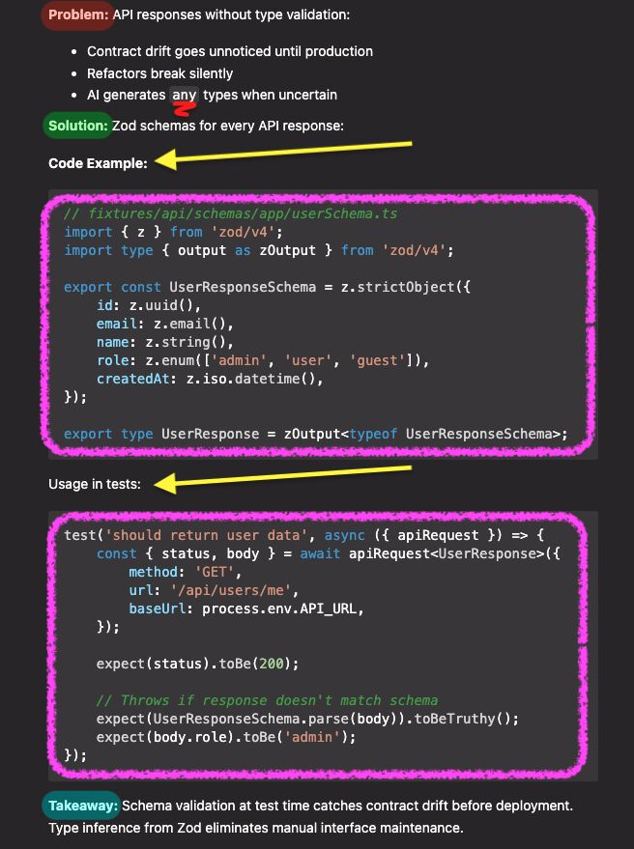

pov: you can't reproduce the failure
the ci logs say "email already exists", but you swore you randomized it. or maybe you hardcoded test@test.com. and 5 parallel workers tried to login at the exact same time
data is the silent killer of test stability. most frameworks get it wrong. they mix the chaos of random data with the rigidity of static data
so i bifurcated my strategy. two buckets. two strict rules
1. static data (for the edge cases) sql injection strings. xss payloads. invalid boundaries. these must be deterministic. they live in json files. if it fails, i want to know exactly what caused it
2. dynamic data for everything else. unique users. fresh emails. valid flows. these must be isolated. we use factories
my user.factory.ts generates a unique human for every single test run. my invalid.json breaks the system the exact same way every time
static for the edges. dynamic for the flow. never mix them up
ps: do you use faker or hardcoded json?
episode 7 of 15. architecting for reliability.

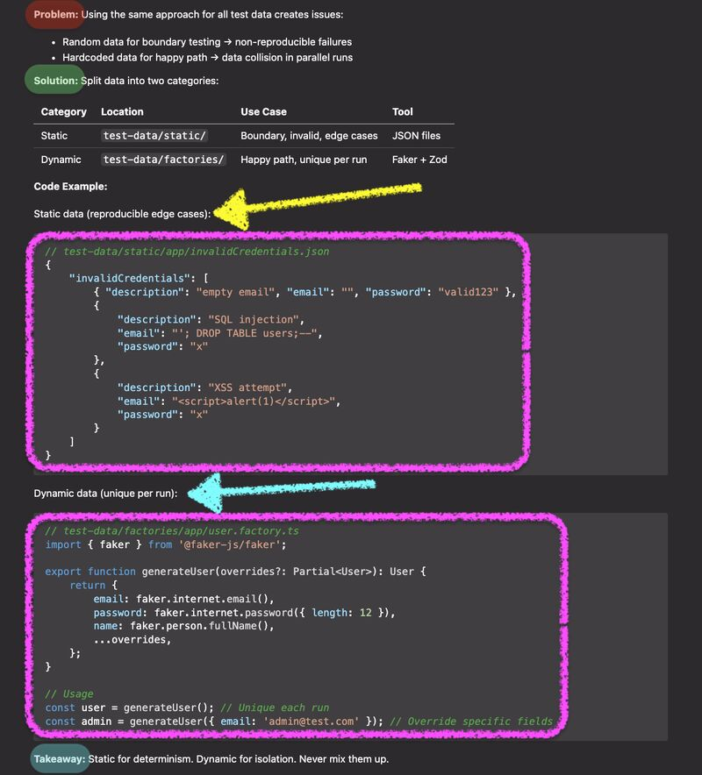

1 minute #Playwright tip to speed up your tests by aborting unnecessary requests
if you are testing functional logic like a signup or newsletter form, you don't need to wait for high resolution marketing images to load
but by default, Playwright waits for the page to fully load. that includes every banner, hero image, and background asset
this slows your tests down. and if those images come from a slow CDN or third party, it makes them flaky too
the fix is simple. use `page.route` to intercept and abort requests you don't care about
`await page.route('**/*.{png,jpg,jpeg,svg,gif}', route => route.abort())`
that one line tells Playwright to immediately kill any image request before it even starts
your page still renders. your buttons, forms, and text are all there. you just skip the heavy stuff that does not matter for your test
✅ faster test execution
✅ less flakiness from slow or unreliable CDNs
✅ cleaner test focus on what actually matters
this works for more than images. you can abort analytics scripts, tracking pixels, video preloads, or any request pattern that is not relevant to the behavior you are validating
hasztag

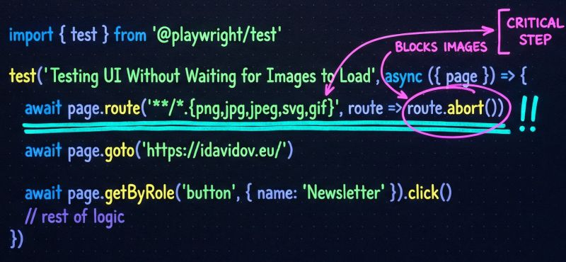

1 minute #Playwright tip to use accessibility locators in multi-language apps
when i start talking about accessibility locators, i receive a similar question a ton. what to do when the application has different languages?
most of the engineers panic because their trusted english text locators would break once they change the testing language.
so they abandon accessibility locators and fallback to the dark ages of dom manipulation
they start writing locators like this
🚩 page.locator('.form-group .btn.btn-primary .submit-btn')
🚩 page.locator('//div[@class="login-container"]/div[2]/form/button')
this is how flaky pipelines are born. and the confidence in the testing is ruined
a dev adds one extra wrapper div for a layout tweak and your entire test suite bleeds
there is a much cleaner way to handle this in Playwright. your testing framework just needs a single source of truth
keep it simple. load the correct language json file at runtime using an environment variable
then you just pass that dynamic dictionary right back into your resilient playwright locators
✅ page.getbyrole('button', { name: i18n.submitBtn })
playwright inserts the correct string automatically. english, french, spanish, or whatsoever
it does not matter
you keep the user-centric accessibility locators and ditch the brittle dom paths
do not compromise your architecture just because the text changes. smart systems adapt to the context
adding additional language to the framework is done under a minute
hasztag

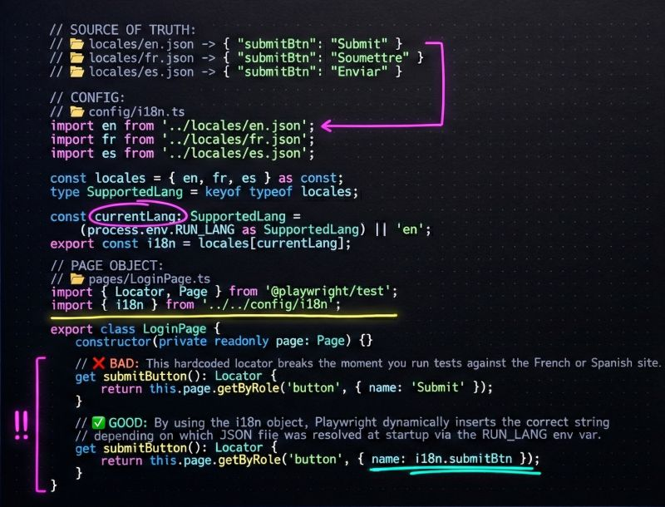

pov: you told the ai to "use page object model"
it nodded. it generated code. it was technically correct.
but it was a mess
some locators were properties. some were methods. assertions were scattered everywhere. documentation was missing
"page object model" is a concept. not a specification. ai needs a blueprint, not a philosophy
so i stopped asking for "pom". i started demanding a specific shape.
i enforced three strict rules:
- locators are getters. they must be evaluated fresh every time. no stale element references.
- jsdoc is mandatory. if you don't document the method, the ai guesses the intent. guesses lead to bugs
- actions verify completion. don't just click. click and wait for the state transition
now my page objects look like this (see the code snippet below)
the more prescriptive your patterns, the more consistent your code
don't just ask for a house. give the ai the blueprints
ps: do you define locators as properties or getters?
episode 6 of 15. standardizing the structure.

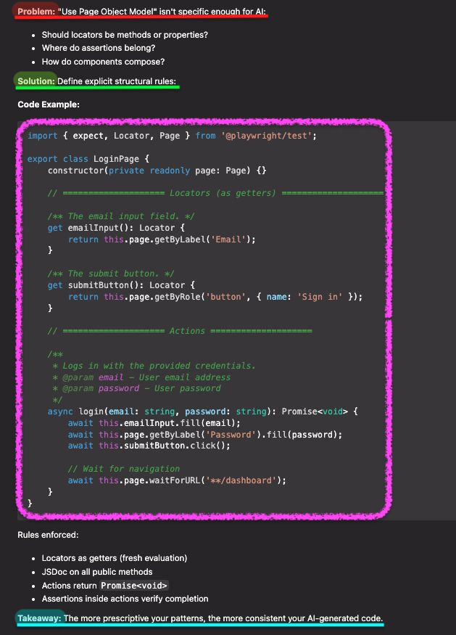

stop writing scripts. start building systems
on monday we looked at the high-level roadmap. today, let's dive into the exact steps to go from "script writer" to "framework architect"
if your automation feels messy or hard to maintain, you are probably stuck on one of these levels:
🔸 level 1: the foundation - stop using any (it completely dismiss the benefits of typescript. structure your test data using interfaces so it actually matches your app
🔸 level 3: the blueprint - stop writing brittle tests. use the page object model to hide your private locators. use getters for efficient lazy evaluation
🔸 level 4: the flow - stop fighting the browser. use try / catch to handle random popups without crashing. use promise.all to drastically speed up your execution
🔸 level 6: the architect avoid the massive "god object". use composition and mixins to snap your classes together based on exactly what the test needs
typescript isn't about adding complexity. it's about adding confidence
i put together this full carousel breaking down all 6 levels. there is even a syntax cheat sheet on the very last page
which level is your current framework sitting at?

pov: the developer changed a css class name
and 50 tests failed
it wasn't a bug. the app worked fine. the button still clicked. the form still submitted
but the tests were brittle. they relied on `.btn-primary`. they relied on `#submit-button`. they relied on implementation details that users don't care about
so i deleted the css selectors. i banned xpath. i told the ai: "if the user can't see it, you can't test it"
we established a strict hierarchy. a priority order for survival
- getbyrole (the king. accessibility first)
- getbylabel (for forms. if it has a label, use it)
- getbyplaceholder (the fallback for inputs)
- getbytext (for static content)
- getbytestid (the absolute last resort)
now, when the design team changes the button from blue to green? the test passes. because it's still a button. it still says "submit"
semantic selectors are accessibility selectors. they target meaning, not markup
ps: is data-testid your first choice or your last resort?
episode 5 of 15. writing tests that survive refactors
hasztag
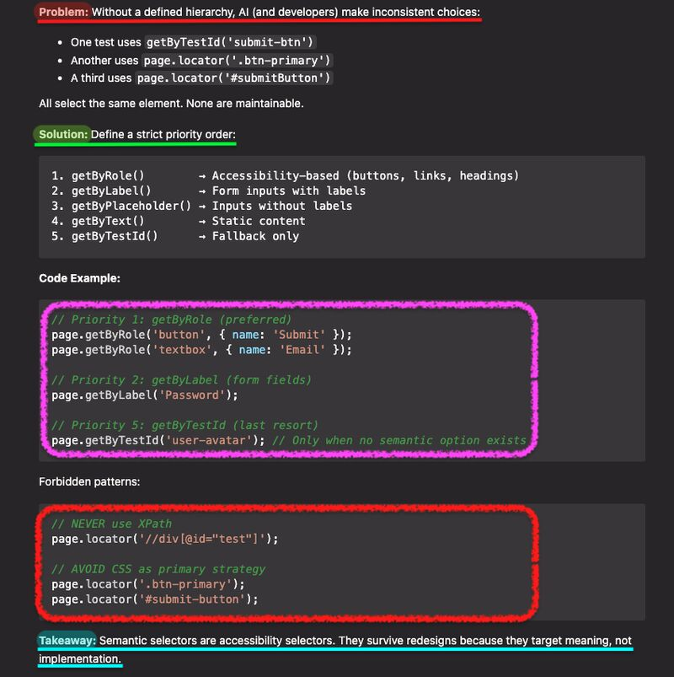

stop trying to learn "all of typescript" before you start writing automation
you don't need to be a frontend developer. you just need a safety net
if you want to move from manual testing to automation (or upgrade your messy javascript framework), you need a clear plan. here is the exact roadmap:
phase 1: building the foundation
🔸 core types - strings, numbers, arrays. make sure your test data actually matches the app
🔸 logic & reusability - loops and functions. stop copy-pasting code. keep it dry
🔸 interfaces - create strict "contracts" for your object shapes. this is how you validate api payloads without guessing
phase 2: framework architecture
✅ scalable page objects - organize locators with classes, private modifiers, and getters. hide the ugly stuff from your tests
✅ async mastery - stop fighting the event loop. control the flow with async/await and use promise.all for much faster execution
✅ advanced safety - use enums to ban silly typos. use generics to build api clients you can reuse everywhere
typescript catches runtime errors before your pipeline fails
which phase are you currently sitting in?

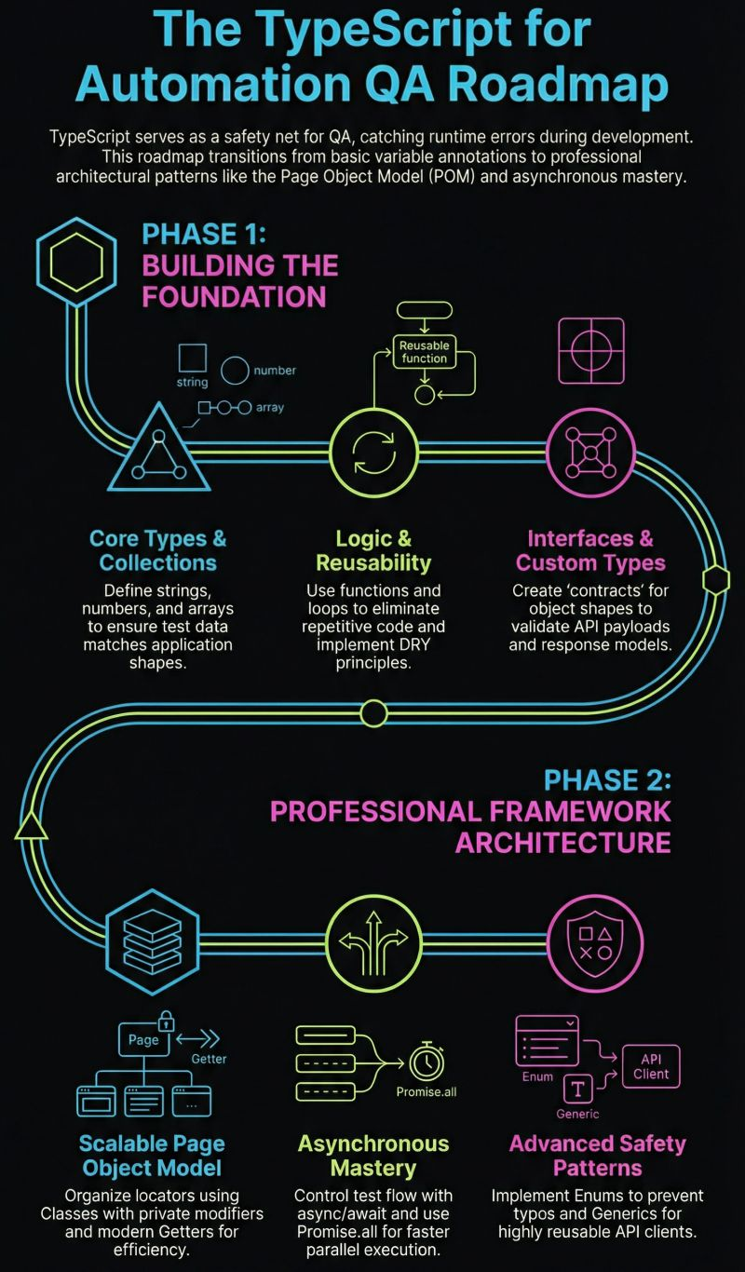
pov: you see 'new loginpage(page)' in a pull request
it works. but it smells
manual instantiation is a trap. your tests know too much about how objects are built. if the constructor changes? you have to fix 50 different files
and when ai writes the tests? it does it differently every time. sometimes a factory. sometimes a class. sometimes inline
so i banned the 'new' keyword in spec files. we moved to dependency injection. in #Playwright, that means fixtures
we don't just use fixtures for data setup. we use them as our DI container
we define the objects once. loginPage: async ({ page }, use) => await use(new LoginPage(page))
and the tests just ask for what they need. test('should login', async ({ loginPage }) => { ... }
clean signatures. centralized logic. zero boilerplate
fixtures aren't just for setup. they are the backbone of a scalable architecture
ps: do you use fixtures for page objects or just data?
episode 4 of 15. decoupling the test logic
hasztag

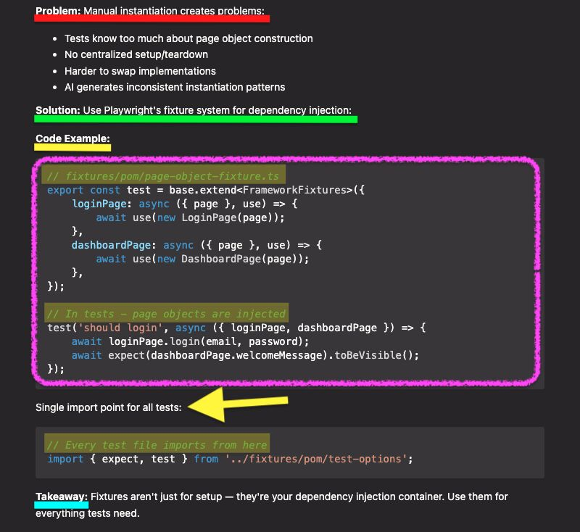

pov: you let the ai guess the selectors
it was confident. it wrote the code in seconds. it assumed there was a 'submit' button. it assumed the email field had an id
then i ran the test. fail. element not found
the ai wasn't coding against my app. it was coding against a hallucination. it was building based on probability, not reality
so i introduced a strict rule. explore before you generate
never ask for code immediately. force the discovery phase
my prompts now look like this:
- navigate to the target url
- read the accessibility tree
- capture the real labels and roles
- then write the page object
the result? i get getByRole('button', { name: 'Sign in' }) instead of a broken guess for 'Submit'
10 seconds of exploration. saves 10 minutes of debugging. never let the ai code blind
ps: how often does ai hallucinate elements in your tests?
episode 3 of 15. grounding the ai in reality

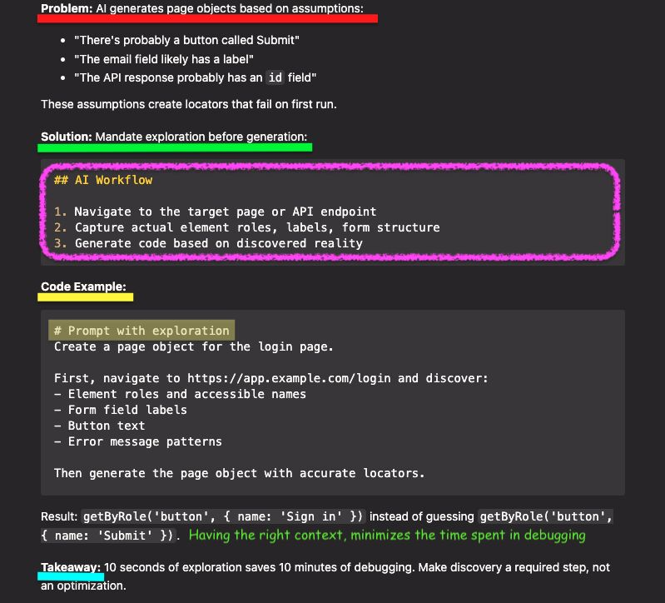

writing complex xpath is the most useless skill you can master
i see engineers bragging about it
"look at this 50-character unreadable query i wrote"
congratulations. go back and refactor it. you just built technical debt
three reasons why i banned xpath in my teams:
1. it tests the dom, not the user
users don't click //div[2]/span. they click "checkout"
if you test the structure, you are testing implementation details
2. it is invisible to accessibility
your xpath test passes even if the button is hidden from screen readers, because it lacks accessibility tag
that is not a feature. that is a bug
3. it breaks on refactor
developers move divs all the time
why write a test that needs maintenance every sprint?
real seniority isn't about mastering complex syntax
it's about choosing tools that don't require maintenance
stop trying to be a "selector wizard"
start being a product verifier
use getByRole. sleep better at night

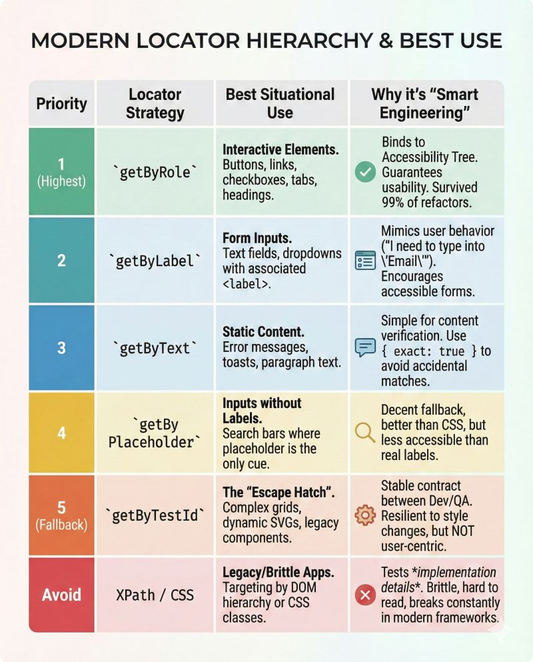

you delete half your boilerplate code
stop instantiating page objects manually in every single test
it creates noise. it kills readability
yesterday i listed this as a "must" rule. today i am sharing the code
the fix takes five minutes. use #Playwright custom fixtures
extend the base test object. inject your pages automatically. never write `new LoginPage(page)` again
the results are immediate
less clutter. clearer tests. pure logic
ps: have you switched to custom fixtures yet?
hasztag

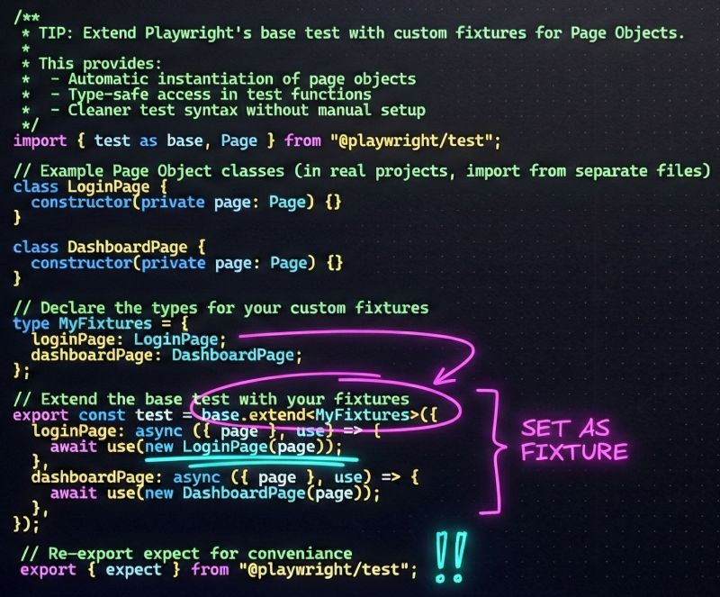

your tests pass but production is broken
the dashboard is green. but the api response changed. just one parameter gone. silent drift without a ticket
tests missed it. because we checked values. not the contract
if you use #Playwright, you need #Zod
stop guessing. define the schema. infer types with z.infer
one schema. zero drift
this is end-to-end type safety
ps: are you validating schemas or just status codes?
hasztag
hasztag

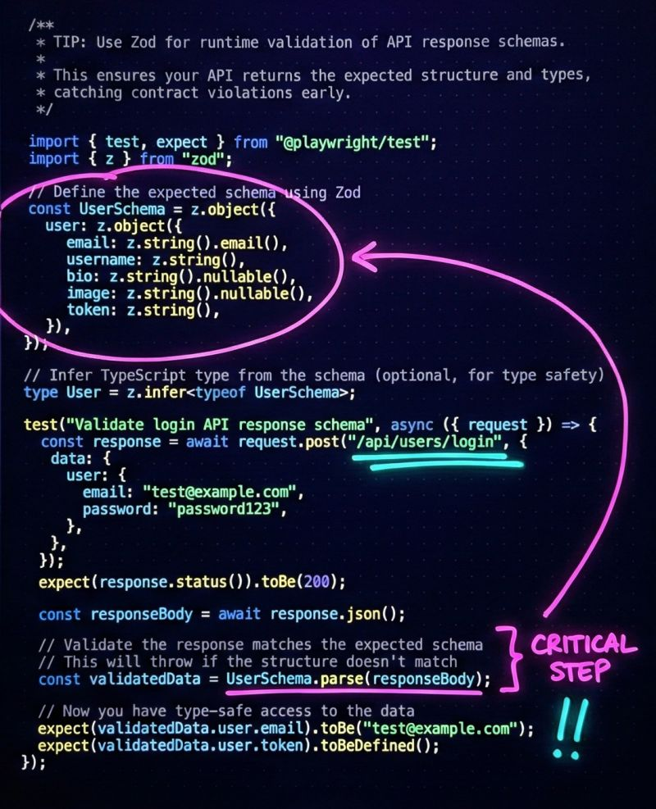

using XPath for locators is Technical Debt
with #Playwright you can drill down naturally using filtering
here is how(see the code in the image):
1. find the card
2. filter for the specific text
3. grab the button inside it
write code for humans first, not only for the machines
hasztag
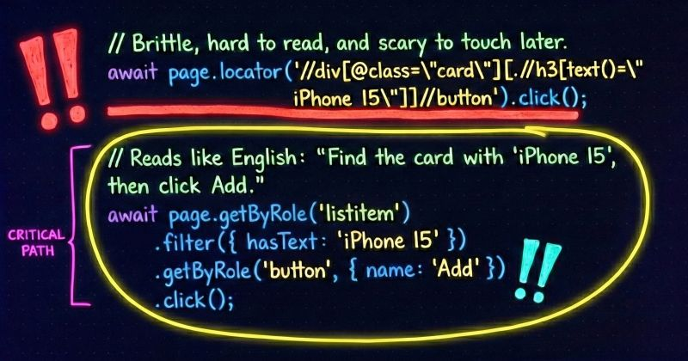

Stop over-engineering your Page Objects
I often see overcomplicated frameworks just for the sake of Clean Code
A common debate in Page Object Model design is how do we handle happy paths vs. negative testing
The textbook answer is often to split the logic:
performLogin() (Just actions)
loginAndVerify() (Actions + Assertions)
I prefer a simpler approach
I use a single method with a default parameter
`async logIn(username, password, isLoggedIn = true)`
Here is why this wins:
================
- For all happy path tests, I just call logIn(user, pass). The default parameter handles the safety check automatically
- For all my negative tests, I explicitly pass false. The code reads just like "Log in, but don't expect success"
- New team members don't have to guess which method to use. There is only one.
Is passing a boolean flag a Clean Code violation? Maybe.
Does it make my test suite cleaner and easier to maintain? Absolutely.
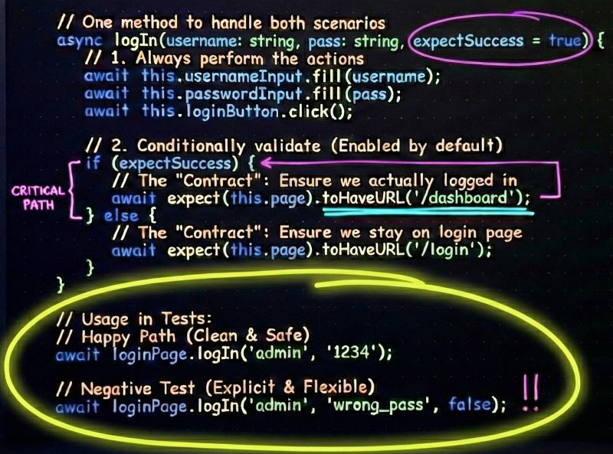

If you are initializing User Access Tokens inside a beforeEach hook or a standard Fixture, you are slowing down your test suite
I recently saw a framework where every spec file re-authenticated the "Admin" user.
100 tests = 100 login requests.
That is unnecessary noise and latency.
The Fix: Use Playwright's "Setup Projects" (Global Setup).
Instead of treating Auth as a "Test Step", treat it as Pre-Test Configuration.
Create a Setup Project: Define a dependency in your `playwright.config.ts`
Run Auth Once: Execute the login request one time before the test workers spin up.
Store Globally: Save the token (or storage state) to process.env or a generic JSON.
Now, every test in your suite simply reads process.env.ACCESS_TOKEN_ADMIN and starts validating immediately. No login screen, no API lag.
Efficiency isn't just about fast tests. It's about smart architecture.
Save this for your next refactoring session.
How do you handle Auth in your parallel runs - Storage State files or clean API tokens?
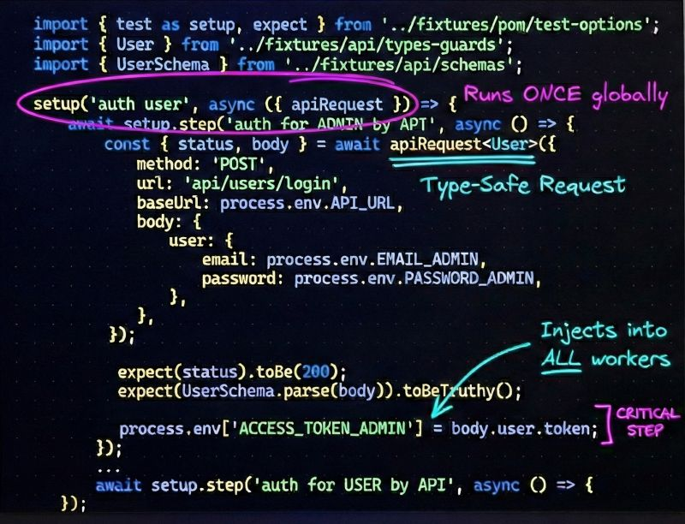

lways forget your #Playwright commands?
Use 'package.json' to solve this forever
Ever been annoyed by the need to type Playwright commands over and over again in the terminal?
Every day I had to type 'npx playwright test --project=chromium --ui' and I even created a txt file with all these commands.
Then I found that there is an easy solution for such problem - just define all commands I needed into my `package.json` and use them in my terminal and CI/CD pipelines.
You can do it too:
1. Add all commands you need into "scripts" section in your 'package.json file'. You can find mine in the image below
2. Use the command you need by 'npm run <​script name>'
Life can be so much easier!
hasztag

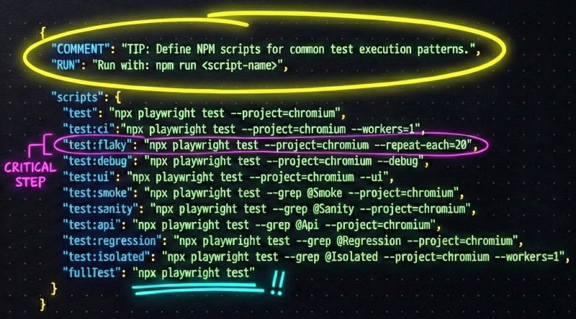

1 minute #Playwright trick to perform visual regression tests for UI with dynamic data
These tests are powerful but flaky if you have dynamic content like dates, timestamps, or user IDs.
You don't need to disable the test! Just use the mask option.
Playwright will draw a pink box over these elements before taking the screenshot, ensuring your comparison is always stable.
What is your strategy for dynamic data in visual tests?
hasztag

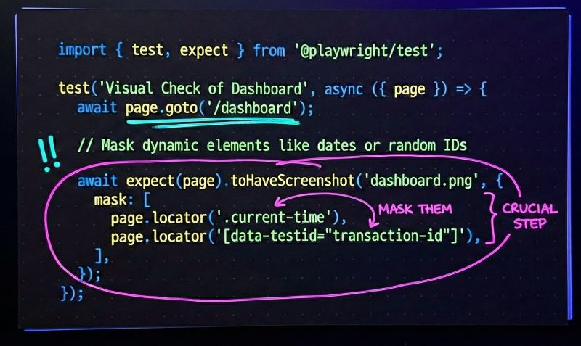

1 minute #Playwright trick to use data, coming as API Response, triggered from UI Test
You should simply use `Promise.all` and run simultaneously both UI function, that sends the API request, and to listen for API Response from the request sent.
As an example, we can use `Promise.all` to get the resource ID for test.afterAll, which ensures created resources are deleted via an API call, even after a test fails.
hasztag

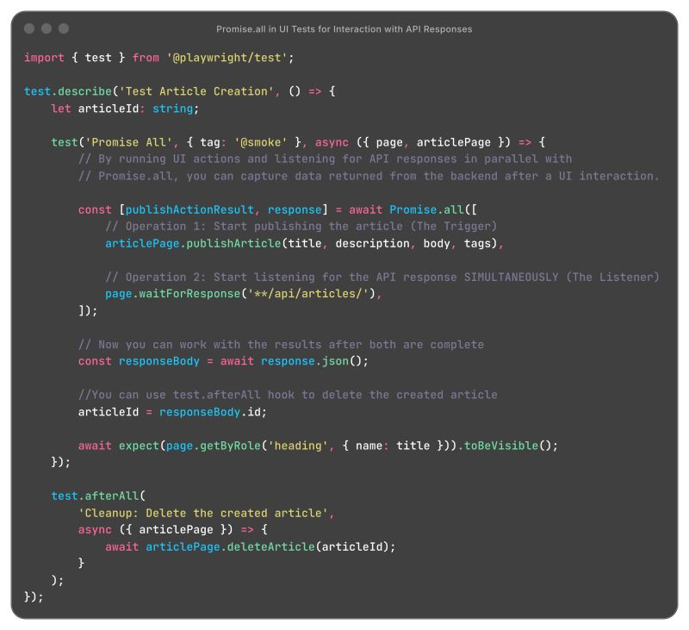

The 1-minute #Playwright trick that saves hours of setup
Starting a new automation project often feels like reinventing the wheel.
You spend days just setting it up before writing a single test.
That is why I want to share Playwright Scaffold.
This is a production-ready test automation framework built with TypeScript and Playwright.
The goal is to provide a solid foundation for UI, API, and E2E testing so you can start coding immediately.
Here is what is included out of the box:
---------------------------------------
🏗️ Structured Architecture - It uses the Page Object Model design pattern. This keeps your code organized and scalable as your test suite grows.
💉 Smart Dependency Injection - The framework utilizes fixture-based dependency injection to manage state and context cleanly.
🔍 API Validation - It includes Zod schema validation. This gives you strict type safety and confidence when testing your APIs.
🛡️ Quality & Tooling - Code quality is enforced from the first commit. It comes pre-configured with ESLint, Prettier, and Husky.
hasztag

1-minute #Playwright trick to Test File Downloads without headaches
Testing file downloads can be flaky if you rely on checking the file system manually.
Playwright has a built-in waitForEvent('download') that handles the handshake perfectly.
Why this wins:
✅ Reliable - It waits for the browser event, not a file system watcher.
✅ Clean - You get a stream you can validate instantly.
✅ Safe - No need to hardcode download paths.
Have you ever had a download test fail because the file wasn't ready yet?
hasztag
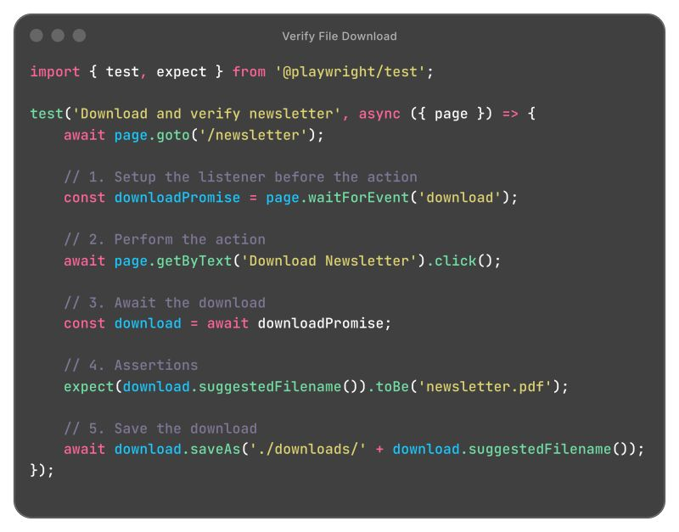

Here is a 1-minute #Playwright trick to test edge cases
Testing specific scenarios like "Empty States" or server errors often requires complex data setup.
You usually have to modify the database or corrupt data in a staging environment just to see how the UI reacts.
That approach is slow and often risky.
Instead, you can use Network Interception.
This allows you to force the application to handle specific scenarios without actually touching the backend data.
On the image is shown how you can verify a "No users found" message by mocking the API response.
Why this works well:
----------------------
✅ Speed: You skip the heavy database setup.
✅ Stability: You get the exact same response every time.
✅ Safety: You do not risk deleting real data in your test environment.
This simple pattern gives you total control over the data your frontend consumes.
hasztag
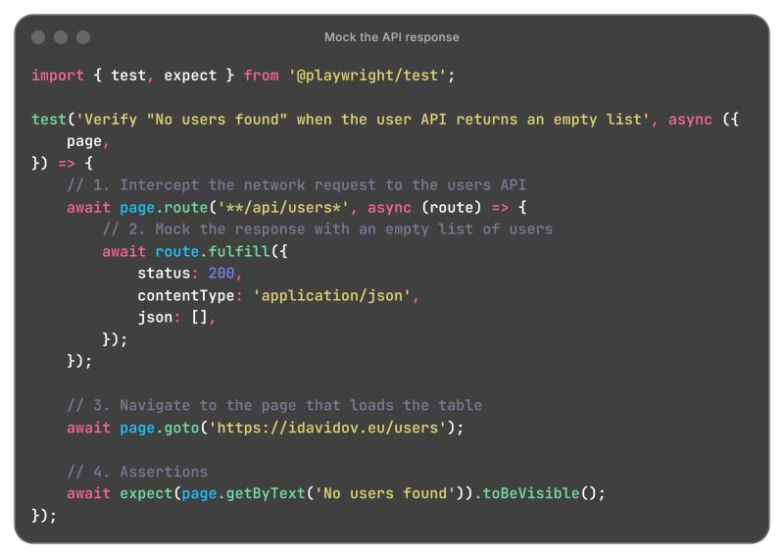

The "Happy Path" is a myth.
We often pretend that users will follow the flow exactly as we designed it. But reality is much messier than our test cases.
In the real world:
------------------
🔸 Users rage-click the submit button.
🔸 API calls time out without warning.
🔸 Mobile networks drop when the user enters an elevator.
🔸 Inputs contain characters the database hates.
If you only validate the happy path, you haven't actually tested the software. You have only tested your hopes.
True quality assurance isn't about proving it works when conditions are perfect. It is about ensuring the system remains stable when conditions are terrible.
Don't just verify the sunshine. Focus on the rainy day scenarios.
What is the wildest "edge case" bug you have found that a happy path test would have missed?

-----------
1 minute #Playwright trick to catch all bugs in a single test case
Standard assertions are ruthless.
They stop the test immediately when they fail.
This often creates a frustrating cycle where you fix one bug only to find the next one immediately after re-running the suite.
Enter Soft Assertions.
Soft assertions log the error but allow the test to finish execution.
This is perfect for checking multiple UI elements like labels, inputs, or layout consistency in one go.
By switching to `expect.soft` in your code the test continues running even if checks fail. The framework collects all the errors and reports them at the very end of the test case.
Why this matters:
🔸 You get a complete picture of everything that is broken on a page in a single execution.
🔸 You save time by grouping your fixes rather than hoping there are no more.
This is a total game-changer for validating complex areas like forms, large data tables, and dashboards.
Does your framework fail fast or fail smart?
hasztag
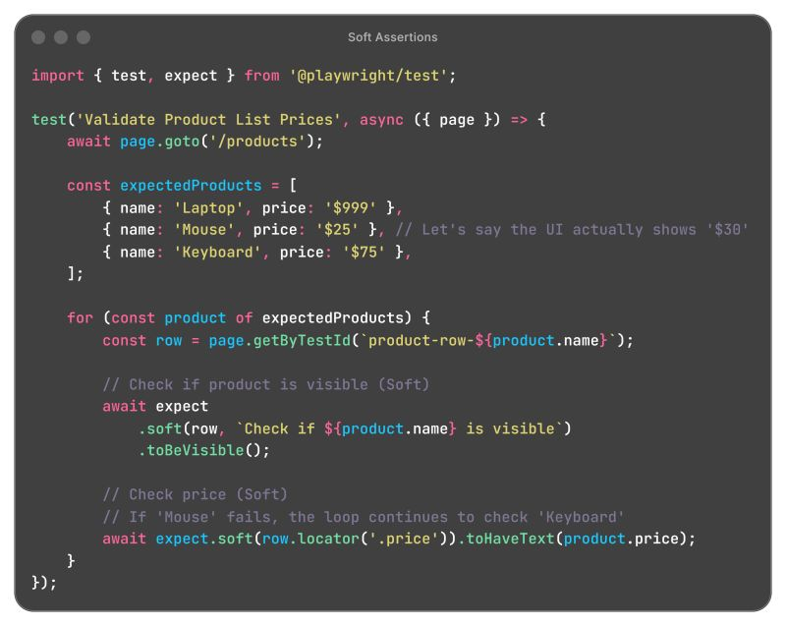

------

Dominoes are for games, not for tests. Strictly follow the Test Isolation Principle.
If Test A fails, Test B should not care.
If Test B depends on Test A’s data, you don't have a test suite. You have a house of cards. One minor UI change shouldn't trigger 50 unrelated red flags.
Why isolation matters:
-------------------------
➡️ Zero Side Effects: One test’s "garbage" shouldn't become another test’s "input"
➡️ Order Independence: You should be able to run your tests in reverse, or in parallel, without a single failure.
➡️ Debugging Sanity: When a test fails in an isolated environment, you know exactly where the issue is. You don't have to spend two hours "chasing the ghost" through three previous test files.
How to enforce it:
--------------------
➡️ Reset state between tests: Every test starts from a "clean slate."
➡️ Use Hooks: Leverage test.beforeEach to set up specific conditions and test.afterEach to tear them down.
➡️ Avoid Shared Global State: If you’re using a database, use transactions or unique IDs for every run to prevent data bleeding.
Isolation is the key to CI/CD confidence. If your tests are flaky, your team will eventually stop trusting them. And a test suite that no one trusts is just expensive noise.
----------
1 minute #Playwright trick for Polling for Non-Deterministic States
Sometimes an element doesn't appear immediately, or a status takes time to update. `expect.poll` allows you to retry a check until it passes or times out.
Waiting for a database sync or a long-running process?
await page.waitForTimeout(5000) is a bad practice! ❌
Use `expect.poll` instead.
It keeps retrying the assertion until it passes or the timeout is reached. It returns as soon as the condition is met.
hasztag

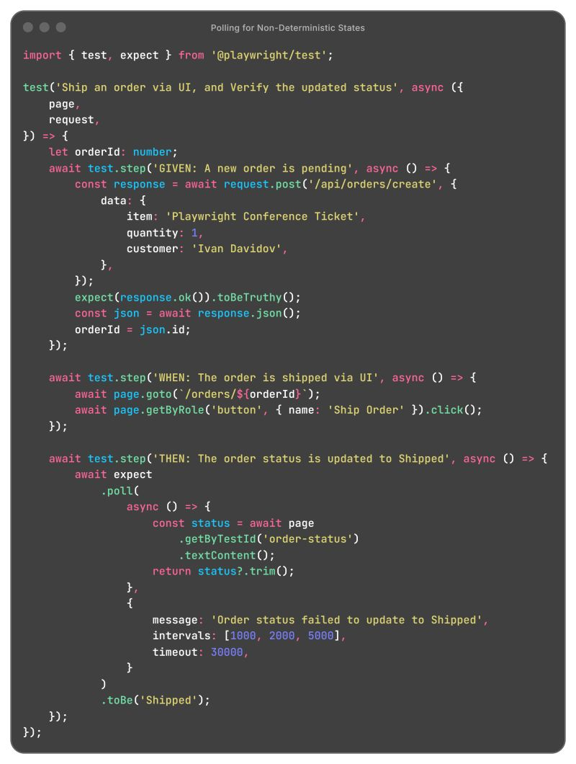

Why process always comes before automation?
Automation is a force multiplier. But multipliers only amplify what is already there. If you automate a messy, undefined process, you simply get messy results. The only difference is that you get them faster.
You can’t expect a testing script to save the day if the development workflow is broken. This is especially true for large teams, where lack of structure doesn't just slow you down. Instead it scales the chaos.
Before you build, you must organize.
The Golden Rule:
🏛️ Stabilize: Define the steps and remove the friction.
📄 Standardize: Ensure everyone follows the same path.
⚙️ Automate: Use tools to speed up that proven path.
In simple words - refine the flow first, then build the robots.

------
Stop using #Playwright for clicking through the UI to set up your test data
If your E2E tests are taking forever, it’s usually because you are doing everything via the browser.
Here is a simple pattern to speed up your Playwright suite - the API Shortcut.
Instead of logging in, clicking "Create New", filling out a form, and clicking "Save", you just hit the backend API directly.
The Strategy:
1️⃣ Arrange: Use request to inject data in milliseconds
2️⃣ Act & Assert: Use page to verify the user actually sees it.
Why this wins:
✅ Stability: Fewer UI steps mean less flakiness
✅ Speed: API requests are instant compared to browser rendering
✅ Focus: You test the specific feature, not the data entry form
Below is a quick example of creating a product via API, then checking the UI.
hasztag

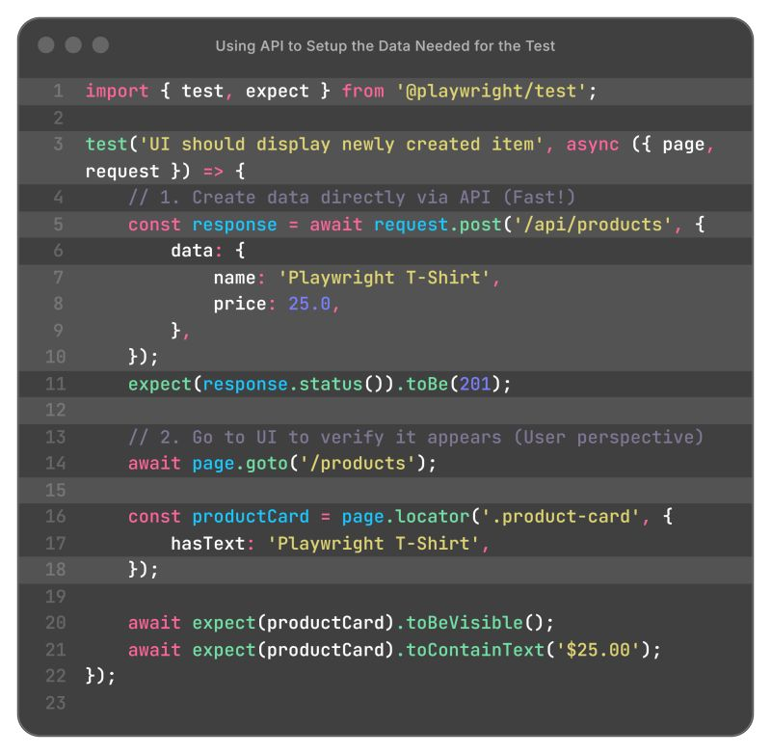

#Playwright has time machine for your Bugs
Screenshots and videos can show you *what* happened.
Trace Viewer shows you *why* it happened.
It captures DOM snapshots, console logs, and network calls for every action.
Simply it is a full time-machine for #debugging.
Do you actively use it for debugging bugs, or it is not part of your toolbox?
hasztag
------------
he single most important Trick for #Playwright Automation Testing Framework
It is not the Fixtures. It is not the Design Pattern. It is certainly not Zod schema validation.
It is joining the community!
This is where you learn something new every day. The most successful engineers in IT share one common thing - they never stop learning. They strive for perfection, and that collective effort is why our industry progresses so rapidly.
You can learn every trick in a given field, yet if you don't know *Why* to use it or *How* to apply it effectively, it will be worthless.
I am deeply grateful for the last few years I’ve been part of this community. It has been essential to my own growth.
Now, I want to pay that forward. I am trying my best to help as many fellow QAs as possible build their skills, just as the community helped me build mine.
hasztag
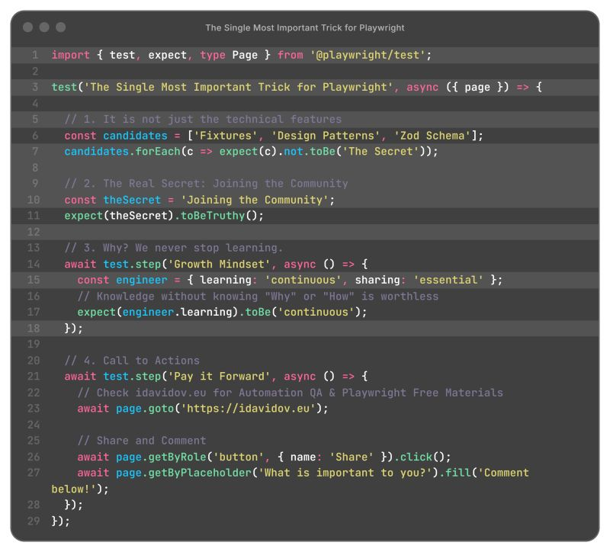

5-minute #Playwright trick - Login once, test forever.
Implement `setup` stage before your actual test run.
Save your cookies/local storage to a `auth.json`.
Inject it into other tests.
Skip the login screen and jump straight to the feature.
Save minutes on every test run.
Additionally, you can set your tokens too.
P.S. In the example below, I used a custom abstraction for API calls, implemented #POM as fixtures, #Zod for schema validation and #dotenv for managing environment variables.
You can implement it by using Playwright out-of-the-box tools.
hasztag
hasztag
hasztag
hasztag

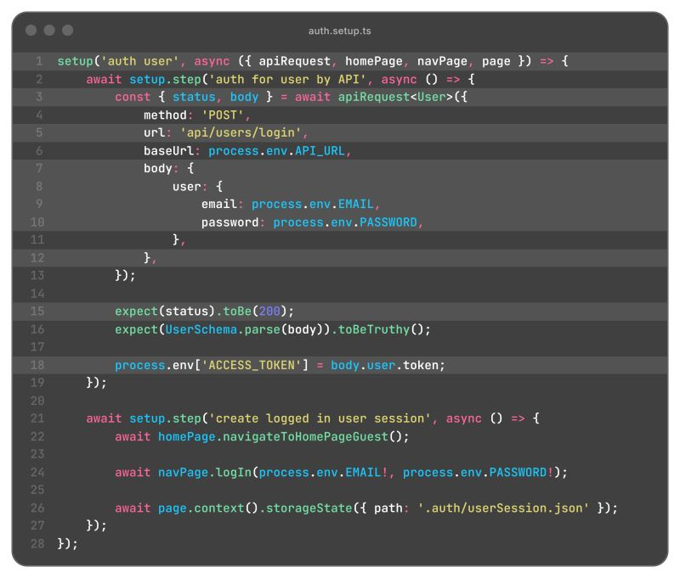

implest way of implementing Data-Driven Automation is For...Of Loop
Talking about the verification of software validations, we can't skip one of the most important tools - for...of loop.
Data-Driven Automation can be easily implemented by:
1. Creating an array of "chaos" (aka invalid data)
2. Unleash a simple For...Of loop
3. Sit back and watch the assertions fly
It’s clean and it’s scalable
Do you automate them like this, or do you have a different secret you are hiding?

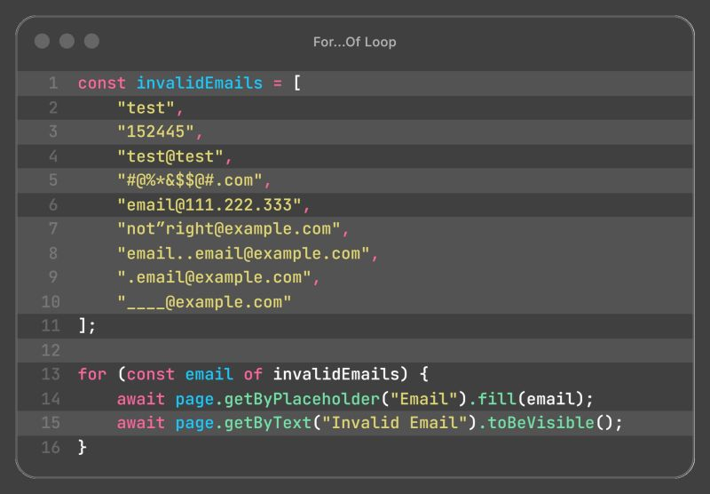

1-minute #Playwright Performance Hack - Abort heavy and slow API request to improve the performance of your tests
If you are testing functional logic (like a signup for newsletter form), you don't need to wait for high resolution marketing images to load. Aborting them speeds up the tests.
Additionally, by using `page.route` to abort such resource you can easily improve stability of your UI tests and reduce the flakiness.
Try it and share how it is going in your specific case.
hasztag

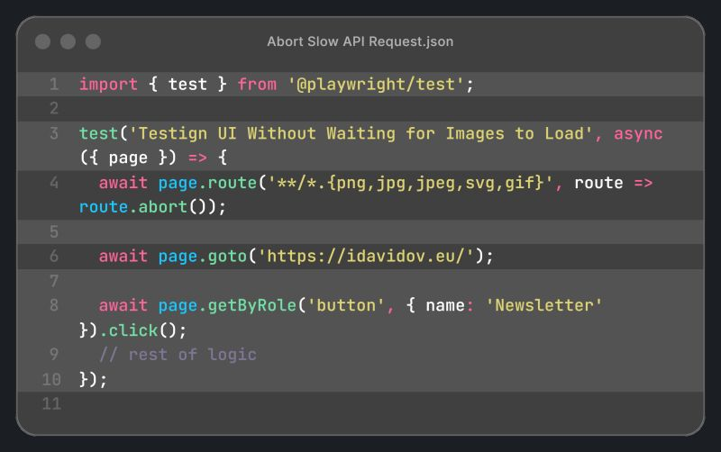

UI tests are slow and flaky
They must be the tip of the pyramid, not the foundation. This place is reserved for the API tests.
Why? Because they provide:
1. Speed: 100x faster.
2. Stability: No rendering issues.
3. Coverage: Test edge cases easily.
Your UI tests should compliment your testing, not to be the only testing you perform. Support them with a massive API test layer.
Tools like #Playwright are fantastic for automation testing, and do tremendous job handling the flakiness, but they cannot overcome the slow nature of these tests.
hasztag

1-minute #Playwright FIX – Stop instantiating Page Objects inside your tests. Start using Custom Fixtures.
Instead of instantiating Page Objects in every test, extend the Playwright test object to provide them automatically.
By using this, so-called "Page Object Wrapper", you will save so much pain during development.
The results are immediate:
⛔ less code
✅ better readability
hasztag

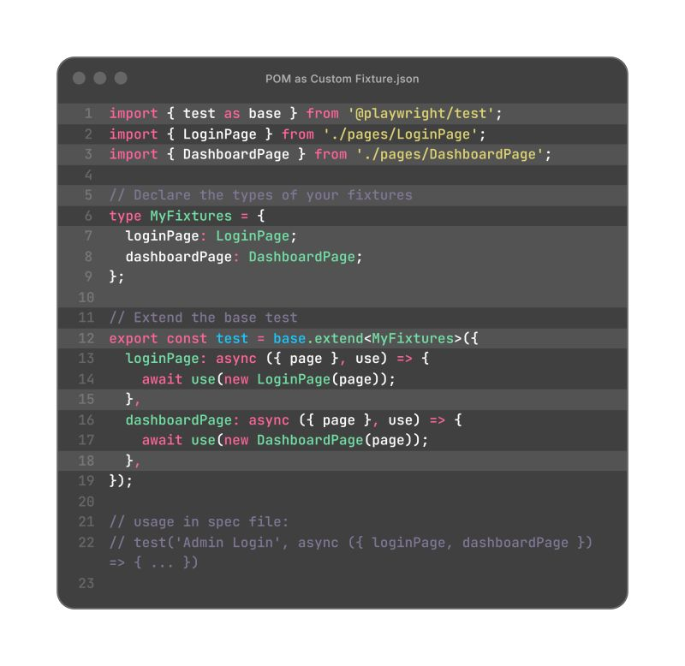

ired of writing assertions in #Playwright? Here is what you can do:
I hate typing the same assertions or boilerplate code over and over again in my Test Automation Frameworks.
That's why I use User Snippets - they can be configured in a few minutes and used forever.
Below is an example of probably the most common assertion in UI tests - expecting a locator to be visible.
By typing `exv` and hitting enter, you can instantly insert the complete code `await expect().toBeVisible();` with your cursor placed exactly where it should be - in the parentheses of the expect.
Do not miss the opportunity to configure and use these snippets in your project.
A complete guide with my snippets can be found below.
hasztag

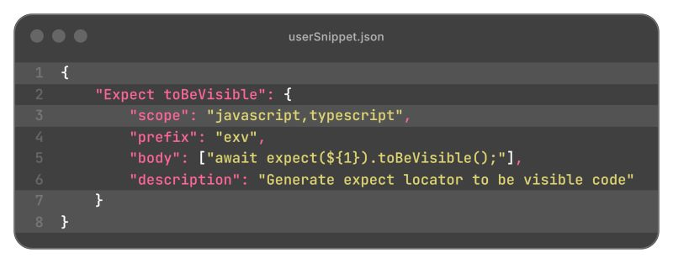

Using scripts from `package.json` is way easier than typing all #Playwright commands manually
Ever be annoyed by the need to type Playwright commands over and over again in the terminal?
There is an easy solution for such cases - just define this commands into your `package.json` and use them in your terminal and CI/CD pipelines.
The life can be so much easier!
Do you have additional ticks you are using in your projects?
hasztag

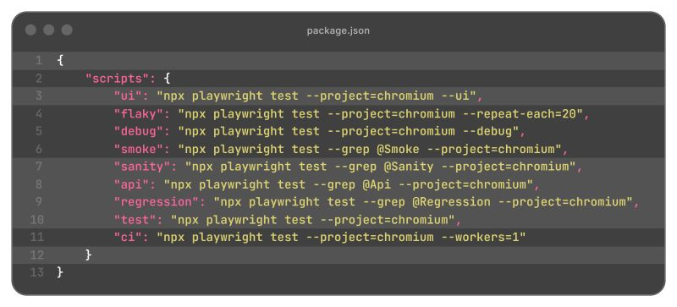

Your API Response Changes Without Ticket, All Your Tests are Passing, and You Find Out in Production!?
How many times during development, a functionality that is working has been changed without a ticket or proper notification?
Many times, adding or removing a parameter in the API response body goes under the radar, and that can lead to a huge defect.
If you are using Playwright, the solution for that is simple - a library, called Zod.
You have to define a schema and infer your types from it by method `z.infer`.
One schema, two benefits, zero drift.
This is called end-to-end type safety.

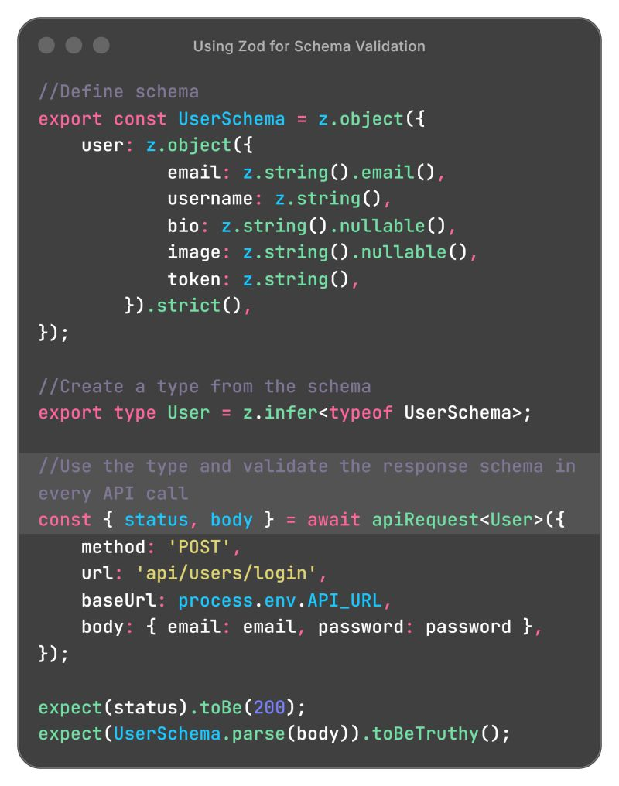

If you think a rigid, monolithic BasePage is the only way to share code between your Page Objects in Playwright, please scroll down!
Traditional inheritance (class A extends B) is powerful, but it has limits.
In TypeScript, a class can only extend one other class.
The Mixin Design Pattern lets you create reusable "feature packs". They are small classes focused on a single piece of functionality (like navigation or table handling). You can then "mix" these feature packs into any Page Object that needs them.
This approach allows you to:
🔰 Share functionality across unrelated classes
🔰 Avoid deep inheritance chains, keeping your code flat and manageable
🔰 Keep Page Objects clean and focused on their primary purpose
The article is a walk through a practical example of adding shared navigation functionality to a object without using inheritance.

--------
BDD is Often Just Glorified, Poorly Written User Stories and Test Scripts
It is bad that too many teams adopt Gherkin syntax without the collaboration, missing the entire point.
It is even worse when the QA is not part of the collaboration in User Story creation.
But the worst thing is when the management insist on Cucumber implementation in the automation testing framework.
The real value of Behavior-Driven Development is in the collaboration and conversation, not the Gherkin syntax, or in any tool.
If you want a successful project - implement proper BDD - collaborative conversation that creates a shared understanding between product, development, and QA.

Since I am a Stubborn, I Want to Continue the Topic About Adding Assertions in the Methods in Automation Frameworks =>
Many engineers point out that if we want to test the negative scenario of the method, that has assertion inside, we are stuck.
It is partially true, because while we are implementing our method, we can add a default parameter (in our example isLoggedIn) to use the correct assertion with if-else statement.
There is a single reason to check if performed login is unsuccessful with invalid credentials and it is while we are testing the login functionality itself.
In that case, we have just to add `false` as 3rd parameter in the function and voilà - we use the right assertion.
Please, change my mind

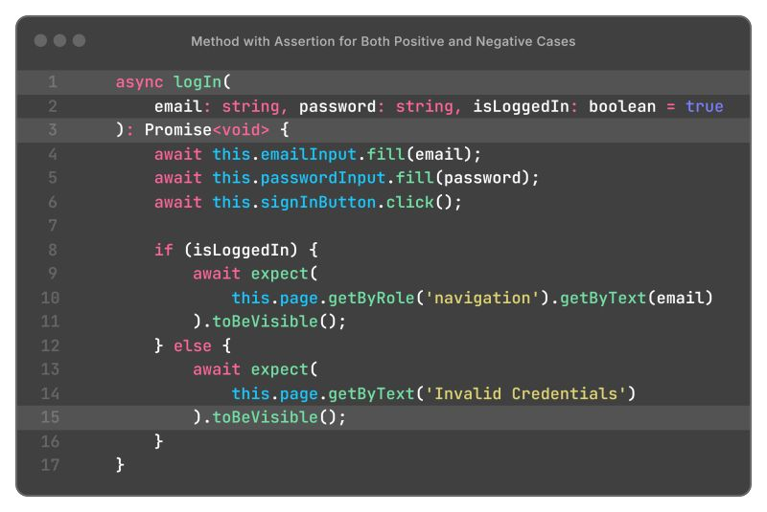

Let's Talk About Single Responsibility Principle (SRP) in Automation Testing Frameworks =>
The definition of SRP for functions/methods, I liked the most, is that "each function should focus on a single task, execute it well, and avoid doing anything unrelated to that task".
First, we have to define what is the task of the method we are writing. It is one of those things, that if you ask 10 different engineers, you can receive 11 different answers.
I personally think that a method from automation testing framework has the goal to validate outcome, which means that the actions leading to that validation can be treated as prerequisites.
Let's look at the example of a `logIn` method from a Playwright framework. There are 4 separate actions - all of them, an abstract method, coming from Playwright itself. There are a few different assumptions that can be made:
1. The goal of the method is to fill the login form
2. The goal of the method is to submit already filled form
3. The goal of the method is to fill and to submit the form
4. The goal of the method is to fill the form, to submit it and to validate the success
Certainly, there are pros and cons to every single implementation, but let's be clear - the main goal is to solve the problem, and in most of the cases, it is just an engineer solution of it.
Do you think that I missed a major point or you have totally different view about creating automation test methods?

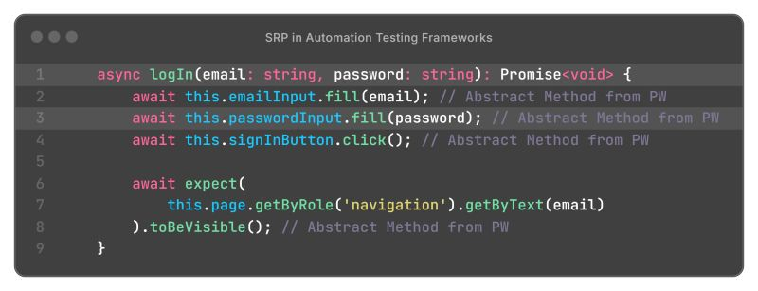

Are You Adding Assertions to the Method Itself to Verify that It is Successful, or You Add Them in the Test?
I understand that adding an assertion in a method violates the Single Responsibility Principle (SRP), but I personally like to have them inside my methods. It keeps my framework more readable and easily to maintain.

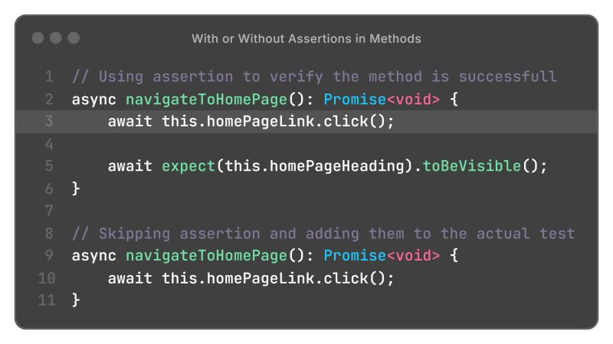

Which Way of Defining Locators in a POM do You Prefer - Using `Getters` or the Classic Definition, and Why?

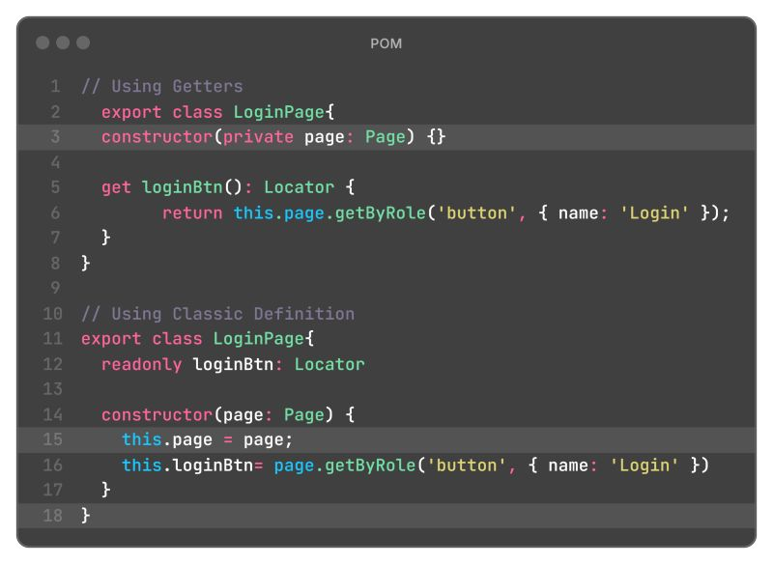

Ever Wonder How to Use Data, coming as API Response, Triggered from UI Test? Here is How =>
You should simply use `Promise.all` and run simultaneously both UI function, that sends the API request, and to listen for API Response from the request sent.
As an example, we can use `Promise.all` to get the resource ID for test.afterAll, which ensures created resources are deleted via an API call, even after a test fails.

How Important is to Use Optional and Default Parameters in Your Test Automation Functions?
For me, it is crucial to use them in your functions, because they give you an opportunity to use your function in different situations.
If we use the example below, we can easily test the registration flow with different inputs - we can provide only the mandatory parameters, we can provide mandatory ones and the optional one, or we can provide all 4 of them.
This keeps your code clean and easy to maintain.
Are you a fan of optional and default function parameters, or you prefer separate functions?

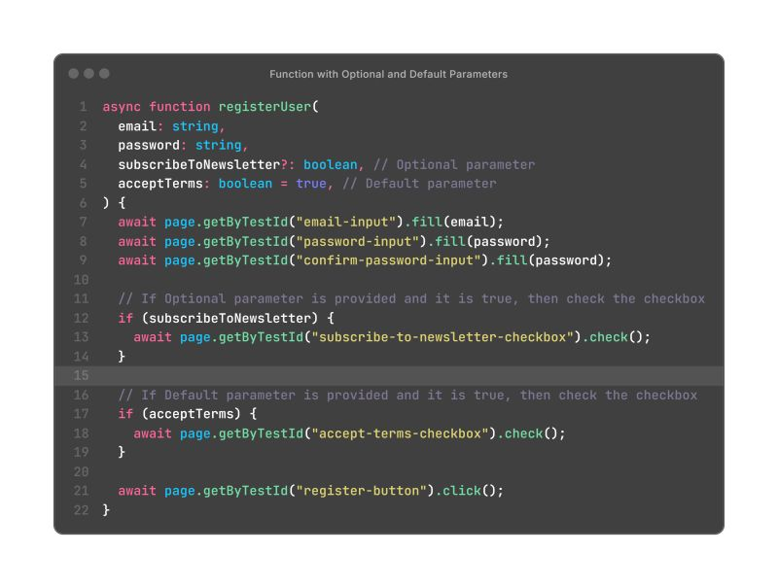

Both UI and API Validation Are Crucial - One for the User Experience, the Other for Safety
Automation tests, for both UI and API are the best way for verifying validations.
And what is a great solution for implementation of these tests? Creating an array of all invalid data, and iterating through it with For...Of loop.
Simple, and scalable.
Do you care for validation, and if yes, how you verify it?

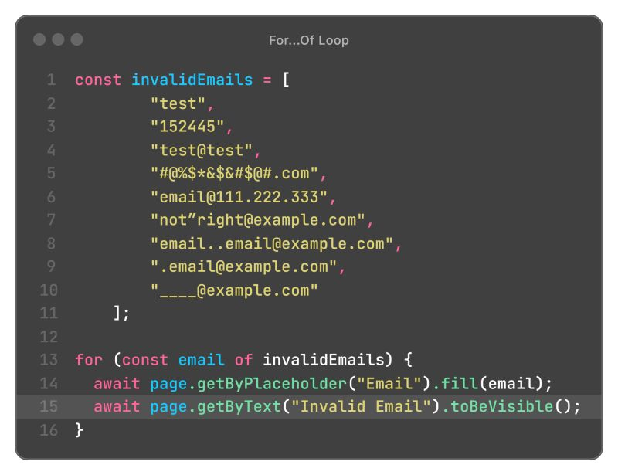

Developing Playwright API Testing Framework? Use Initial Setup for User Access Tokens
During my live session about "Developing Playwright Framework for REST API Testing", I received an interesting question.
"Can I use Playwright Fixtures to initialize access tokens for all my users?"
Despite it is possible, there is better solution to this problem. It lies into right setup, before actual testing even start.
On the image below, you can find how to execute needed number of steps to create `process.env` variables, holding the auth tokens, for all users you have.
Later, you can refer to `process.env.ACCESS_TOKEN_USER` to use it.
Once the run is completed, all variables are deleted.

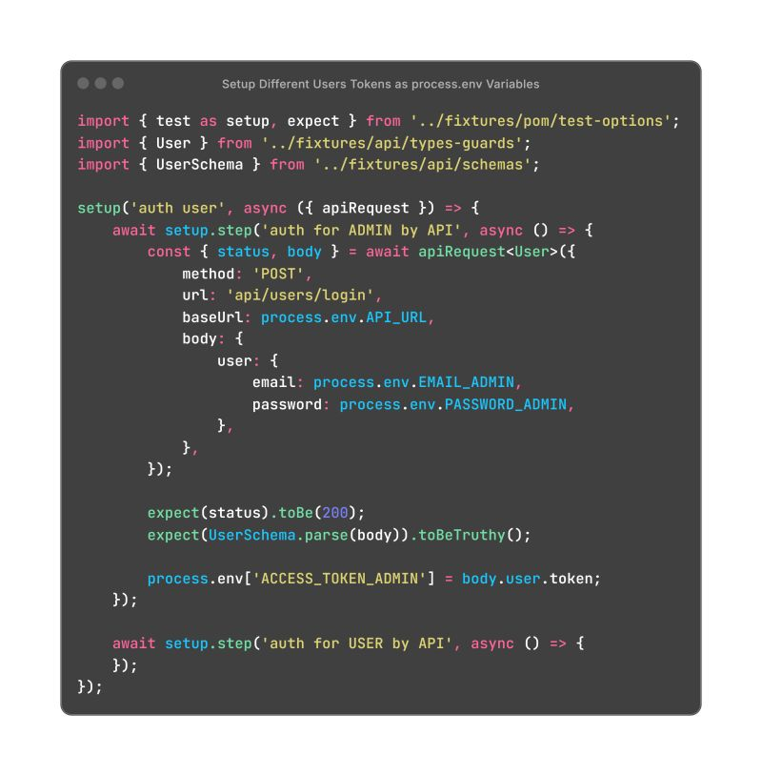

Writing API Request Logic Inside Your Test Cases? There's a Much More Scalable Way to Handle it with Custom Fixtures!
I have the opportunity to work on two large projects with the exact setup, described in the article (check comment section), and I am pretty confident that it works great.
The complexity is abstracted is a reusable helper function that handles all your API requests (GET, POST, PUT, DELETE)
It prevents runtime errors by using Zod to define schemas and validate API responses, ensuring data integrity from the start.
Streamline your tests by implementing a custom Playwright fixture that injects API capabilities directly into your test environment.

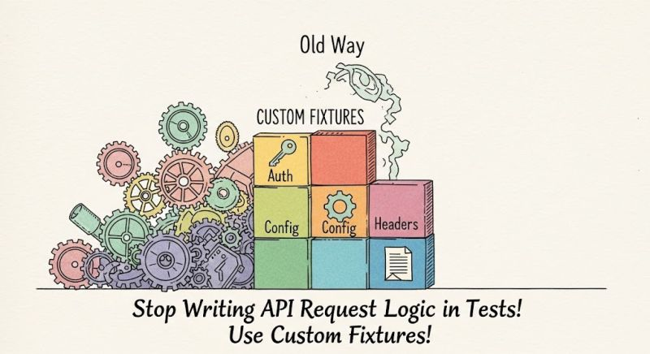

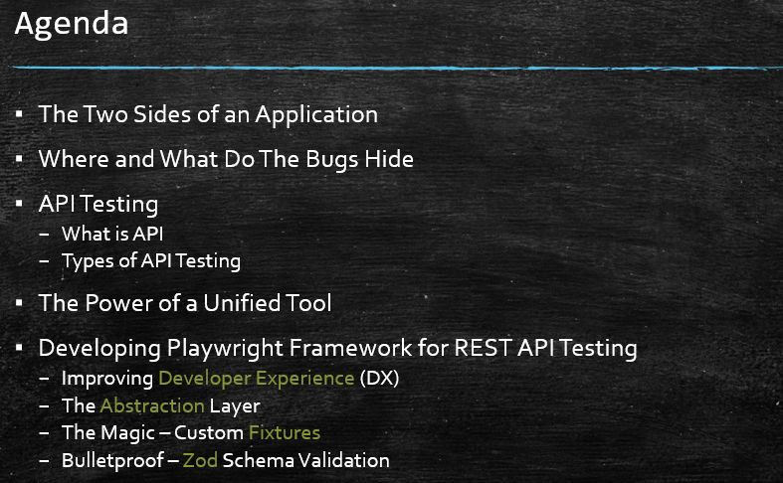

Never ever use XPath as your test automation locator strategy!
Relying on brittle, implementation-dependent locators is the perfect catalyst for a perfect storm - #flaky, unreliable tests that ruin confidence in the #automation #testing.
There're two main approaches for resilient tests: Test IDs and User-Facing Locators
To use User Facing Locators, we need a commitment from our Front-End Developers to write semantic and accessible HTML. They should use proper ARIA roles, labels, and descriptive text, which in my understanding is a big win for the quality.
To use Test IDs, we need our Front-End Developers to follow a convention for adding these test IDs to key interactive elements during development.
In the first case, we ensure that we test the application from a true user's perspective, and in the second, we use the most robust strategy.
In either way, we should communicate it ASAP with the Front-End team.
hasztag
hasztag
hasztag

--

This deep dive into TypeScript's power could redefine your framework.
💻 This article tackles common problems with:
1. 🚫 Eliminating hidden bugs from "magic strings" and hardcoded values.
2. ♻️ Maximizing code reusability for functions like API requests without sacrificing type safety.
3. 🔒 Ensuring data integrity by validating API responses at runtime and keeping types in sync.
4. ✨ Creating flexible and precise types for objects and API payloads with minimal effort.

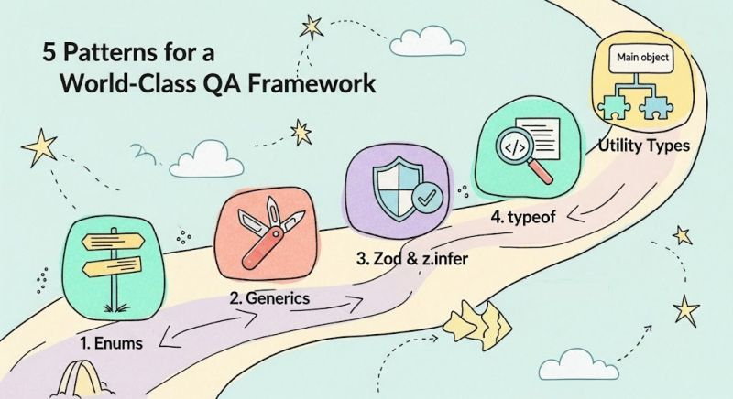
Viktor Konovalov
Playwright tip: snapshots aren't just for UI
When people hear "snapshot testing", they usually think about screenshots.
But snapshots are just as useful for API testing.
They're especially useful when you need to verify that stable parts of an API response never change unexpectedly.
Instead of writing dozens of assertions for large JSON payloads, you can compare the entire response against a stored snapshot.
Before creating the snapshot, remove dynamic fields such as IDs, timestamps, or tokens. This keeps the comparison focused on the data that should remain stable.
Snapshots work especially well for:
• configuration endpoints
• feature flags
• large API payloads
• API contract verification
The goal isn't to replace assertions.

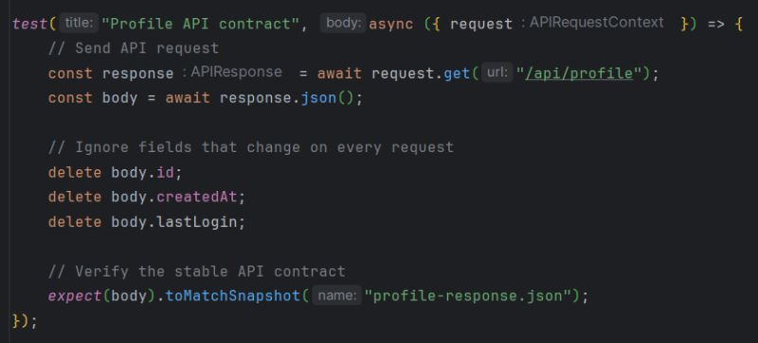

An interesting AI-powered QA product recently came my way, and I plan to explore it together with you.
The main question is:
Can AI manage the complete test automation lifecycle?
Generating a test is only the beginning. Real automation also requires:
• UI and API coverage
• test data
• CI/CD
• reporting
• failure analysis
• maintenance
I will test the platform against real automation challenges and openly share the results, limitations and failures.
The goal is not to prove that AI can replace QA engineers.
It is to understand what work AI can genuinely remove, and where engineering control is still essential.
"Can AI generate a test?" is no longer the most interesting question.
The real question is:
"Can we trust the automation it creates?"

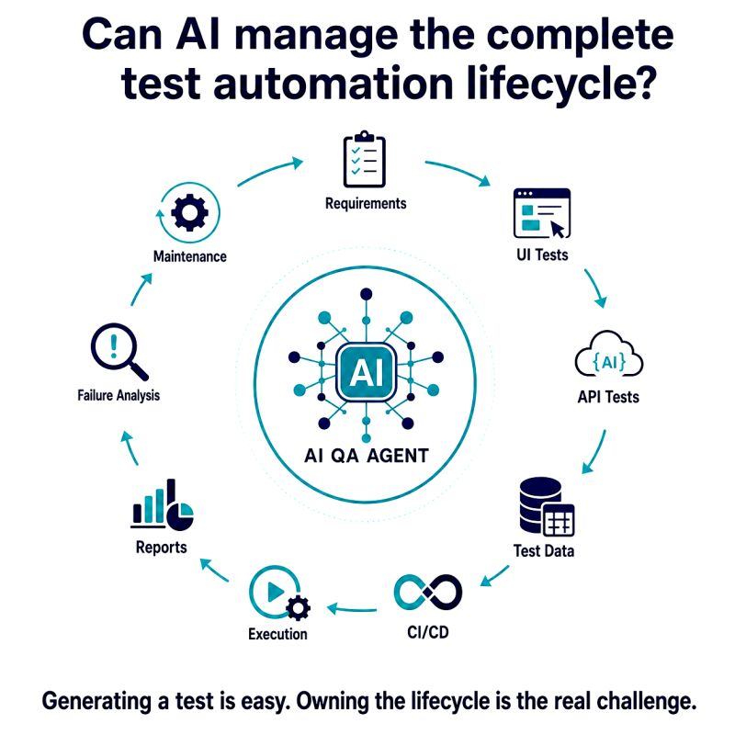
Tech Explained #3: Race Conditions
What is a race condition?
Imagine two users click "Buy" at exactly the same time.
There's only one item left in stock.
Who gets it?
If your system isn't prepared for concurrent requests,
both users might succeed.
That's a race condition.
The final result depends on which request reaches the critical section first.
Race conditions often cause random, hard-to-reproduce bugs.
Common symptoms include:
• Duplicate orders
• Negative inventory
• Lost updates
• Random test failures
That's why concurrent testing is just as important as functional testing.

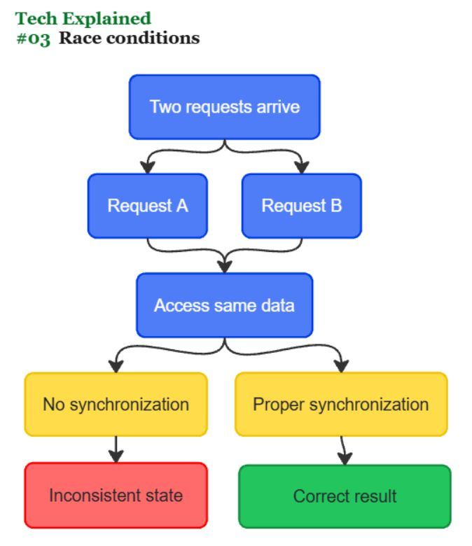

Playwright tip: build self-healing locators with a Locator Factory
UI changes happen.
• A button gets a new test id.
• A CSS class is renamed.
• A designer wraps an element in another container.
Suddenly dozens of tests start failing.
Instead of hardcoding a single locator, create a Locator Factory that knows multiple ways to find the same element.
For example, it can try:
• getByTestId()
• getByRole()
• getByLabel()
• CSS or XPath as a last resort
If one strategy breaks, the next one is used automatically.
Your tests become much more resilient to harmless UI changes without hiding real bugs.
Auto-healing isn't about ignoring failures.
It's about recovering from locator changes while still failing when the application's behavior is actually broken.

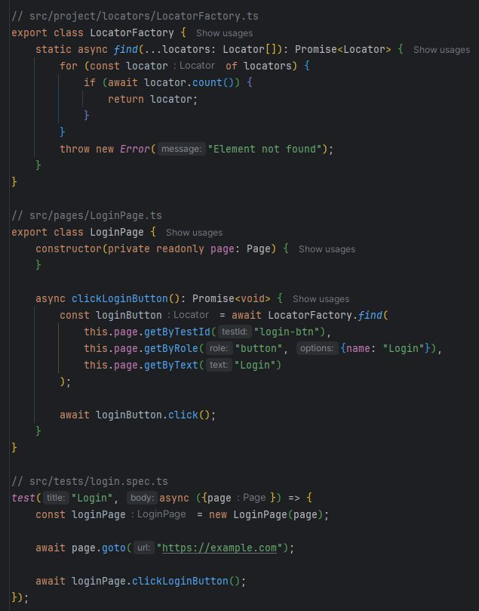

Tech Explained #2: Caching
What is caching?
Imagine you open the same page twice.
Should your browser download every image, stylesheet and script again?
Hopefully not.
That's exactly why caching exists.
Instead of downloading the same data every time, a cache store
previously fetched resources and reuses them when possible.
Without caching, applications become:
• Slower
• More expensive to run
• Less responsive
Caching improves performance, but it can also confuse QA engineers.
Sometimes you're not testing the latest version of the application.
You're testing what your browser saved yesterday.

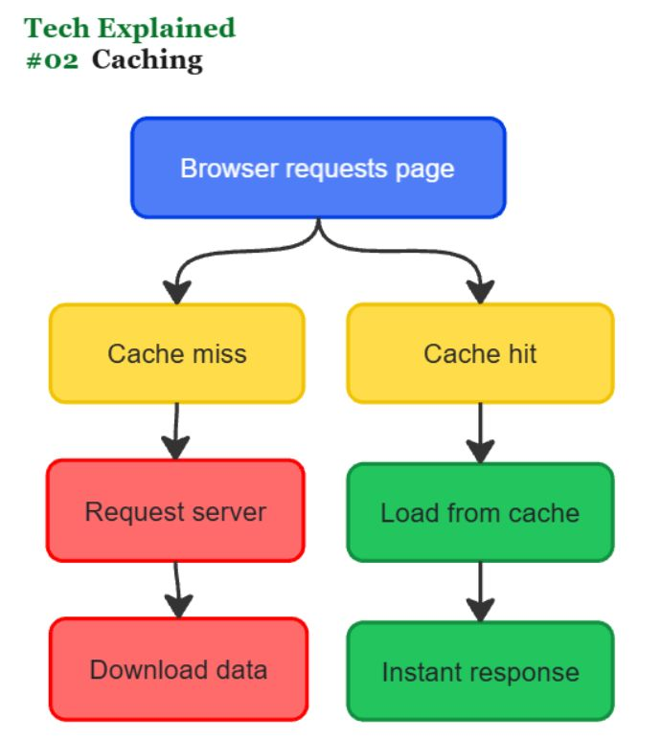

Playwright tip: use locator.evaluateAll() to process elements in one browser call
Need to read data from many elements?
Many tests do something like this:
• get all locators
• loop through them
• call textContent() for each one
It works.
But every textContent() is a separate round trip
between Node.js and the browser.
locator.evaluateAll() executes your code inside the
browser and returns the final result in a single call.
This is especially useful when extracting:
• table values
• lists of links
• product names
• IDs
• attributes
• any transformed data
Less browser communication.
Cleaner and often faster tests.
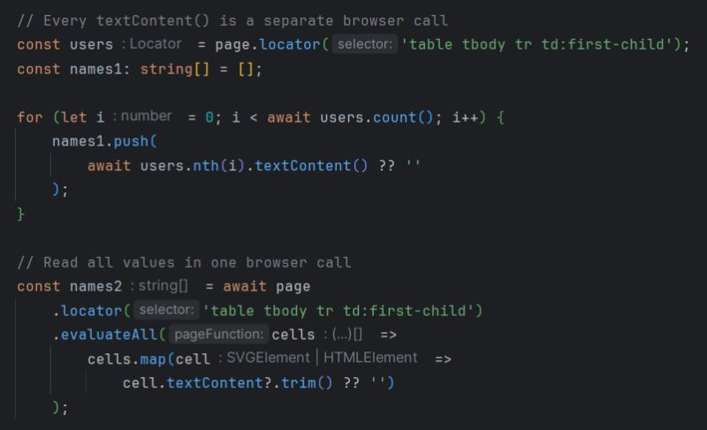

Playwright tip: control time with the Clock API
Time is one of the biggest sources of flaky tests.
Think about features like:
• countdown timers
• session expiration
• scheduled notifications
• delayed UI updates
• date and time calculations
Waiting for real time makes tests slower and less reliable.
Playwright's Clock API lets you freeze time, fast-forward it, or set any date you need.
Your tests become deterministic because time only moves when you tell it to.

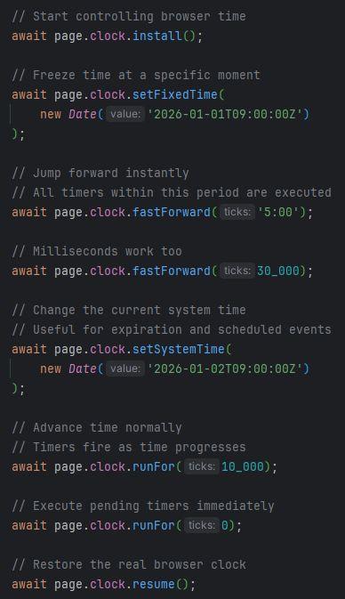
Playwright tip: understand the Route object
Imagine the browser is about to send a request:
GET /api/users
Playwright intercepts it and gives you a route object.
Your job is to decide what happens next.
The most common options are:
• fulfill() -> return your own response instead of calling the real backend.
• abort() -> block the request completely.
• continue() -> send the request to the real , optionally modifying it.
• fallback() -> pass the request to the next matching route handler.
• fetch() → get the real response and modify it.
• request() → inspect request details without changing its behavior.
Once you understand these methods, network mocking in Playwright becomes much easier to reason about.
You're not just intercepting requests.
You're deciding their entire lifecycle.

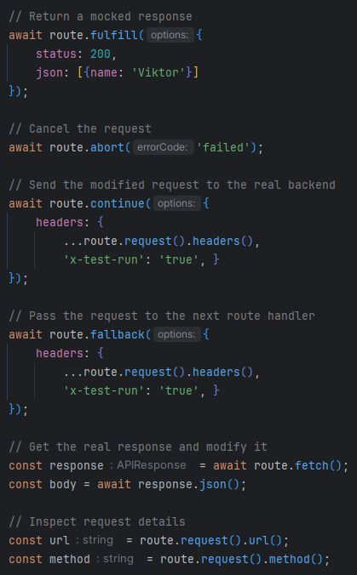

Playwright tip: use route.fallback() when one request needs multiple handlers
Most teams use page.route() to mock requests.
But sometimes you want to do more than one thing with the same request.
For example:
• add a custom header to every API call
• log all requests for debugging
• mock a specific endpoint
Without route.fallback(), the first matching route handles the request and the rest never run.
With route.fallback(), the request can continue to the next matching route.
This allows you to split network logic into small, focused handlers instead of building one large route full of conditions.
A simple way to think about it:
> continue() → send the request to the backend
> fallback() → send the request to the next route handler

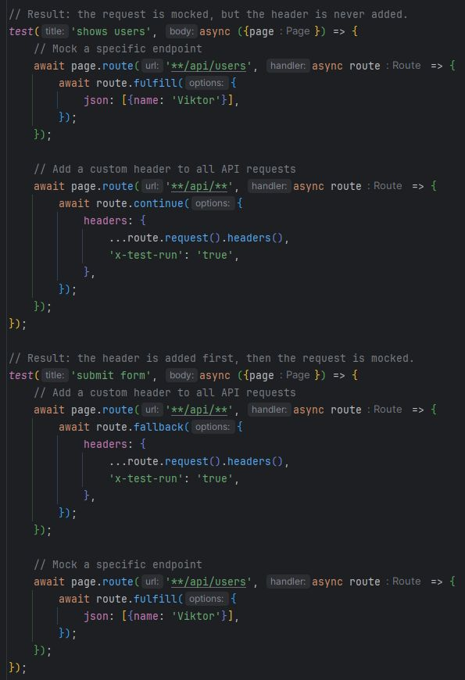

laywright tip: validate the accessibility tree, not the DOM
Many UI tests are tightly coupled to implementation details: CSS classes, element IDs, and page structure. The problem is that users never interact with those things.
Instead of asking "Does this div exist?", ask "Can a user find and use this button?"
Using accessibility-based locators like getByRole() and getByLabel() gives a few advantages:
• tests focus on user behavior instead of implementation details
• selectors become more stable during UI refactoring
• accessibility issues are often discovered earlier
• test code becomes easier to read
Good tests verify what users can do, not how the page is built.

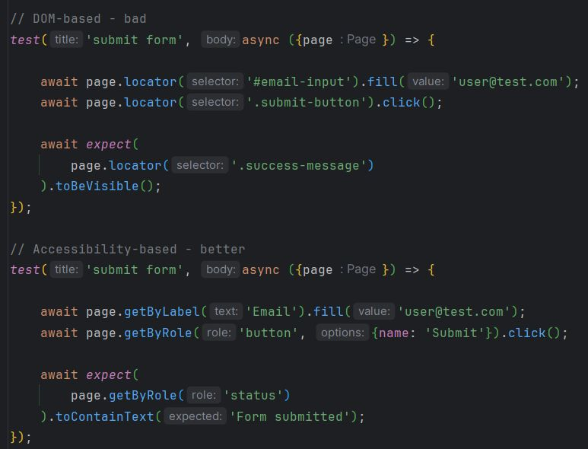

Playwright tip: use page.addInitScript() to modify the env. before the app starts
Sometimes you need to control browser state before your application loads.
For example:
• feature flags
• localStorage values
• session data
• Math.random()
• browser APIs
Many teams set these values after page.goto().
The problem is that the application may have already read them during startup.
page.addInitScript() runs before any page scripts execute.
This makes tests more predictable and avoids race conditions during
initialization.

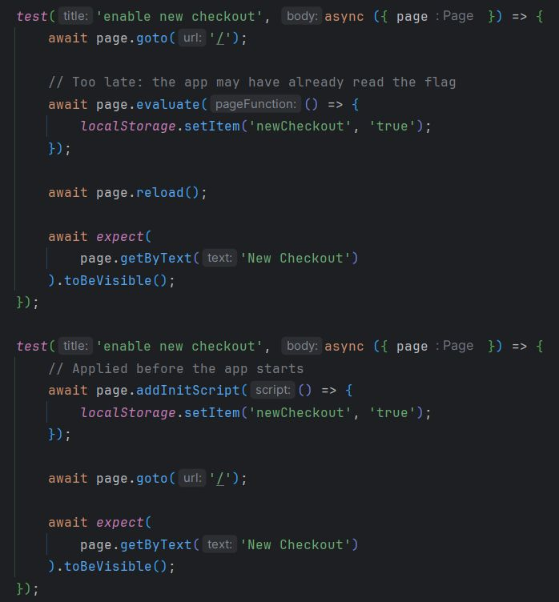

Playwright tip: use expect.toPass() when a single assertion retry is not enough
Most Playwright assertions already retry automatically.
But sometimes the flaky part is not the assertion.
It's the entire flow.
For example:
• trigger an action
• wait for backend processing
• verify the result
In these cases, retrying only the final check may not help.
expect.toPass() retries the whole block until it succeeds or times out.
Useful for eventually consistent systems, background jobs, and delayed updates.
Good automation is not about adding retries everywhere.

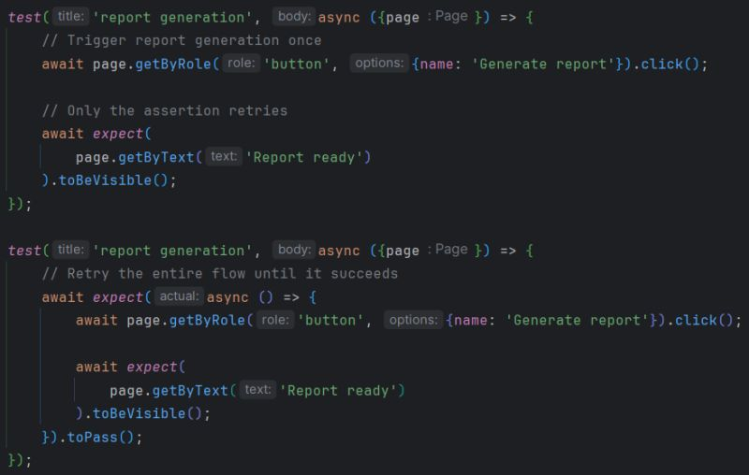

Playwright tip: use .toHaveScreenshot() where visuals actually matter
This assertion captures a screenshot of the page or element
and compares it with a baseline image.
It helps catch visual regressions that regular assertions often miss:
• broken layout
• spacing issues
• missing elements
• wrong styles
• UI shifts
But not every UI check needs visual comparison.
Usually, regular assertions are enough:
• await expect(button).toBeVisible();
• await expect(price).toHaveText('$99');
Use .toHaveScreenshot() for areas where the visual appearance itself is important:
• design systems
• critical components
• checkout flows
• dashboards
• marketing pages
Avoid using it everywhere.
Full-page visual tests on highly dynamic pages often become flaky and noisy.
Keep screenshots small and stable.
Mask only truly dynamic content.
Visual tests should protect the user experience,
not become another maintenance problem.

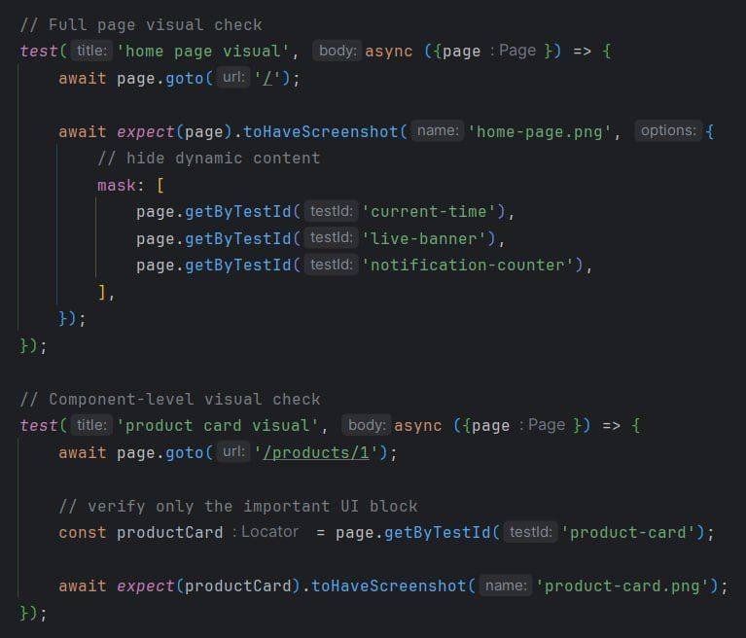

laywright tip: use test.step() for readable reports
A test can be technically correct and still be hard to analyze after failure.
Especially in CI.
When a long E2E test fails, the question is not only:
"Which test failed?"
The better question is:
"Which user action failed?"
Without clear steps, you often need to open the trace, inspect the logs, and mentally rebuild the whole scenario.
test.step() helps structure the test around meaningful business actions.
It does not make the test more stable by itself.
But it makes failure analysis faster, reports cleaner, and debugging much easier.
This is especially useful for smoke and regression scenarios where one test may cover several user actions.
Good automation is not only about execution.
It is also about fast failure investigation.

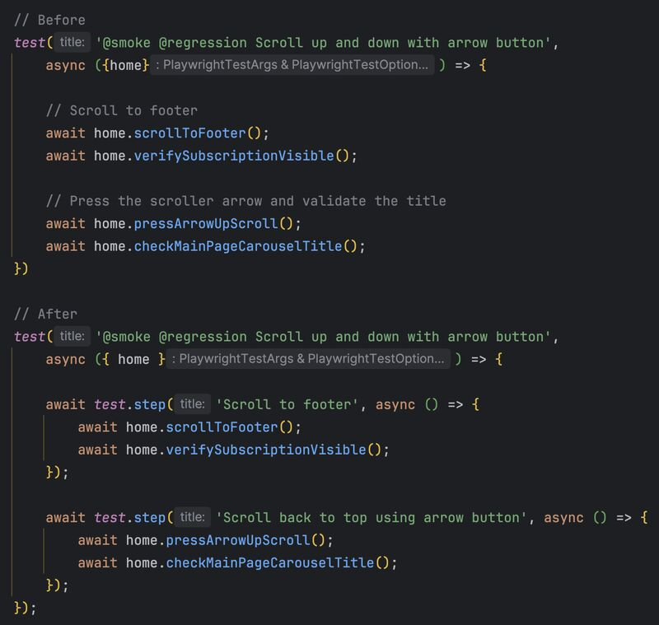

Playwright tip: be careful with force: true
One of the most common “fixes” in Playwright tests is adding force: true to a click.
The test passes.
The pipeline becomes green.
But the real issue often stays hidden.
In many cases, force: true bypasses actual UI problems:
• loading overlays
• unstable state
• wrong locators
• timing issues
By default, Playwright waits until the element is truly actionable.
force: true skips those checks.
So while the automation passes,
the real user experience may still be broken.
Sometimes force: true is valid.
But as a default solution, it is usually a red flag.
If force: true “fixes” the test,
the test was probably trying to tell you something.

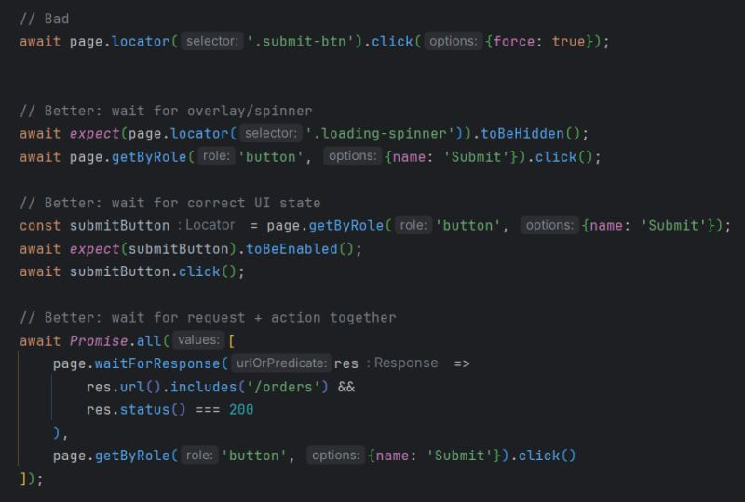

Playwright tip: use test.use() for authentication separation
One of the most popular uses of test.use() is authentication handling.
But far from the only one.
A very common problem in Playwright suites:
tests accidentally inherit the wrong user state.
For example:
• guest tests run as authenticated users
• admin tests run as regular users
• /login redirects to /dashboard
• state leaks between scenarios
Using test.use() makes the expected session explicit.
When declared inside a describe block, the configured
storageState is automatically applied to every test inside it.
At the same time, each test still runs in its own isolated
browser context, helping prevent state leakage between scenarios.
This improves:
• readability
• isolation
• maintainability
• scalability of the framework

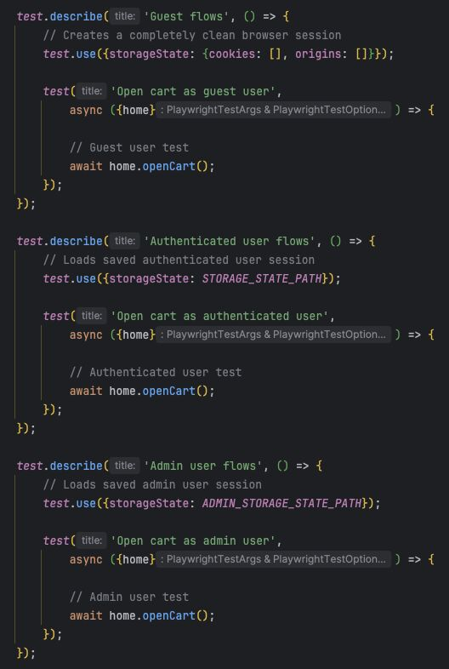

laywright tip: use locator.drop() for drag-and-drop testing
Playwright 1.60 introduced locator.drop()
Before this, drag-and-drop tests usually required:
• manual DataTransfer
• custom browser events
• helper utilities
• extra boilerplate
Now Playwright handles it with a single API.
> Cleaner tests.
> Less setup.
> Less browser event plumbing.
One of those small Playwright features that quietly improves everyday test automation work.

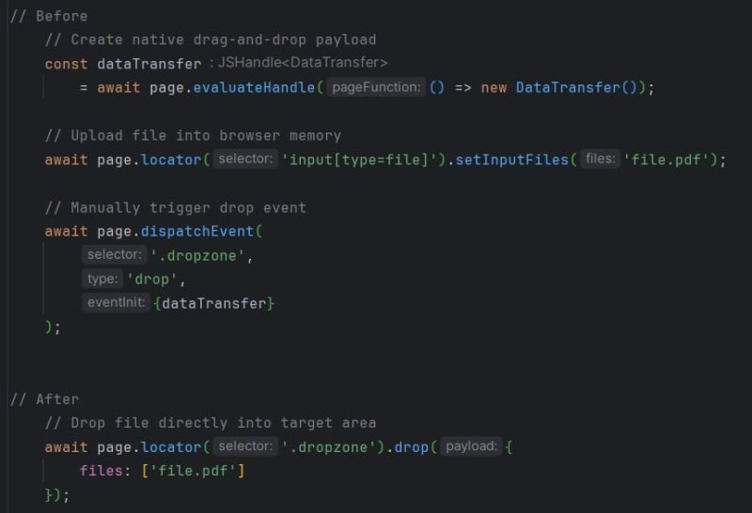

Playwright tip: use storageState instead of logging in every test
One of the biggest slowdowns in UI suites:
logging in through the UI before every test.
It works.
But over time it creates:
• slower execution
• duplicated setup
• flaky authentication flows
• unnecessary dependency on login pages
• longer CI pipelines
Most tests are not testing authentication itself.
They are testing what happens after login.
Playwright already provides a built-in solution:
storageState
The idea is simple:
authenticate once, save the browser session, and reuse it across the suite.
Now tests start already authenticated:
• faster
• more stable
• less setup duplication
• cleaner test intent
Save UI login flows for dedicated auth tests.
Not for the entire regression suite.

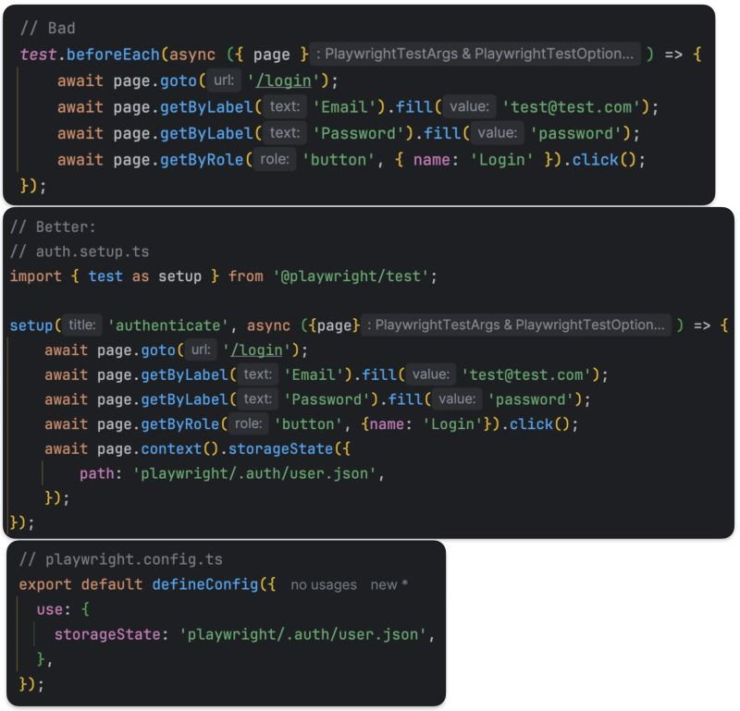

Playwright tip: stop using .nth() to find elements
.nth() feels like a quick win.
Need the second card? Just use .nth(1) and move on.
But this is one of the most fragile patterns in UI tests.
Why it fails:
• UI order changes → test breaks
• data changes → test breaks
• new element appears → test breaks
Not because behavior changed.
But because your test depends on position.
That’s not what users do.
Users don’t click "the 3rd card".
They click "the card with Premium plan".
Better approach: select by context, not index
Playwright gives you a built-in way to do that: has / hasText

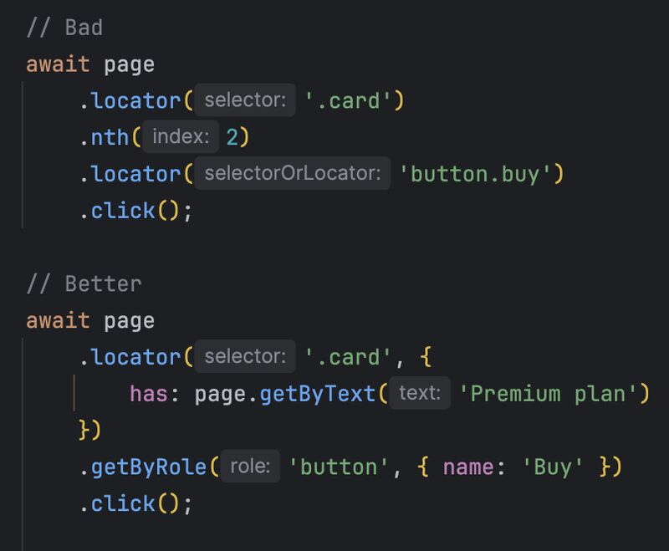

Playwright tip: stop branching for UI states
Looks reasonable.
Your UI can end up in different states -
so you handle it with if/else.
Tests pass. Logic is covered.
But why does it still feel flaky?
>>> The problem
if/else checks the UI at a single moment in time.
Modern apps are async:
• network is still in flight
• state is not updated yet
• UI hasn’t rendered
Your check runs too early.
Nothing is visible -> wrong branch -> test fails.
>>> Why this becomes flaky
You lose synchronization.
You are:
• reading the state too early
• making decisions on incomplete UI
• fighting timing instead of modeling behavior
Result:
• race conditions
• intermittent failures
• non-reproducible bugs

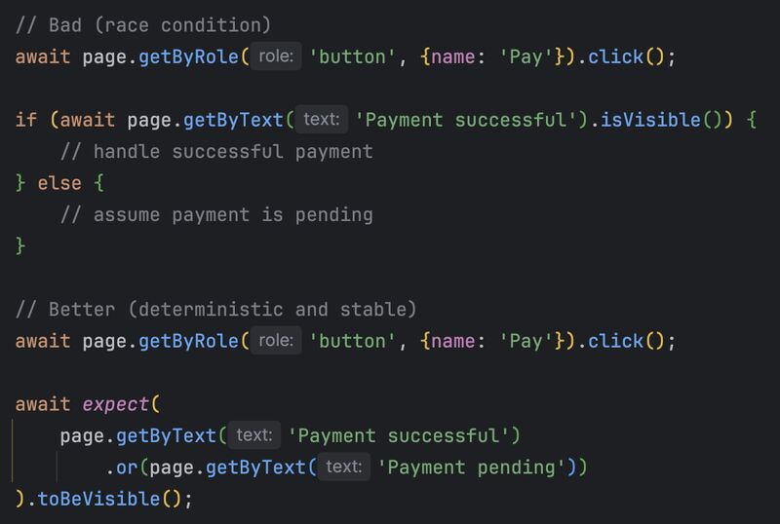

Playwright tip: stop using .first() as a shortcut
Looks harmless.
Your locator matches multiple elements - so you just grab the first one.
Tests pass. CI is green. But what are you actually testing?
The problem
.first() doesn’t fix ambiguity. It hides it.
Your test no longer targets a specific element.
It targets whatever happens to be first in the DOM.
When UI changes:
• a new item is added
• sorting changes
• layout shifts
Your test clicks something else.
Same code. Different behavior.
Why this becomes flaky
From a testing perspective, you lose determinism.
The outcome now depends on DOM order, not on business intent.
This leads to:
• wrong element interactions
• false positives
• hard-to-debug failures

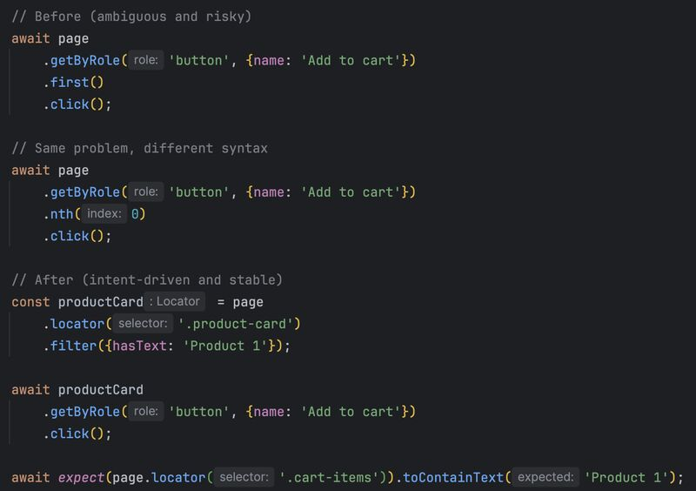

Playwright tip: stop asserting implementation details
Many flaky tests are not flaky because of timing.
They are flaky because they assert the wrong thing.
A common mistake:
We verify how something is built instead of what the user actually experiences.
It works… until:
• a refactor changes the DOM
• styles are updated
• API structure evolves
Result: tests fail - but the feature still works.
That’s not a bug. That’s a bad assertion.
Shift the focus:
Test user-observable outcomes, not implementation.
This approach is most relevant for:
• UI / E2E tests
• user journeys
• business flows
For lower levels:
• API tests → validate contracts, schemas, statuses
• component/unit tests → validate internal logic
Different levels - different goals.

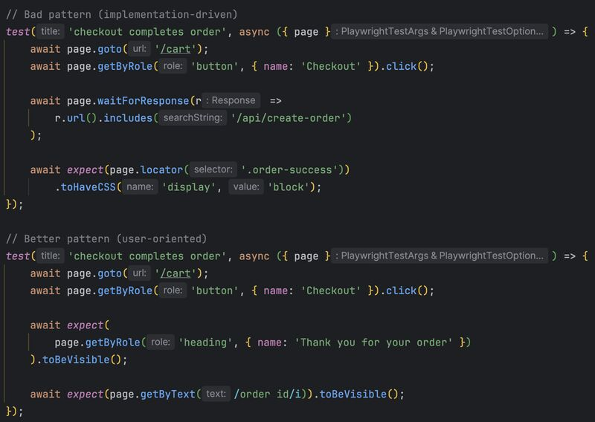

Playwright tip: stop fighting popups in UI
Flaky tests often come from ads, consent banners, and third-party overlays.
> They appear randomly.
> They block clicks.
> They break tests.
A common approach is to handle them in UI:
Detect -> Check -> Close.
Seems logical. But it doesn’t scale.
Why it fails:
• popups can be inside iframes
• they appear unpredictably
• selectors are unstable
• logic gets duplicated across tests
Result: complex and still flaky tests.
The real problem is not the popup. It’s the uncontrolled environment.
Better approach: Remove the source of noise.
> No ads.
> No overlays.
> No randomness.
Key idea:
Don’t fix symptoms in UI. Control the environment.

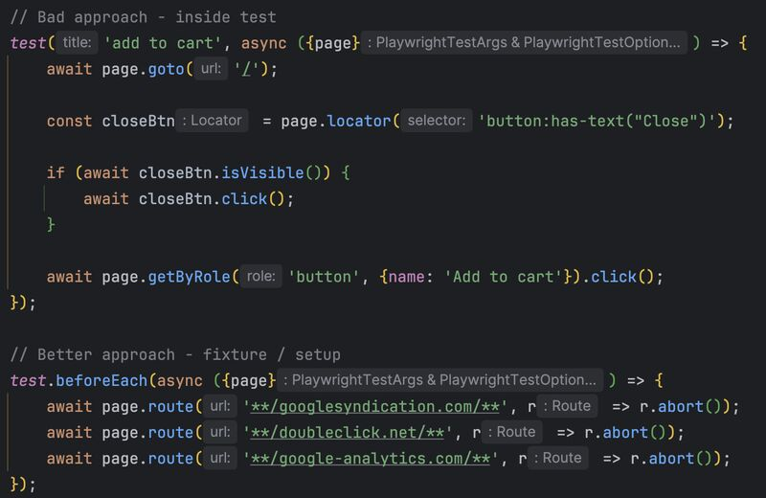

Playwright tip: stop waiting blindly - use expect.poll()
Some waits don’t fit into standard UI assertions.
Not everything is:
• visible
• clickable
• present in DOM
Sometimes you need to wait for:
• backend job completion
• async state change
• external system update
And this is where many tests become flaky.
Why it works:
• retries automatically
• stops as soon as condition is met
• faster + more stable
When to use expect.poll()
• async backend processing
• status endpoints (pending -> done)
• queues, jobs, payments
• anything outside UI lifecycle
Risks:
• unnecessary load on the backend
• rate limiting
• unrealistic user behavior

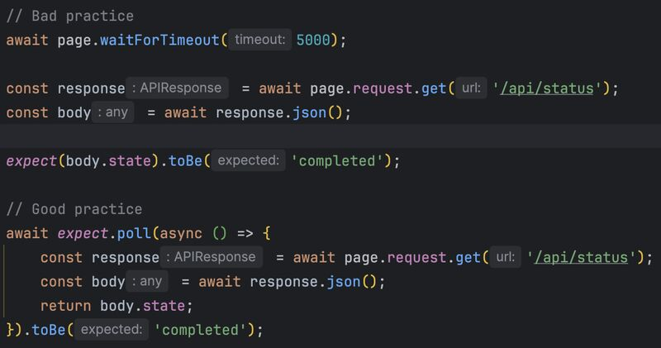

laywright tip: stop testing what you don’t own
Flaky tests often come from one mistake:
We rely on real backend behavior even when we test UI.
• APIs are slow.
• Data changes.
• Environments are unstable.
Result:
Tests fail - but not because of your feature.
The fix:
Control dependencies.
Mock what is outside your responsibility.
This does NOT replace end-to-end tests.
It makes UI tests:
• deterministic
• fast
• focused
Use real backend for smoke.
Use controlled data for stability.
Most flaky tests are not UI problems.
They are uncontrolled dependencies.

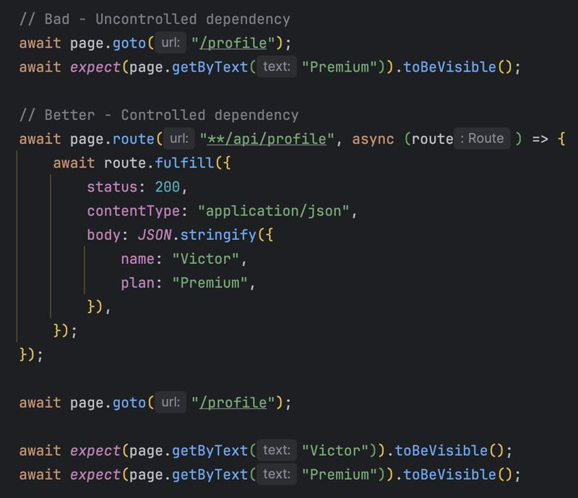

Playwright tip: why your "successful click" does nothing
Flaky tests often come from one mistake:
We wait for UI. But not for the system.
A button can be visible and clickable - but the application is still not ready.
Result:
Playwright reports a successful click, but nothing actually happens.
The fix
Wait for real signals - not just UI.
Think in terms of:
• network response
• state change
• backend confirmation
(not just "element is visible")
Most flaky tests are not timing issues.
They are wrong waiting strategy.

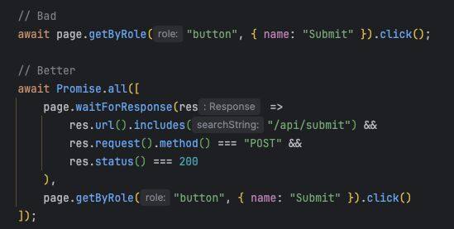

How to Write UAT Test Cases (for Business Analysts)
I remember when I was a junior BA - the idea of UAT scared me.
I didn’t want to admit I didn’t know where to start... So I stayed quiet and tried to figure it out on my own.
Turns out, I’d built it up to be more complicated than it really is.
Here’s what I learned:
As a BA, your role in User Acceptance Testing (UAT) is to ensure the solution actually meets the business need… not just that it functions.
To do that effectively, you need a structured approach to writing UAT test cases.
Here's how I do it:
1️⃣ Start with the Requirement
→ Begin with a single requirement or user story.
→ Each requirement must be tested, and depending on how many acceptance criteria it has, you may need multiple test cases.
(Think: What is the business expecting from this requirement?)
2️⃣ Review the Acceptance Criteria
→ Acceptance criteria define the boundary of success for a requirement.
→ They help you understand what “good” looks like from the business’s perspective.
(Use these criteria as your guideposts for what to test)
3️⃣ Develop Test Cases Based on the Acceptance Criteria
→ Each acceptance criterion should translate into at least one test case.
→ Some may need both a positive (happy path) and negative (error or edge case) scenario.
(If a criterion says “User must receive a confirmation email,” test both a valid scenario and one where the email fails)
4️⃣ Complete the UAT Template for Each Test Case
→ For each test case, fill in these fields:
☑ Test Description – A clear statement of what’s being tested
e.g. “Test password reset email is triggered for valid email addresses”
☑ Preconditions – Any setup required before testing
e.g. “User is logged out and on the login page”
☑ Test Steps – Step-by-step actions for the tester to perform
e.g. Click “Forgot Password”, enter email, submit form
☑ Expected Result – What should happen if the system works correctly
e.g. “User receives reset email within 2 minutes”
(TIP: Keep the language business-friendly so anyone can run the test)
5️⃣ Repeat for Each Requirement
→ Once you've completed the test cases for one requirement, move to the next and repeat the process.
→ This ensures full coverage and traceability back to each business objective.
6️⃣ Review with Business Stakeholders
→ Once your test cases are drafted, share them with your business SMEs or stakeholders.
(This step is critical - their feedback confirms that you’re testing what really matters to them)
7️⃣ Prepare for Execution
→ After validation, the test cases are ready to be run.
→ Depending on your project, UAT may be carried out by business users, or you may help execute or facilitate it as a BA.

-----
https://medium.com/@faizan4199/advanced-playwright-authentication-a-multi-role-fixture-for-scalable-e2e-testing-9ce89af14223

https://dev.to/johnnyv5g/playwright-browsercontext-what-it-is-why-it-matters-and-how-to-configure-it-3gi8?utm_source=substack&utm_medium=email
https://elaichenkov.github.io/posts/17-playwright-testing-mistakes-you-should-avoid/
https://github.com/currents-dev/playwright-best-practices-skill
https://medium.com/kenshoos-engineering-blog/good-infrastructure-genai-how-we-migrated-300-e2e-tests-to-playwright-in-1q-b6afe90d750f
https://testingplus.me/playwright-in-practice-page-object-pattern/
https://abigailarmijo.substack.com/p/send-and-test-mails-with-mailtrap?back=%2Fpublish%2Fposts%2Fscheduled

https://www.thegreenreport.blog/articles/database-rollback-strategies-in-playwright/database-rollback-strategies-in-playwright.html

https://medium.com/technology-hits/lesser-known-strengths-of-playwright-9638f77089cd
https://dev.to/olhapi/playwright-e2e-testing-cheatsheet-15gl?utm_source=substack&utm_medium=email
https://www.thegreenreport.blog/articles/tracking-ui-to-api-connections-with-playwright/tracking-ui-to-api-connections-with-playwright.html

https://dev.to/vitalets/global-cache-make-playwright-beforeall-run-once-for-all-workers-2a6l

https://medium.com/@qa.gary.parker/%EF%B8%8F-advanced-playwright-fixtures-supercharge-your-test-setup-and-teardown-20b8bb68e68e

https://dev.to/rodrigoobc/docker-for-qas-playwright-tests-on-docker-46cj?utm_source=substack&utm_medium=email
https://medium.com/@joaovitorcoelho10/milliseconds-make-millions-turning-playwright-tests-into-performance-audits-68f7fd6bc74d

https://medium.com/singapore-gds/brewing-quality-at-scale-performance-testing-with-playwright-and-artillery-6164a73977dc

https://medium.com/@evgeniy.otsevich/one-test-two-wins-run-ui-and-accessibility-tests-from-your-playwright-page-objects-with-706da09fdaec

https://medium.com/@jameskip/waiting-on-graphql-reliable-handling-of-in-flight-requests-in-playwright-a935129dfad9

https://medium.com/@indraaristya/centralized-playwright-api-logs-with-grafana-loki-368c21a76aba

https://www.thegreenreport.blog/articles/offline-but-not-broken-testing-cached-data-with-playwright/offline-but-not-broken-testing-cached-data-with-playwright.html

https://pradappandiyan.medium.com/pixel-by-pixel-visual-testing-using-playwright-with-github-actions-f47700f8a50e

https://www.thegreenreport.blog/articles/supercharging-playwright-tests-with-chrome-devtools-protocol/supercharging-playwright-tests-with-chrome-devtools-protocol.html?utm_campaign=Software%2BTesting%2BWeekly&utm_medium=email&utm_source=Software_Testing_Weekly_273

https://0xislamtaha.medium.com/part-2-count-me-out-assert-me-wrong-two-sneaky-playwright-pitfalls-5b53639f645f

https://0xislamtaha.medium.com/part-2-count-me-out-assert-me-wrong-two-sneaky-playwright-pitfalls-5b53639f645f

https://lewis-38728.medium.com/speeding-up-playwright-tests-with-dynamic-sharding-in-github-actions-91906aa9ed8f
https://medium.com/@qa.gary.parker/%EF%B8%8F-advanced-playwright-fixtures-supercharge-your-test-setup-and-teardown-20b8bb68e68e

https://medium.com/@jameskip/functional-page-model-for-playwright-a-scalable-alternative-to-classic-pom-007d8ec26333

https://hrmeet.medium.com/using-playwright-custom-matchers-to-automate-layout-testing-be8fa0063ebd

-------
8 Handling Authentication in Playwright 🔑
Authentication in test automation should be fast, efficient, and secure. Here’s how to do it right.
𝗛𝗮𝗻𝗱𝗹𝗶𝗻𝗴 𝗗𝗶𝗳𝗳𝗲𝗿𝗲𝗻𝘁 𝗔𝘂𝘁𝗵𝗲𝗻𝘁𝗶𝗰𝗮𝘁𝗶𝗼𝗻 𝗠𝗲𝘁𝗵𝗼𝗱𝘀
✔ 𝗕𝗮𝘀𝗶𝗰 𝗔𝘂𝘁𝗵 – Simple but limited
Use httpCredentials to send credentials automatically.
test.use({ baseURL: 'https://example.com', httpCredentials: { username: 'admin', password: 'admin' } });
✔ 𝗢𝗔𝘂𝘁𝗵 / 𝗦𝗦𝗢 – Handles redirects automatically. Playwright seamlessly manages multi-domain logins like Google or Okta
await page.goto('https://example.com/login');
await page.getByLabel('Email or phone').fill(process.env.GOOGLE_USER);
await page.getByRole('button', { name: 'Next' }).click();
await page.getByLabel('Enter your password').fill(process.env.GOOGLE_PWD);
✔ 2𝗙𝗔 & 𝗢𝗧𝗣 – Automate One-Time Passwords
Use otpauth to generate verification codes dynamically.
import * as OTPAuth from 'otpauth';
const totp = new OTPAuth.TOTP({ secret: process.env.GITHUB_OTP, digits: 6, period: 30 });
await page.getByPlaceholder('XXXXXX').fill(totp.generate());
✔ 𝗔𝗣𝗜 𝗧𝗼𝗸𝗲𝗻𝘀 – Secure & scalable
Store tokens as environment variables and pass them in request headers.
const response = await request.get('https://lnkd.in/dz48DrYF', {
headers: { Authorization: `Bearer ${process.env.API_TOKEN}` }
});
🔄 𝗥𝗲𝘂𝘀𝗶𝗻𝗴 𝗔𝘂𝘁𝗵𝗲𝗻𝘁𝗶𝗰𝗮𝘁𝗶𝗼𝗻 𝗦𝘁𝗮𝘁𝗲 𝗘𝗳𝗳𝗶𝗰𝗶𝗲𝗻𝘁𝗹𝘆
1️⃣ 𝗖𝗮𝗽𝘁𝘂𝗿𝗲 𝗦𝘁𝗮𝘁𝗲 𝗢𝗻𝗰𝗲
Save session data:
👉 await page.context().storageState({ path: 'playwright/.auth.json' });
2️⃣ 𝗨𝘀𝗲 𝗜𝘁 𝗶𝗻 𝗧𝗲𝘀𝘁𝘀
Load saved authentication to skip login:
👉 test.use({ storageState: 'playwright/.auth.json' });
3️⃣ 𝗚𝗹𝗼𝗯𝗮𝗹 𝗦𝗲𝘁𝘂𝗽 (𝗕𝗲𝘀𝘁 𝗣𝗿𝗮𝗰𝘁𝗶𝗰𝗲 💡)
Run authentication once before tests in auth.setup.ts, saving time and API requests.
import { test as setup } from '@playwright/test';
setup('authenticate', async ({ page }) => {
await page.goto('https://example.com');
await page.getByRole('button', { name: 'Login' }).click();
await page.fill('#email', process.env.USER_EMAIL);
await page.fill('#password', process.env.USER_PASSWORD);
await page.getByRole('button', { name: 'Sign In' }).click();
await page.context().storageState({ path: 'playwright/.auth.json' });
});
hasztag
hasztag
https://dev.to/vitalets/request-mocking-protocol-a-new-approach-to-mocking-server-side-requests-in-e2e-testing-3p2i

https://medium.com/@evgeniy.otsevich/a-practical-look-at-the-object-pool-pattern-for-playwright-tests-dd767053b636

https://medium.com/@juanpromanzio/parallel-testing-with-playwright-how-to-avoid-collisions-and-failures-dc89651fc92e

https://dev.to/danteukraine/playwright-graphql-revolutionize-graphql-testing-with-auto-generated-type-safe-client-4i1l?utm_source=substack&utm_medium=email
https://blog.scottlogic.com/2025/02/12/playwright-visual-testing.html?utm_campaign=Software%2BTesting%2BWeekly&utm_medium=email&utm_source=Software_Testing_Weekly_259
https://medium.com/@dneprokos/sdet-building-a-simple-configuration-mechanism-for-your-playwright-project-c49ffc29cb06

https://www.linkedin.com/pulse/automated-accessibility-test-scripts-playwright-marcin-michalak-qn6oe/?trackingId=slS0%2BXkLSlkCvTIF0qlv1w%3D%3D

https://github.com/marcinet/a11y-playwright/blob/main/utils/a11-helpers.ts
https://playwrightsolutions.com/tip-playwright-copy-as-playwright-api-request-button/?ref=playwright-solutions-newsletter

https://dev.to/playwright/organizing-playwright-tests-effectively-2hi0
https://dev.to/vitalets/show-metadata-in-playwright-html-report-a-complete-guide-b51

https://medium.com/@adam_pajda/playwright-visual-tests-with-git-lfs-and-docker-d537ddd6e86a
https://medium.com/@merisstupar11/achieving-wcag-standard-with-playwright-accessibility-tests-f634b6f9e51d

https://medium.com/@merisstupar11/achieving-wcag-standard-with-playwright-accessibility-tests-f634b6f9e51d

https://mailosaur.com/blog/testing-otp-playwright

------

Can ARIA Snapshots Slash Your UI Test Suite?



Callum Porter

Staff Quality Engineer at Ceros | AI-Enabled Quality Engineering Leader | QA Automation Specialist

What if the key to faster and more reliable test automation is eliminating UI tests instead of writing more?

In the high-stakes world of quality assurance, where every second counts and reliability is essential, Playwright's latest update prompts us to rethink our approach to UI test automation. Traditional UI tests have long been the backbone of QA strategies, but are they preventing us from achieving efficiency? Enter ARIA snapshots, the tool that could transform how we validate web applications by emphasising accessibility instead of exhaustive checks of UI content.

Why More UI Tests Aren't the Answer
For years, the prevailing belief has been that writing more UI tests results in higher application quality. However, this perspective is beginning to show its limitations. Comprehensive UI tests are not only time-consuming but also highly fragile. Even minor changes to the user interface can cause these tests to fail, leading to a maintenance headache and slowing down your release cycles.
The myth of comprehensive UI testing fails to acknowledge the diminishing returns associated with adding more tests. Each additional UI test can increase the maintenance burden without significantly improving defect detection rates. Furthermore, redundant tests frequently check the same functionalities, wasting valuable testing resources and resulting in flaky tests undermining trust in your test suite.
Accessibility is becoming the new frontier in QA automation. By moving our focus from superficial UI validations to meaningful accessibility checks, we can better address applications' semantic correctness and usability. ARIA snapshots provide a detailed view of a web page's accessibility tree, including the roles, attributes, and relationships between elements. This approach ensures compliance with standards like WCAG and inherently addresses essential aspects of UI correctness, reducing the need for redundant UI content tests.

Harnessing ARIA Snapshots for Efficient QA
ARIA snapshots can significantly enhance your test automation strategy. They provide a human-readable and machine-processable YAML representation of the accessibility tree. This structured format enables thorough validation of your application's accessibility features.

Implementing ARIA Snapshots is straightforward:
- Capture an ARIA Snapshot: Utilise Playwright's toMatchAriaSnapshot assertion to capture the current accessibility tree.
await expect(page.locator('body')).toMatchAriaSnapshot();
- Store Snapshots: Save the generated YAML snapshots in your test repository to enable future comparisons.
- Automate Comparisons: Integrate snapshot comparisons into your CI/CD pipeline to automatically identify discrepancies.
- Update Snapshots: Use the --update-snapshots flag to refresh snapshots when legitimate UI changes occur.
npx playwright test --update-snapshots

Balancing ARIA Snapshots with Essential UI Tests:
While ARIA snapshots can effectively replace many UI content tests, specific scenarios still necessitate traditional UI testing. Traditional UI tests help verify visual layouts, validate data, and assess user interactions. By adopting a hybrid testing strategy—where ARIA snapshots manage accessibility and semantic structure alongside selective UI tests for visual and interactive elements—teams can achieve a comprehensive approach that combines the strengths of both methods.

Best Practices:
- Selective Snapshotting: Concentrate on creating snapshots of critical components to minimise noise and reduce maintenance efforts.
- Regular Updates: Periodically review and update snapshots to ensure they accurately reflect intentional changes made to the user interface.
- Version Control Integration: Store snapshots in version control systems to monitor changes over time.

Embracing a Smarter Approach to Test Automation
Traditional UI tests are valuable, but they often involve high maintenance costs, brittleness, and slow execution times, which can hinder the efficiency and scalability of test automation efforts. ARIA snapshots provide a focused, resilient, and efficient alternative by validating the semantic structure and accessibility of web applications, thereby reducing the reliance on extensive UI content tests.
The Future of QA Automation is increasingly centred on accessibility-driven testing. As the industry emphasises inclusivity, tools like ARIA snapshots are becoming essential for developing robust and maintainable test suites. By adopting ARIA snapshots, QA professionals can overcome the limitations of traditional UI testing and achieve greater efficiency, reliability, and inclusivity in their test automation strategies.
In the quest for faster and more reliable test automation, sometimes the path forward is not to add more tests but to reimagine what and how we test.
Have you experimented with ARIA snapshots in your test automation workflows yet? I'd love to hear about your experiences—whether you've seen significant improvements in test efficiency or faced challenges in implementation.
https://dev.to/leading-edje/playwright-visual-testing-dynamic-data-34ia
https://adequatica.medium.com/is-it-worth-mocking-websockets-by-playwright-e611cb016ec5

https://testandanalysis.home.blog/2024/10/14/make-your-playwright-tests-run-faster-by-using-the-playwright-api-to-wait/

https://blog.martioli.com/playwright-tips-and-trick-4/

https://dev.to/vitalets/supercharge-your-e2e-tests-with-playwright-network-cache-58jm

https://medium.com/@testerstalk/api-mocking-using-playwright-0cffefbd327c

https://medium.com/@vrknetha/effective-utilization-of-playwright-fixtures-a-comprehensive-guide-841150525c7e https://medium.com/@vrknetha/effective-utilization-of-playwright-fixtures-a-comprehensive-guide-841150525c7e
https://adequatica.medium.com/timeouts-against-flaky-tests-true-cases-with-playwright-9f4f28d2c391

https://ultimateqa.com/a-test-data-strategy-for-parallel-automation-in-playwright/?utm_source=substack&utm_medium=email
https://abigailarmijo.substack.com/p/localize-your-test-with-playwright

https://medium.com/@ctrf-io/detect-and-handle-flaky-playwright-tests-5ab4af087492

youtube.com/watch?si=aE8NyyL23lTuAh5-&v=qvlfbHFxqnI&feature=youtu.be
https://www.thegreenreport.blog/articles/handling-unreliable-api-endpoints-with-custom-retry-logic-and-mocking/handling-unreliable-api-endpoints-with-custom-retry-logic-and-mocking.html

https://adequatica.medium.com/api-contract-testing-on-frontend-with-playwright-4509b74b3008

https://adequatica.medium.com/google-authentication-with-playwright-8233b207b71a

https://adequatica.medium.com/google-authentication-with-playwright-8233b207b71a

https://adequatica.medium.com/hidden-gems-of-playwright-part-2-ca3e38a5954a

https://adequatica.medium.com/hidden-gems-of-playwright-part-2-ca3e38a5954a
https://blog.martioli.com/playwright-interview-questions-that-you-are-going-to-love/?utm_campaign=Software%2BTesting%2BWeekly&utm_medium=email&utm_source=Software_Testing_Weekly_221
https://www.thegreenreport.blog/articles/frontend-performance-testing-with-playwright-and-lighthouse/frontend-performance-testing-with-playwright-and-lighthouse.html
https://argos-ci.com/blog/speed-up-playwright

https://blog.martioli.com/playwright-interview-questions-that-you-are-going-to-hate/
https://blog.martioli.com/playwright-tips-and-tricks-3/

https://qa-nora.medium.com/how-to-parameterize-projects-in-playwright-82da3b8a1baf

https://blog.martioli.com/full-parallelization-with-playwright/

https://medium.com/@merisstupar11/strategic-tagging-optimizing-your-playwright-test-suit-4ab109343fed

https://mikestopcontinues.hashnode.dev/advanced-snapshot-testing-in-playwright?utm_source=substack&utm_medium=email
https://blog.martioli.com/debugging-tests-with-playwright/?utm_campaign=Software%2BTesting%2BWeekly&utm_medium=email&utm_source=Software_Testing_Weekly_209

https://medium.com/@dneprokos/sdet-quick-introduction-to-allure-reports-with-playwright-397d5c9986b5

https://medium.com/@dneprokos/playwright-stories-navigating-tricky-ui-automation-scenarios-for-beginners-7195e50486eb

https://medium.com/@semihkasimoglu/understanding-playwrights-test-slow-and-slowmo-option-a-guide-for-efficient-test-management-8caf3a5183ba
https://qualitymatters.hashnode.dev/how-to-parameterize-projects-in-playwright?utm_campaign=Software%2BTesting%2BWeekly&utm_medium=email&utm_source=Software_Testing_Weekly_206
https://blog.martioli.com/playwright-tips-and-tricks-2/
https://blog.martioli.com/playwright-tips-and-tricks-1/
https://www.houseful.blog/posts/2023/playwright-standards/

